November 26, 2017
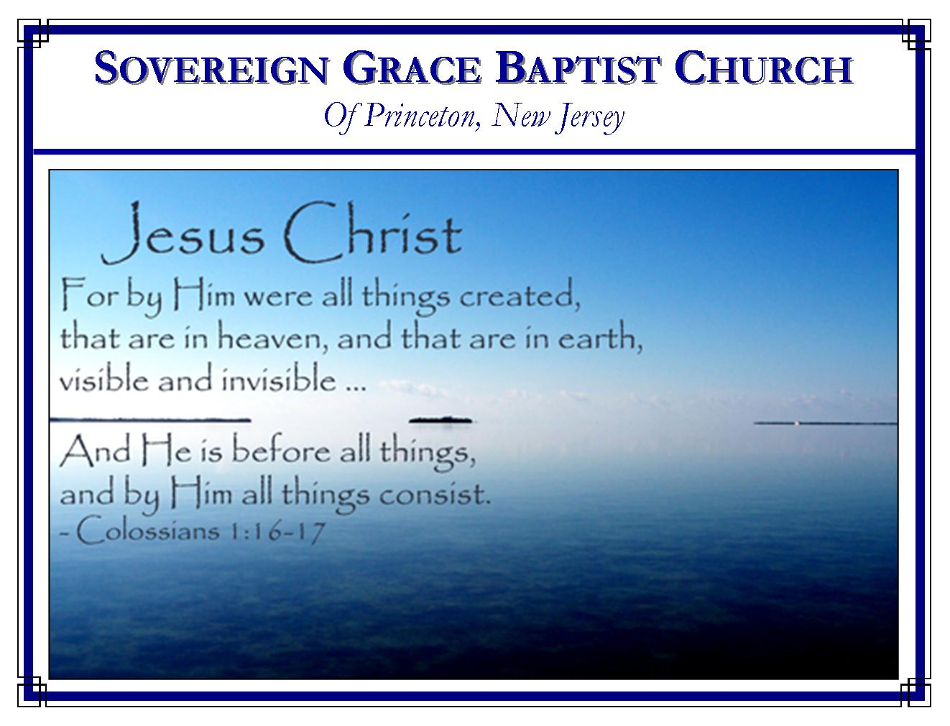
Weekly Schedule of Services
Sunday: | 10:15 AM | Bible Class
 | 11:00 AM | Morning Service
Thursday: | 7:30 PM | Mid-week Service
Services Broadcast Live @ www.FreeGraceMedia.com/live

Web Address
Be sure to bookmark our website for daily articles and audio messages:
www.FreeGraceMedia.com
Weekly Meeting Location  251 Green Lane  Ewing, NJ, 08638 | Mailing Address  7 Birch Street  Pennington, NJ 08534  Clay Curtis, pastor
Phone: 615-513-4464 | Email: clay@freegracemedia.com
If you would like to receive this bulletin sent weekly
to your email then send a note to the email address above.
Articles in this bulletin are by the pastor unless otherwise noted.
SCHEDULE OF SERVICES
10:15 am. Bible Class
11:00 a.m. Service: Hymns * Scripture Reading * Message* Hymn.
Scripture Today: Art D’Armiento Scripture Thurs: Kevin Thacker Nursery Sun: Kristyn K; Debbie D. Nursery Thurs: Carol D.
BDays: Kevin D-8th; Rachael D-9th; Scott K-9th; Josiah T-11th; Peter D-20th; William K-23rd; Robert K-29th; Wedding Anniversaries: Kevin and Kimberly T. 11th; Ravi and Urmilla I. 17^{th;} November Cleaning: The Cooper’s

Sept Cleaning: The Kane Family

The videos on our youtube website are now listed as individual sermons, as well as full services. Be sure to visit and subscribe and tell a friend to visit.

-----------------------------
SUNDAY’S READING IN PROVERBS
Proverbs 10: 15: The rich man’s wealth is his strong city: the destruction of the poor is their poverty.
-----------------------------
Fathers, Teach Your Children -- “And these words, which I command thee this day, shall be in thine heart: and thou shalt teach them diligently unto thy children, and shalt talk of them when thou sittest in thine house, and when thou walkest by the way, and when thou liest down, and when thou risest up.” – Deuteronomy 6:6-7

It is the preacher/teacher’s job to teach the Word of God to us and our children. But he can only do that on the Lord’s day and midweek. The father (grandfather) of the children is the spiritual leader of his home and it is his responsibility to talk and teach these things to his children throughout the week. Fathers, you must talk to them, you must lead by example. They must hear, believe and walk by faith or they will perish in this world; die in their sins, without God and without Christ. It is the best thing you can do for them. If you love them, talk to them, ‘when thou sittest and walkest and liest down and risest up.’ Pastor Paul Mahan

-----------------------------
“He that justifieth the wicked, and he that condemneth the just, even they both are abomination to the Lord.” (Proverbs 17:15).

How this can be, I do not know, but it is so…. when Christ was made sin on Calvary’s tree, He never ceased to be the sinless One. Even when He was made sin, He Himself remained impeccable. He never sinned! It is equally true that when He who knew no sin was made sin, it became His sin. He owned it, felt all the shame, guilt, and defilement of it, and was forsaken by God on account of it. He experienced everything about sin with the exception of the commission of it. Here is the glory of this - just as my sin literally became His sin, His righteousness literally became my righteousness. With His righteousness, I the sinner am really one who has never sinned. Pastor Todd Nibert
-----------------------------
WHY PREACH THIS?

When beholding the trouble and divisions which arise because we preach the gospel that Christ, who knew no sin, was made sin for us, that we might be made the righteousness of God in him, some may ask, “Why preach this? If this doctrine causes some to part then why not cease preaching this?” If we cease preaching this then we cease preaching the gospel of Christ and him crucified; if we cease preaching this then we cease preaching the righteousness of God which is what Christ came to manifest; if we cease preaching this then we cease declaring the good news that as truly as our sin became Christ’s so that he owned it to be his very own, Christ’s righteousness has become ours so that we, even better, so that God owns it to be our very own. You see, brethren, if we cease preaching this then we cease preaching the glory of God.

-----------------------------

THE BREACHES
Nehemiah 4: 7: But it came to pass, that when Sanballat, and Tobiah, and the Arabians, and the Ammonites, and the Ashdodites, heard that the walls of Jerusalem were made up, and that the breaches began to be stopped, then they were very wroth, 8: And conspired all of them together to come and to fight against Jerusalem, and to hinder it. 9: Nevertheless we made our prayer unto our God, and set a watch against them day and night, because of them.

When the enemies heard that the breaches in the wall began to be built up they were enraged. All the enemies conspired together to come and fight at the point of those breaches that they might hinder the work.
These enemies and the breaches in the wall represent satan and his seed and that point of the doctrine of Christ they are attacking at any given time. Our enemies are not attacking the point of the gospel where the wall stands strong. They attack at whatever point they think there may be a breach in the wall.
May God make us like those faithful men in this passage! Pray unto him without ceasing because except God build up the breach then it will not be built up. Set a watch against our enemies day and night defending Christ’s faithful preachers who preach that point of Christ’s gospel which is most under attack so that our enemies will not hinder the work.

-----------------------------

BELIEVING GOD, WE CANNOT BE PRESSURED INTO COMPROMISE
If we truly believe God, we will serve him with confidence and peace, simply trusting his total sovereignty, power, wisdom, and grace. The fear of man shall not be a threat to us. The favor of man shall not be a motive to us. The circumstances of the hour shall not pressure us. And the desire for results shall not alter our message, or cause us to employ the devised methods of others. If we believe God, we will simply perform our responsibilities faithfully and wait upon the Lord to perform his work according to his own will. Pastor Don Fortner
-----------------------------

A man’s best efforts to earn righteousness before God will leave him impoverished, with no righteousness at all, but God’s mercy will make him rich. A man’s best efforts to avoid sin will leave him in the depths of sin, but God’s mercy will lift him up to God. Then let’s shun our works and beg God for mercy. Pastor Frank Tate

-----------------------------

“I therefore, the prisoner of the Lord, beseech you that you walk worthy of the vocation wherewith ye are called” (Eph. 4:1). None of us know what a day will bring. We’re not promised the next second. While we have breath, by God’s grace, may we consider our conduct and attitude…May we be found conducting ourselves as children of light…walking in love, as Christ also hath loved us, and hath given Himself for us an offering and a sacrifice to God for a sweetsmelling savor. Pastor Marvin Stalnaker

-----------------------------

MY PRAYER FOR THIS GENERATION

After the last presidential election, many colleges and universities had to establish “safe places” in which refuge and counseling could be found by students unable to cope with the fact that their candidate had lost. I am unaware of any generation in the USA before this one that was so ill-equipped for the difficulties of life that some event as inconsequential as a political election could drive it to despair. However, this does not greatly surprise me. This present generation of college age students in the USA (commonly called Generation Z – the last generation?) was raised in a time unprecedented academically, religiously, culturally and societally. Government schools have evicted God and His Christ. Most “Christians” are so only in name and lip-service. Unchristian religions including atheism are increasing. Few parents endeavor to lead their children away from the world and to Christ. In both our society and culture, immorality and ungodliness and the spirit of anti-Christ are becoming more pervasive. Current events suggest God is withdrawing His restraining hand from the wicked. Christ has been made to be “like a stranger in the land” (Jeremiah 14:8).

My heart cries for this generation. For I have family members and friends in it. And I dearly love my country and am greatly concerned for its future. If a political election drives many in this generation to despair, what will they do when they face the far more consequential events in their future? Where will they find a “safe place” and counseling when they are no longer in their schools? What is the future of our country when this generation is in charge of it?

How sad is the plight of those who are ignorant of Jesus Christ the Hiding-Place (Psalm 32:7; 119:114; Isaiah 32:2) and “Wonderful Counselor” (Isaiah 9:6)!

I therefore pray with the psalmist, “Now also when I am old and grayheaded, O God, do not forsake me, until I declare Your strength to this generation, Your power to everyone who is to come” (Psalm 71:18). Missionary Daniel Parks

