May 14, 2017
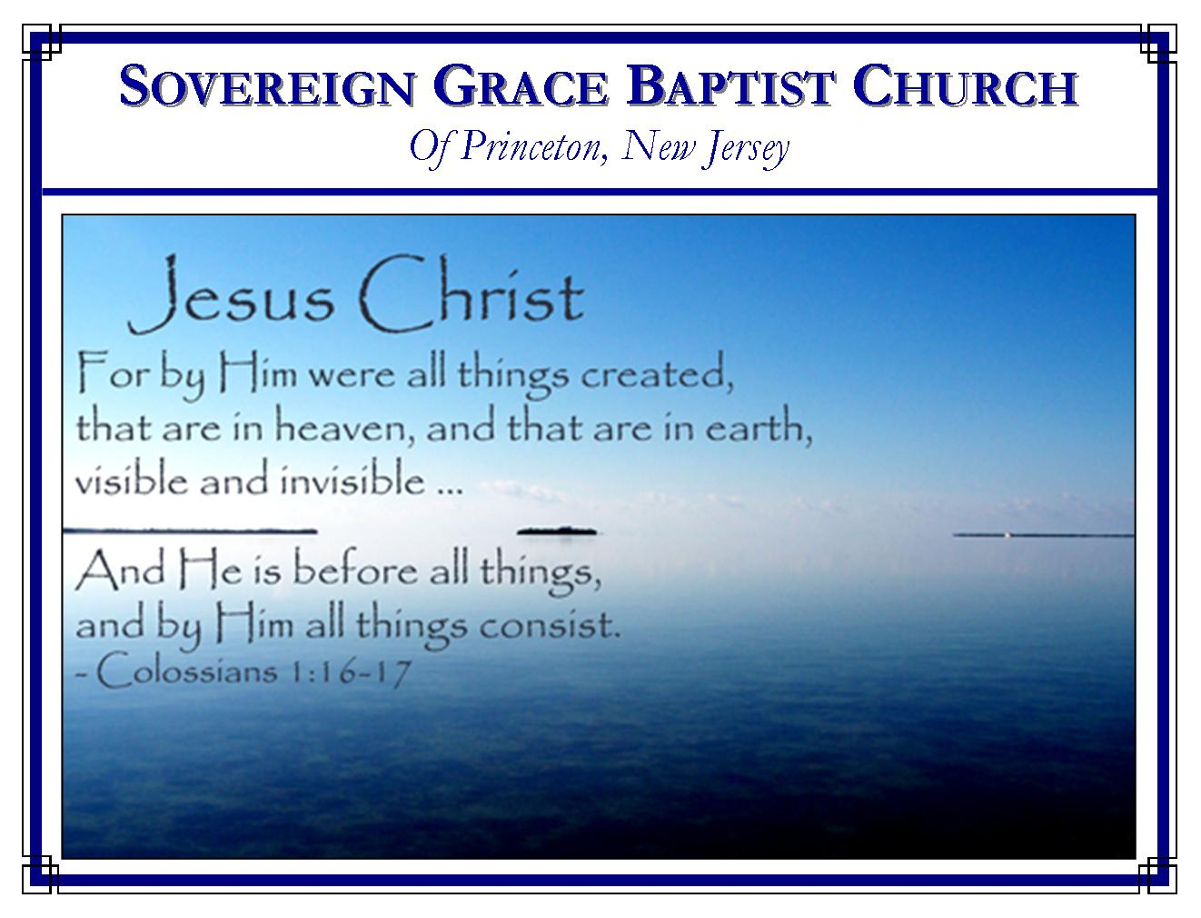
Weekly Schedule of Services
Sunday: | 10:15 AM | Bible Class
 | 11:00 AM | Morning Service
Thursday: | 7:30 PM | Mid-week Service
Services Broadcast Live @ www.FreeGraceMedia.com/live

Web Address
Be sure to bookmark our website for daily articles and audio messages:
www.FreeGraceMedia.com
Weekly Meeting Location  251 Green Lane  Ewing, NJ, 08638 | Mailing Address  7 Birch Street  Pennington, NJ 08534  Clay Curtis, pastor
Phone: 615-513-4464 | Email: clay@freegracemedia.com
If you would like to receive this bulletin sent weekly
to your email then send a note to the email address above.
Articles in this bulletin are by the pastor unless otherwise noted.
SCHEDULE OF SERVICES
10:15 am. Bible Class 11:00 a.m. Service: Opening Hymns * Scripture Reading * Message* Closing Hymn
Nursery Today: Carol D; Melinda C Nursery Thurs: Alyssa L
BDays: Greg C—1st; Martha C—4th; Eric L—9th; Will C—14th; Chloe D—26th; Lenore R—27th; Anniversary: Ravi and Debbie D—4th; Eric and Michelle L—21st, Mike and Jamie Lutz—23rd; May Cleaning: De Ritter

SUNDAY’S READING IN PROVERBS
Proverbs 6: 16: These six things doth the LORD hate: yea, seven are an abomination unto him: 17: A proud look, a lying tongue, and hands that shed innocent blood, 18: An heart that deviseth wicked imaginations, feet that be swift in running to mischief, 19: A false witness that speaketh lies, and he that soweth discord among brethren.

-----------------------------

Beware of Hypocrisy
Pastor Henry Mahan
The very prayer that encourages you to pray for mercy instructs you to forgive. “Forgive us our sins as we forgive those who sin against us.” There is no grace in the heart unwilling to overlook faults; there is no love in the heart which holds a grudge against others while asking God to forgive themselves.

-----------------------------

“YE ARE COMPLETE IN HIM” “YE ARE COMPLETE IN HIM”
Colossians 2:10
Pastor Bruce Crabtree
The believer’s standing in Christ does not fluctuate with his feelings, not even the increase or decrease of his faith or understanding or anything else. He stands complete in Christ. God would never trust any of His children to stand before him at any time in their own selves – that is, in their merits or certain good frames of mind. He knows our frame. He remembers that we are yet dust. Therefore, He has on purpose provided for them this perfect standing in Christ Jesus. “Ye are complete in Him,” the Holy Ghost said. He says in another place, “Ye are perfect in Christ Jesus,” (Col. 1:28.) The very nature of our God requires us to be perfect and complete before Him at all times. He, out of necessity, therefore provided all this for His children: a perfection, a completeness, which can never be diminished. It is as unchanging as God himself, (Hebrews 6:17; 13:8).

-----------------------------
THE SPIRIT GIVETH LIFE
2 Corinthians 3: 6: Who also hath made us able ministers of the new testament; not of the letter, but of the spirit: for the letter killeth, but the spirit giveth life.

Preaching “of the spirit” is declaring that God in Christ fulfilled all the obligations of the new covenant for his people so that all the promises of God are yes and amen to the believer in Christ. (2 Cor 1: 20; 1 Cor 1: 31; 2 Sam 23: 5)

“The spirit giveth life.” The word “spirit” is not speaking of God the Holy Spirit. It means breath, spirit, life. Christ said, “It is the spirit that quickeneth; the flesh profiteth nothing: the words that I speak unto you, they are spirit, and they are life.” (Jn 6: 63) In the garden, God took a dead body and breathed into Adam the breath of life and he became a living soul. Christ takes a dead sinner, speaks his word into us and his word is spirit and life which quickeneth us to spiritual life. “And so it is written, The first man Adam was made a living soul; the last Adam was made a quickening spirit.” (1 Cor 15: 45) Christ said, “For as the Father raiseth up the dead, and quickeneth them; even so the Son quickeneth whom he will….Verily, verily, I say unto you, The hour is coming, and now is, when the dead shall hear the voice of the Son of God: and they that hear shall live. For as the Father hath life in himself; so hath he given to the Son to have life in himself.” (Jn 5: 21, 25-26)

This is how God puts the new spirit [little s] in his people like he promised in Ezekiel 36: 26-27: “A new heart also will I give you, and a new spirit [little s] will I put within you: and I will take away the stony heart out of your flesh, and I will give you an heart of flesh. I will put my spirit [little s] within you, and cause you to walk in my statutes, and ye shall keep my judgments, and do them.”

The gospel is not taught us in our old sinful stony heart but only in the new spirit Christ puts in us. The sinful old man can do nothing. It is in the new spirit Christ puts in us in which we are given faith, taught the gospel and worship God. Christ said, “The hour cometh, and now is, when the true worshippers shall worship the Father in spirit [little s] and in truth: for the Father seeketh such to worship him. God is a [capital S] Spirit: and they that worship him must worship him in [little s] spirit and in truth.” (Jn 4: 23-24) When we are born-again we are given a new spirit. The new spirit is one with God the Holy Spirit within us but it is not God the Holy Spirit. They are one but distinct. Therefore, “The [capital S] Spirit itself beareth witness with our [little s] spirit, that we are the children of God.” (Rom 8: 16) God does not teach us the gospel in our old man which is dead. It is only in the new spirit that the Spirit of God bears witness. In every believer there is the old fleshly man of Adam and there is God the Spirit and the spirit he puts in us. That is why Christ said, “That which is born of the flesh is flesh; and that which is born of the [capital S] Spirit is [little s] spirit.” (Jn 3: 6)

Christ’s preachers are called “ministers of the spirit” because Christ does this work through the preaching of the gospel. “Ye have purified your souls in obeying the truth through the Spirit…Being born again, not of corruptible seed, but of incorruptible, by the word of God, which liveth and abideth for ever…And this is the word which by the gospel is preached unto you.” (1 Pet 1: 22-25)
THE AMAZING BODY

Ephesians 4: 15: But speaking the truth in love, may grow up into him in all things, which is the head, even Christ: 16: From whom the whole body fitly joined together and compacted by that which every joint supplieth, according to the effectual working in the measure of every part, maketh increase of the body unto the edifying of itself in love.

Another reason for which Christ gives his preachers is that Christ might grow his body into him through the preaching of the gospel.

GROW UP
When we are first born of God to faith in Christ we are babies. Through the preaching of the gospel, Christ grows us in grace and knowledge of him in the inward man. Christ is the Truth. (Jn 14: 6) The gospel is the Truth. Christ is formed in the new spirit by the Spirit of Truth. (Jn 15:26; 16: 13) When the love of God abides in a sinner he speaks the truth of Christ because the Truth makes his new spirit have no guile. (Eph 4: 21, 25; 1 Jn 4: 1-8; Ps 32: 2) Therefore this growth is accomplished through his preachers “speaking the truth in love.”

GROW UP INTO HIM
Believers together are Christ’s body. Christ is our Head. Each member is growing up into Christ. We grow up into him as we grow more assured of our unbreakable union with Christ who established his covenant, justified us and purchased us with his own blood so that Christ shall lose none. (Jn 6: 37-39) He grows us up into Christ by the Spirit creating in us the fruit of the Spirit. (Gal 5: 22-23) This growth is “in all things” meaning the believer is grown in every grace in the new man. (2 Pet 1: 5-11)

FROM WHOM
“From whom” means from Christ our Head his church is “fitly joined together and compacted by that which every joint supplieth.” Christ finds each dry bone, gives us life, and fits us in his body. Each believer has the same Life, Light, Righteousness, and Holiness, Christ our All. (1 Cor 12: 12) He “compacts”, cements, us together “by that which every joint supplieth.” From Christ our Head nourishment is ministered through the body using each member to distribute to each other member. This work is effectual by Christ “according to the effectual working in the measure of every part.” Thus Christ “maketh increase of the body unto the edifying of itself in love.” Thus Christ makes each member necessary for the health of the whole body.

What amazing wisdom of God! The human body is astounding but Christ and the church is by far more amazing than the human body! Knowing all this is done through the truth of the gospel conveys to us how important it is to hear the gospel continually. There are some things we can afford to miss but the gospel is not one! (Pro 23: 23) Since the gospel is so important to each member, Christ teaches us to love each other, to overlook one another’s faults, so that the gospel may continue among us as he continues to call out his redeemed. What amazing wisdom of God!

