June 22, 2014
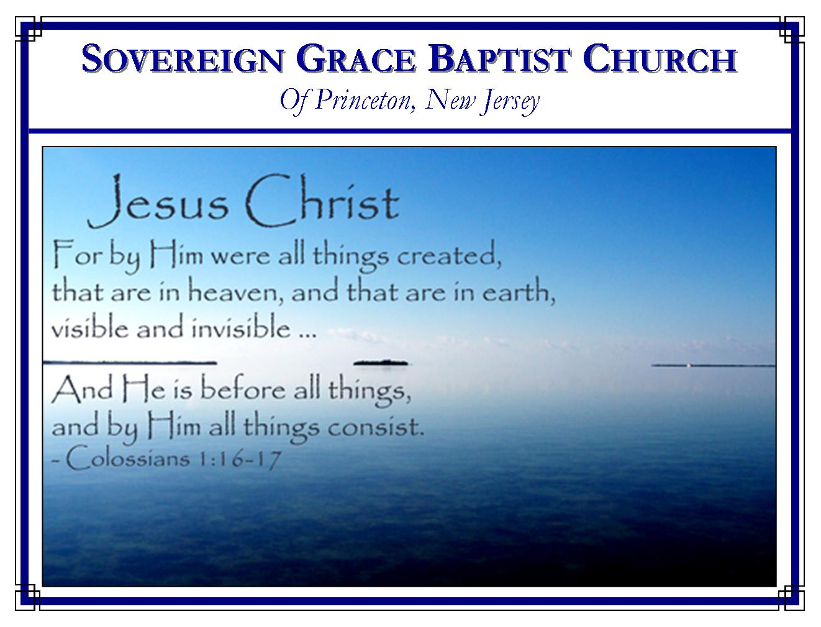
Weekly Schedule of Services
Sunday: | 10:15 AM | Bible Class
 | 11:00 AM | Morning Service
Thursday: | 7:30 PM | Mid-week Service
Services Broadcast Live @ www.FreeGraceMedia.com/live

Web Address
Be sure to bookmark our website for daily articles and audio messages:
www.FreeGraceMedia.com
Weekly Meeting Location  Rocky Hill Firehouse, 2nd floor  150 Washington Street  Rocky Hill, NJ 08553 | Mailing Address  7 Birch Street  Pennington, NJ 08534  Clay Curtis, pastor
Phone: 615-513-4464 | Email: clay@freegracemedia.com
If you would like to receive this bulletin sent weekly to your email then send a note to the email address above. Articles in this bulletin are by the pastor unless otherwise noted.

SCHEDULE OF SERVICES
10: 15 am Bible Class
11:00 a.m. Service
Opening Hymns
Scripture Reading
Message
Closing Hymn
Nursery Today: Michelle L. Nursery Thurs: Carol D. Birthdays: Laxman Inderjeet—23rd; AJ D—26th; Wedding Anniversary: Laxman and Davika Inderjeet—30^{th;} Announcements: As always, if you offer extra toward our building fund be sure to mark the offering as such. * On the offering envelopes, please only put the amount on the outside, not your name *

Please, no drinks or food in the service. Also, we have a nursery equipped with a digital flat screen television broadcasting all services live, for children four and under.
*******
- Bro. Scott Keller is scheduled to preach the gospel to you here this Thursday night.
- Bro. Eric Lutter is scheduled to preach the gospel to you here next Sunday, June 29, at 11am. There will be no 10:15 service.
- I am scheduled to preach this Wednesday--Sunday for Sovereign Grace Baptist Church in The Dalles, OR where Bro. Norm Wells is pastor.
- Bro. Ravi Doodnath is scheduled to preach the gospel to you here Thursday night, July 3.
- I am scheduled to preach Friday, July 4, for Rescue Baptist Church in Rescue, CA where Bro. Gene Harmon is pastor.
- Lord willing, I will be back to preach the gospel to you 10:15 am, Sunday, July 6.
- Our annual meeting is scheduled here Thurs-Sun, July 24-27. Don Fortner pastor of Grace Baptist Church, Danville, KY is scheduled to preach Thursday & Friday 7:30 pm and Saturday morning. Angus Fisher, pastor of Shoalhaven Gospel Church in Nowra, NSW, Australia is scheduled to preach Saturday and Sunday morning at 10:15am. We will have ice cream after Fri night’s service and a full meal after services Sat and Sun.

EVERY SERMON
Mt 28:20: Teaching them to observe all things whatsoever I have commanded you:
Every sermon, no matter the text or subject, must be preached with the awareness that there are sinners listening who do not know Christ, do not know themselves to be ruined in sin, nor do they know that God saves sinners by grace, through God’s gift of faith in Christ, altogether by the finished work of Christ alone. Every sermon must be preached with the awareness that the only way sinners, believers or otherwise, are profited, reproved, corrected, and instructed in righteousness, and that by the effectual grace of God, is by preaching Christ and him crucified—absolutely no other way!
Therefore, every sermon must clearly declare who Christ is, why Christ came, what Christ accomplished, where Christ is now and what Christ is doing now. Every verse or passage is best expounded by first, and as quickly as possible, declaring how Christ fulfilled it, how Christ glorified the Father and how Christ accomplished the salvation of the elect thereby. Then, if the verse or passage applies to the believers walk, if God gives a spiritual understanding in the heart, the believer will be comforted that Christ alone has made them the righteousness of God thereby; their flesh will be mortified as they behold how far short they come of heeding the instruction; and they will be given a desire in the inward man to heed the instruction constrained only by the love of Christ for them—our only motive.
Before every sermon is preached it is best to ask oneself, “If I were a lost sinner, after hearing this sermon will I be shut up to the truth that salvation is by God’s sovereign grace alone, through God’s gift of life and faith in Christ alone, and left with absolutely no room to conclude anything else but that my flesh profits nothing.” If so the sermon will declare the one thing needful; if not, it must be discarded for a sermon that does!

*******
IF BAPTISM DOES NOT SAVE, WHY IS IT IMPORTANT?
Baptism is a ceremony, and nothing more. There is no saving efficacy in it nor is it a means through which grace is conveyed. But, that does not take away from its importance. The marriage ceremony does not cause a man and woman to love one another. They love each other before they participated in the marriage ceremony. But if they refuse to participate in the marriage ceremony, and live together without it, they say by that, that they do not love one another enough to be totally committed to one another. This shows how important the marriage ceremony is. There is no true love without it. Baptism is the same. It does not cause salvation. It speaks of a relationship that was already there before the ceremony. And that relationship was caused by what baptism depicts: union with Christ. For someone to refuse baptism is like someone who refuses the marriage covenant and ceremony. That person says by their actions, “I do not love Christ enough to commit to Him.” Love like that is not love at all! Yes, baptism is important. “He that believeth and is baptized shall be saved” (Mark 16:16).
Todd Nibert is pastor of Todd’s Road Grace Church, Lexington, KY
*******
WHAT IS THE NEW BIRTH?
In conversion the soul is ushered into a new, spiritual world—emphatically born again. The first birth introduces us into the natural world; the second introduces us into a spiritual world. The first birth ushers us into a world of sin, and woe, and death; the second birth, into a world of holiness, and happiness, and life. It is the birth of the soul into grace…
The truly-converted soul is a living soul, quickened from a death of sin into a life of righteousness. The life, the new-born life, which now animates him, is the life of God, communicated in virtue of his union with Christ, who is our Life, and by the agency of the Holy Spirit, the Divine Quickener. All now is life: new, spiritual, holy, deathless life. The bitterness of spiritual death is past, its sovereign dethroned, its dominion destroyed and the glory, the reign, and the power of a divine and new-born life triumphantly enter the soul; and from henceforth exists an empire as lasting as the being of Him who created it…
And now the soul begins really to live. It swims in an infinite sea of life, the life of God. As from and in Him, so to and for Him that life is now lived. Christ is his life, and to Christ that life is consecrated. Spiritual death—dead faith, dead obedience, dead hope—is abolished, and the spiritually-quickened soul bathes itself in a divine ocean of vitality and bliss…How precious are its actings! Prayer, is life breathing; faith, is life trusting; love, is life adoring; service, is life laboring; submission, is life patiently suffering. Life of God in the soul of man!...
The New Birth likewise consists in the restoration of the Divine image to the soul. The moral image of God was effaced in the fall of the first Adam…The righteousness and holiness in which God originally created us gave place to the empire and reign of sin…But the New Birth is a restoration of the lost image of God to man. By Christ, the Second Man, it is effectually and indelibly recovered…
The New Birth, then, is the restoration of the image of God to the soul of man. But the apostle puts it yet more distinctly, "The new man, which after God [or, the image of God] is created in righteousness and true holiness." (Eph 4:24.) We know not a more correct, and at the same time a more precious, view of the New Birth than this…"Partakers of the divine nature"—"Partakers of His holiness"—for these are the expressions of the Holy Spirit. Octavius Winslow (1808-1878)

