February 9, 2014
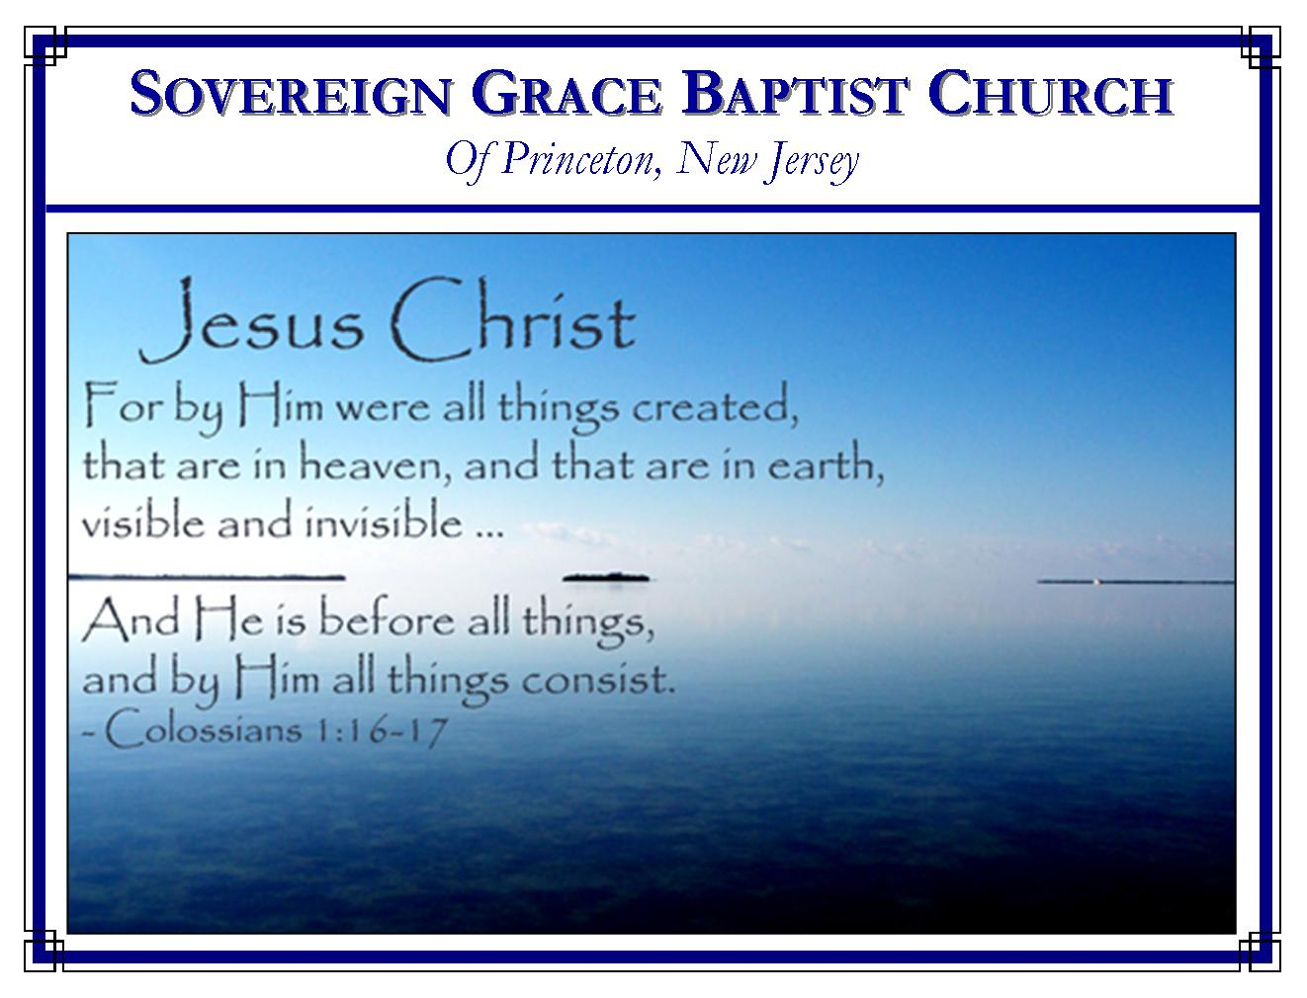
Weekly Schedule of Services
Sunday: | 10:15 AM | Bible Class
 | 11:00 AM | Morning Service
Thursday: | 7:30 PM | Mid-week Service
Services Broadcast Live @ www.FreeGraceMedia.com/live

Web Address
Be sure to bookmark our website for daily articles and audio messages:
www.FreeGraceMedia.com
Weekly Meeting Location  Rocky Hill Firehouse, 2nd floor  150 Washington Street  Rocky Hill, NJ 08553 | Mailing Address  7 Birch Street  Pennington, NJ 08534  Clay Curtis, pastor
Phone: 615-513-4464 | Email: clay@freegracemedia.com
If you would like to receive this bulletin sent weekly to your email then send a note to the email address above. Articles in this bulletin are by the pastor unless otherwise noted.
SCHEDULE OF SERVICES
10: 15 am Bible Class
11:00 a.m. Service
Opening Hymns
Scripture Reading
Message
Closing Hymn
Nursery Today: Melinda C. Nursery Thurs: Debbie D.

“Pride breeds in wealth as the worm doth in the apple,…he is a great rich man indeed and greater than his riches, that doth not think himself great because he is rich.” John Trapp

*******
Isaiah 53: 11: He shall see of the travail of his soul, and shall be satisfied: by his knowledge shall my righteous servant justify many; for he shall bear their iniquities. 12: Therefore will I divide him a portion with the great, and he shall divide the spoil with the strong; because he hath poured out his soul unto death: and he was numbered with the transgressors; and he bare the sin of many, and made intercession for the transgressors.

*******
A GOOD HOPE
It is only when our Lord in grace and mercy takes away our imaginary strength that we truly look to Him and trust Him. This we do not learn in creeds and confessions of faith. This we are taught by Him in personal relationship in the experience of grace. I only find hope in Him when there is no hope anywhere else. It is easy to learn correct doctrine, but faith, hope, comfort, rest in Christ is a living experience. Justification, redemption, atonement, sanctification and glorification are not only doctrinal truths believed in the heart, they are truths experienced in the heart in regeneration. Our Lord is our life, and all that is in Him is ours. There is no hope in what I know, my only hope is in Him and what He has done. May God in mercy shut us up to Christ alone! - Tommy Robbins

*******

SOVEREIGN GRACE AND EVANGELISM

The preaching of Sovereign Grace is not an enemy of true evangelism. Let me hasten to say that the preaching of Sovereign Grace will kill, deader than a doornail, the message and method of present-day evangelism! And some of us believe with deadly intensity that the false message and method must be killed before the true message and method can become effective. We further believe that the only way this can be done is by the preaching of the truth about God, the truth about man, and the truth about Christ, who died and lives that God might be just and justifier!

These lines will appeal to no one who is happy about the results of evangelism today; but should you be one of many who mourn here, you will join in the task of raising up again the standard of Sovereign Grace.

A sovereign Christ is almost unheard of in church circles today – a
Christ into whose hands all things have been given, who has all authority, who gives life and quickens whom He will, who decides the destinies of all men, who is Lord over all flesh. Present-day evangelism, for the most part, poses the question, “What will you do with Jesus?” Bible or true evangelism poses the question, “What will the sovereign Christ do with me?” Present-day evangelism says to men, “Believe and be born again.” Bible evangelism says to men, “Be born again so you can believe.” The one makes the new birth depend on an act of man, the other an act of God.

Present-day evangelism takes for granted God’s mercy and grace, rather than marveling at them in adoration and worship. Hear Paul say, “I obtained mercy.” Hear Peter say, “to all who have obtained like precious faith.” How I long to hear this note in the churches today! Rolfe Barnard
*******
A friend is one to whom you never need to explain yourself, one who always puts the best construction possible upon your actions and words, one who is always ready to help. A friend is someone who steps in when everyone else walks out. I pray for grace to be such a friend. – Don Fortner

*******

TRUE GREATNESS
Mark 9: 35: And he sat down, and called the twelve, and saith unto them, If any man desire to be first, the same shall be last of all, and servant of all.

This was the Lord’s answer to the disciples when they asked, “Who is the greatest in the kingdom of heaven?” Some erroneously teach this as punishment, saying that you will be permitted into heaven but because you wanted to be first you will be last and forced to serve all. No one will be punished in heaven and no one will be considered last by others. The Lord is saying that if any man desires to be what God regards as first then let him desire to be last of all and servant of all.
In order to see how this applies to Christ read Philippians 2: 5-9. The apostle Paul even says, “Let this mind be in you, which was also in Christ Jesus.” Christ Jesus is God and therefore equal with God. But Christ made himself of no reputation. Instead, he took the form of a servant, was made in the likeness of men, humbled himself and served God the Father in perfect obedience as the head and representative of his people, serving his people as he ministered grace to them. He did so even unto the death of the cross whereby Christ put away the sin of all God’s elect and brought in everlasting righteousness for his people. By thus humbling himself and becoming the least, Christ highly exalted God, “Wherefore God also hath highly exalted him, and given him a name which is above every name.” (Php 2: 9)
When the dead sinner is born of the Holy Spirit we are given the mind of Christ in the inward man. As God grows us in grace, the Holy Spirit teaches us in the new man that if we would have the mind and spirit of Christ (which God regards as first, as greatest) then we are not to seek a reputation among men. True greatness with God is not to desire to be served but to be a servant of God and our brethren. It is to obey God in faith, like a very little child obeys its father. When Christ made himself the very least he fully redeemed his people, making us the righteousness of God in him so that Christ’s faithfulness to God highly exalted God. Wherefore, in God’s time, God also highly exalted Christ. So the scripture teaches all who rest complete in Christ that instead of exalting ourselves by making a reputation for ourselves, “humble yourselves therefore under the mighty hand of God, that HE MAY EXALT YOU IN DUE TIME: casting all your care upon him; for he careth for you. (1 Pet 5: 6-7)
The reward of heaven will be Christ. There will be only true righteous humility for all will have Christ, with a total absence of pride, only desiring the other to be first and Christ to be All! And all, loving to be last and to serve all, will be first.

