December 8, 2013
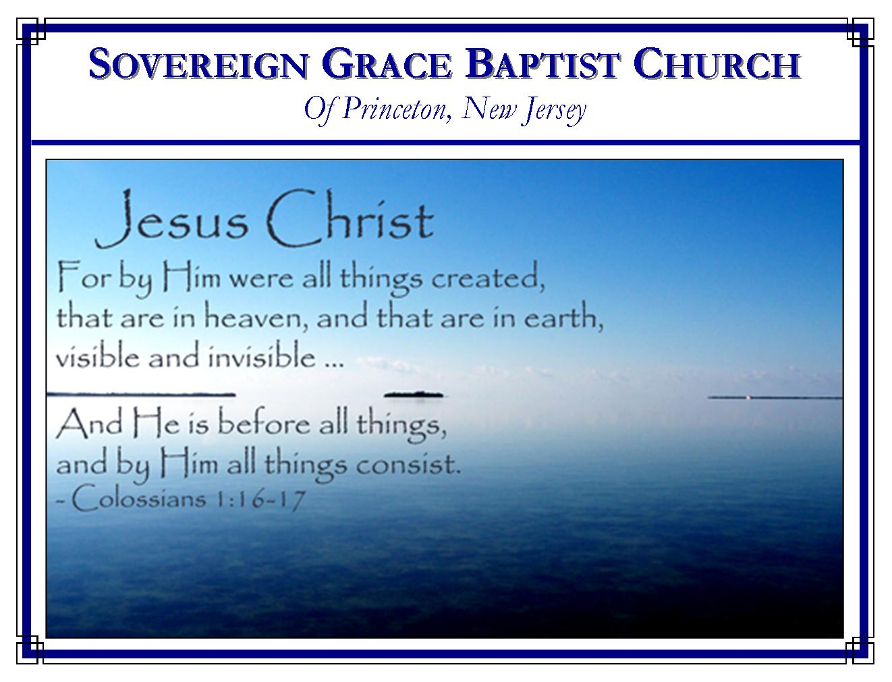
Weekly Schedule of Services
Sunday: | 10:15 AM | Bible Class
 | 11:00 AM | Morning Service
Thursday: | 7:30 PM | Mid-week Service
Services Broadcast Live @ www.FreeGraceMedia.com/live

Web Address
Be sure to bookmark our website for daily articles and audio messages:
www.FreeGraceMedia.com
Weekly Meeting Location  Rocky Hill Firehouse, 2nd floor  150 Washington Street  Rocky Hill, NJ 08553 | Mailing Address  7 Birch Street  Pennington, NJ 08534  Clay Curtis, pastor
Phone: 615-513-4464 | Email: clay@freegracemedia.com
If you would like to receive this bulletin sent weekly to your email then send a note to the email address above. Articles in this bulletin are by the pastor unless otherwise noted.

What Is True Faith?
True faith throbs in a person’s pulse; Looks out of His eyes; Lights up his countenance; Softens his touch; Mellows his voice; Bows his head
Bends his knee; Opens his hand; Humbles his heart; Curbs his tongue; Orders his steps; Opens his ears to the Word; Forgives and forgets the offence; and gives his conscience peace. Henry Mahan

*******
SCHEDULE OF SERVICES
11: 15 am Bible Class followed by short break
11: 00 a.m. Service
Opening Hymns
Scripture Reading
Message
Closing Hymn
B’Days:; Cheryl D.—3rd; Debbie D.—17th; Anthony D--26th; Wedding Anniversay: Joe and Abby Z—2nd Nursery Today: Michelle L. Nursery Thurs: Carol D.

WORKS OF THREE GRACES
1 Thessalonians 1: 3: Remembering without ceasing your work of faith, and labour of love, and patience of hope in our Lord Jesus Christ, in the sight of God and our Father;

Wherever the Spirit has given life, God gives the gift of faith, love and hope. (Eph 2: 8-9)

Work of Faith
Faith’s chief work is to believe on the Son of God, the Lord Jesus Christ. (Jn 6: 28-29) Faith rests in Christ for complete acceptance with holy God, believing Christ has "justified us from all things from which we could not be justified by the law of Moses” (Acts 13: 39; 1 Jn 2: 1-2; 1 Jn 1: 9; Rom 3: 26) Secondly, faith’s work is to live day-by-day by faith. (Heb 10: 38; Gal 2: 16-21) Thirdly, faith’s work is to stand steadfast. (Eph 6: 13-18) This is why faith’s work is described as a fight. (1 Tim 6: 12) We face much opposition and conflict: our own unbelief and sins, the influence of an ungodly world, the subtlety of Satan. But the confidence of faith is that we shall overcome by Christ the Captain of our warfare. (1 Jn 5: 4-5; Rom 8: 37)

Labor of Love
Wherever the love of God is shed abroad in the heart by the Holy Ghost, the Lord Jesus Christ becomes the object of our love. Our love is very feeble at best. But true God-given love labors, constrained by the love of Christ for us. (2 Cor 5: 14-15) Love puts the one it loves first, no longer living for self, but for Christ who lived and died for us. When we love someone, above all things, we desire to be pleasing to that one. We know God’s love is everlasting, unchangeable, sovereign love toward his elect. So we do not labor to keep him loving us. But knowing his love does not change makes the believer love Christ even more. We want the constant presence of the Lord, to hear his Voice, to have the approval of our Beloved. His smile is our only reward. So this labor of love is first, a labor against the coldness and hardness of our flesh. We labor to show our love to Christ by submission to his will, by adorning the doctrine of Christ in our walk, by making his glory our supreme aim
Secondly, this labor of love is toward our brethren. (Heb 6: 10) Believers are so one with Christ that what we do to them we do to him. Therefore, those born of Christ love those begotten of him. (1 Jn 5: 1) We seek the good of our brethren: sympathizing with them in trouble, rejoicing when they rejoice, bearing one another’s burdens, seeking their spiritual benefit and profit. True love lays aside malice, guile and hypocrisy because true God-given love hates strife and division and loves unity. Though we meet with every kind of opposition from without and within, true God-given love never fails because of his love for us. Love will remain when faith and hope become sight. (1 Cor 13: 13)

Patience of Hope
Patience includes meekness, quietness, submission, resignation to the will of God and endurance. (Heb 12: 1) Moses "endured as seeing him who is invisible." (Heb 11: 27) When a father is carving the turkey at Thanksgiving, the children have their plates ready. But each child has to wait on their father. The father fills each plate in the order he will: the sick child first, perhaps he makes the stronger child wait, but he has a choice piece for each child in particular. Yet, each child has to wait patiently to get that part reserved just for them. So it is that God our Father, in all his providential dealings with his children, has just the right portion designated for each of his children as we need it at the right time. We must patiently wait upon the Lord. (Ja 5: 7-11) Job endured the loss of all his children, all his property, the assault of Satan, reviling from his wife and fleshly pain in body and spirit but in the end the Lord crowned him with the crown of life. The Lord is very pitiful and of tender mercy toward his elect, redeemed, children.
Hope is described as the helmet in God’s armor (1 Thess 5: 8) A helmet covers the head. Hope is the protector of the conscience against despair. Our own carnal reason is the enemy of hope. Natural reason is contrary to spiritual mysteries. (1 Ti 3:16) The trinity of God is a mystery, the Son of God made flesh is a mystery, Christ made sin is a mystery, Christ raised from the dead is a mystery, sinners made the righteousness of God and one in Christ is a mystery, Christ our Head in heaven feeding a multitude in the earth by his gospel, as he did the fish and loaves, is a mystery. These mysteries are contrary to natural reason and natural sight. But God said, “as the heavens are higher than the earth, so are my ways higher than your ways, and my thoughts than your thoughts.” (Is 55: 9)
Hope is compared to an anchor (Heb 6: 19-20) An anchor on a boat works unseen in the depths. The harder the waves, the stronger the opposition, the more firmly an anchor holds. Our hope is in Christ therefore we have an anchor within the veil for our souls. Dwelling on past miseries is the enemy of hope. But dwelling on past and present mercies is the strength of hope. (Lam 3: 18-26) The patience of hope makes us cleave to God, rather than giving up and turning again to this world. (1 Jn 3: 2-3)
These graces are strengthened by God exercising us in them. So as your faith is tried look to Christ the Faithful, as your hope is tried look to Christ who for the joy set before him patiently endured the cross and is now seated at God’s right hand and as your love is tried look to Christ who loved us and gave himself for us. And as we behold the works of these three graces in our brethren, let us give thanks to God always for them, knowing that these graces are of God and are the fruit of their election of God. (1 Thess 1: 2, 4)

*******

TRUSTING GOD, NOT MEANS
The Lord used ravens to feed Elijah, but Elijah never thought of trusting in the ravens. If we lean on instruments instead of the hand that used them, we bring down a curse upon ourselves, for it is written, “Cursed be the man that trusteth in man, and maketh flesh his arm and whose heart departeth from the Lord.” Scott Richardson

*******

Isaiah 53:7 He was oppressed, and he was afflicted, yet he opened not his mouth: he is brought as a lamb to the slaughter, and as a sheep before her shearers is dumb, so he openeth not his mouth.

