November 24, 2013
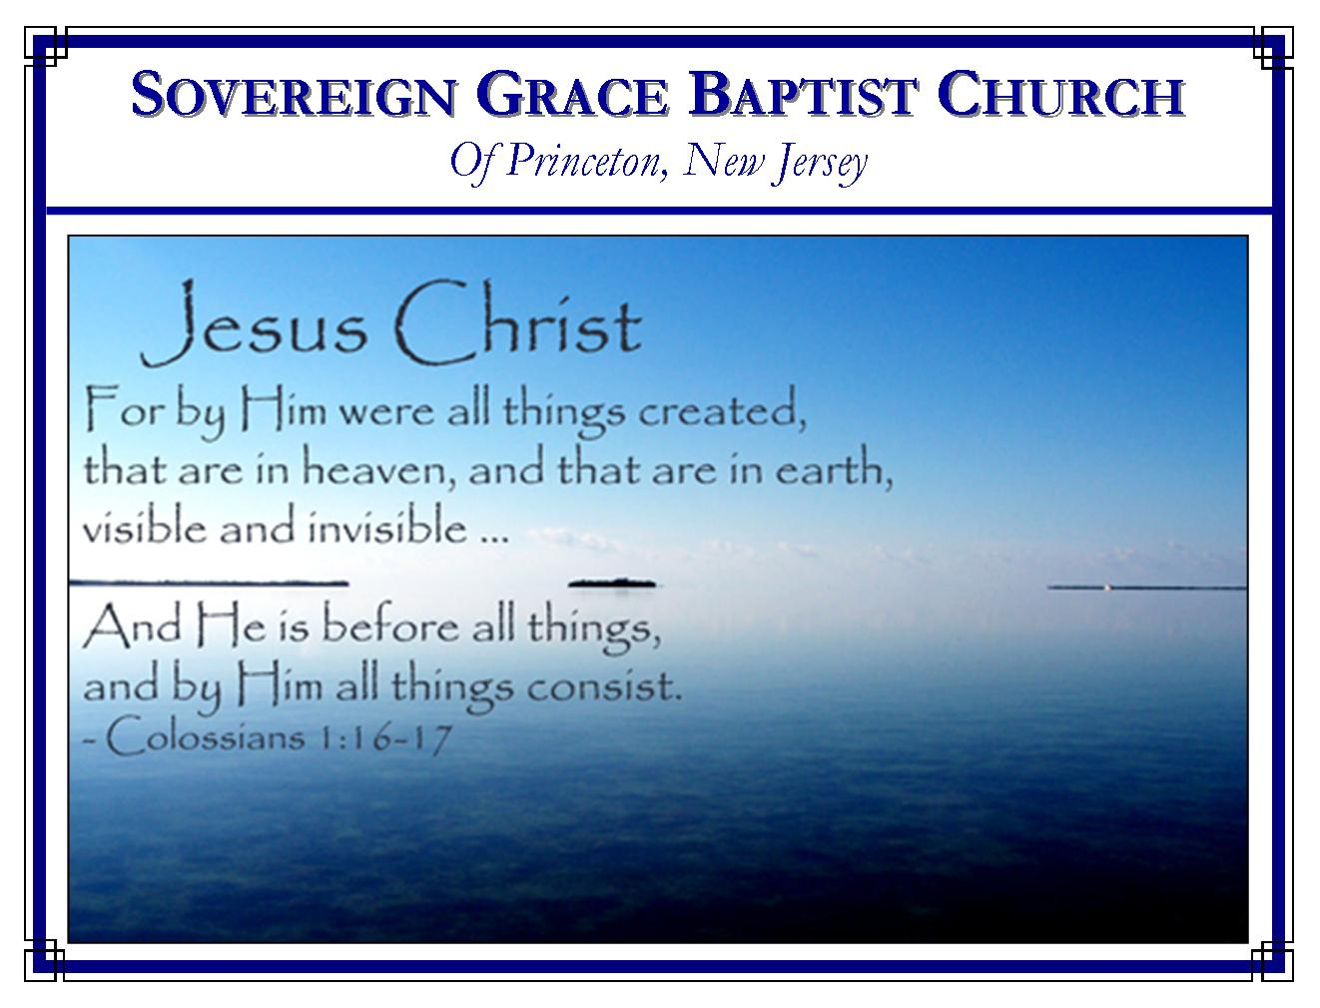
Weekly Schedule of Services
Sunday: | 10:15 AM | Bible Class
 | 11:00 AM | Morning Service
Thursday: | 7:30 PM | Mid-week Service
Services Broadcast Live @ www.FreeGraceMedia.com/live

Web Address
Be sure to bookmark our website for daily articles and audio messages:
www.FreeGraceMedia.com
Weekly Meeting Location  Rocky Hill Firehouse, 2nd floor  150 Washington Street  Rocky Hill, NJ 08553 | Mailing Address  7 Birch Street  Pennington, NJ 08534  Clay Curtis, pastor
Phone: 615-513-4464 | Email: clay@freegracemedia.com
If you would like to receive this bulletin sent weekly to your email then send a note to the email address above. Articles in this bulletin are by the pastor unless otherwise noted.

SCHEDULE OF SERVICES
10:15 a.m. Bible Class followed by short break
11:00 a.m. Service
Opening Hymns
Scripture Reading
Message
Closing Hymn
B’Days:; Kevin D-8th; Rachael D-9th; Scott K-9th; Peter D-20th; Abigail L-23rd; William K-23rd; Robert K.-29th; Wedding Anniversaries: Ravi and Urmilla I—17th; Nursery Today: Christine K. Nursery Thurs: Volunteer

FOUR MUSTS

Luke 24:44: And he said unto them, These are the words which I spake unto you, while I was yet with you, that all things MUST be fulfilled, which were written in the law of Moses, and in the prophets, and in the psalms, concerning me.

John 3:7: Marvel not that I said unto thee, Ye MUST be born again.

John 3: 14: And as Moses lifted up the serpent in the wilderness, even MUST the Son of man be lifted up:

Acts 4:12: Neither is there salvation in any other: for there is none other name under heaven given among men, whereby we MUST be saved.

*******

How faint the best praise! How wandering the best prayer! How selfish the best gift! When we feel that we are nearest to God, how far off we are! When we feel that we are most like God, how unlike God we are! What did the apostle say? “When I am weak, then am I strong.” Our strength is always Christ, never in anything we are or do. Henry Mahan

SEEING EVERY MAN CLEARLY
Mark 8: 22-25

Mark 8: 22: And he cometh to Bethsaida; and they bring a blind man unto him, and besought him to touch him. 23: And he took the blind man by the hand, and led him out of the town; and when he had spit on his eyes, and put his hands upon him, he asked him if he saw ought. 24: And he looked up, and said, I see men as trees, walking. 25: After that he put his hands again upon his eyes, and made him look up: and he was restored, and saw every man clearly.

Before God gives spiritual sight the sinner has none. (1 Cor 2: 14) The sinner cannot see from where his sin originates, he does not see himself as bad as he is, he does not see Christ with saving faith, and he does not see a need to be born again. But when God gives spiritual sight the believer sees every man clearly.

Adam
When God gives spiritual sight we see Adam is the representative man in whom all men fell into sin and death. If we miss this fact, we will not understand our need of a substitute. We will miss why it is we need for God to come in Christ to accomplish the redemption of his people. Adam is the first man. What Adam did affected every one that Adam represented, which was all men. Adam broke the one law God gave him. Sin entered the world and death by sin. All died in Adam. (Ro 5:12-14)

Our Natural Man
When the Spirit of God makes us to see Adam as our representative the Spirit makes us to see clearly that we died in Adam so that our natural man is nothing but sin. (Rom 5:12) Eve conceived a child from Adam, on down the line to you and me. So not only did we fall under the curse judicially because Adam our Federal Head sinned, his corrupt seed was passed on to us so that we are conceived with a corrupt nature. (Ps 51:5; 58:3) We did not sin to become sinners; we sinned because we are sinners. The heart, the nature, is depraved, wicked, enmity against God. (Jer 17:9; Gen 6: 5; Jer 13:23; Job 14:4; 1 Cor 2:14; Jn 3:3, 6; Eph 2:1-3) As we are born the first time, every person is depraved, lost, condemned, without Christ and without hope in this world.

The GodMan
The Holy Spirit makes us to see clearly Christ Jesus, the GodMan. Christ is God in human flesh and Christ is the last Adam, meaning, he is the Head of each elect child which God gave him before the foundation of the world (Rom 5: 14-21) Christ Jesus successfully established everlasting righteousness—and is that righteousness—for all whom he represented by his doing and dying. Each one shall be made eternally alive and given faith by the irresistible grace of God because the Spirit forms Christ in us by his quickening spirit and makes each of his redeemed children to see Christ and to lay hold of him by faith. (1 Cor 15: 22, 45-49; Col 2:9-10; 1 Cor 1:30-31) Do you see the God-Man clearly? In his incarnation we see Christ is God; in his obedience we see Christ is our holiness; in his death we see Christ is our righteousness; in his resurrection we see Christ is our justification; in his exaltation upon his throne we see Christ is our King; in his place at the Father’s right hand we see Christ is our Advocate with the Father; in Christ seated we see that Christ is our completion, the work is finished.

Our New Man
The Holy Spirit makes us to see our new man. After being born of Christ the Seed, the Living Word, by the gospel, that new man within us is born of incorruptible Seed. (Eph 4:24; Col 3:10) Christ formed in you is, the hope of glory. (1 Jn 3: 9-10, 23-24; 2 Pet 1: 4) This new man is a new creature in Christ and, being born of God, according to God, all things become new. And they truly do! (2 Cor 5:17-18) One of those new things is a warfare between the flesh and the Spirit, the old man and the new man, which was not there before. (Gal 5:16-25) All who have been born of God are one new man in Christ, one with him and one in him, “the fulness of him that filleth all in all” and Christ is All and in all. (Col 3: 11)

Now we see but not perfectly. But in that great eternal day we shall see without the least hindrance of sin. Then we shall see Christ face-to-face.

*******

“Am I to bring no works, no faith (not even faith)? NO – your faith brings you. Faith leaves all works behind. It relies on God’s gracious promises. It pleads God’s rich mercy in Christ, to poor perishing sinners. William Mason
*******
The Savior said, “Come unto me, all ye that labour and are heavy laden, and I will give you rest. Take my yoke upon you, and learn of me; for I am meek and lowly in heart: and ye shall find rest unto your souls. For my yoke is easy, and my burden is light.” (Mt 11: 28-30)

