August 18, 2013
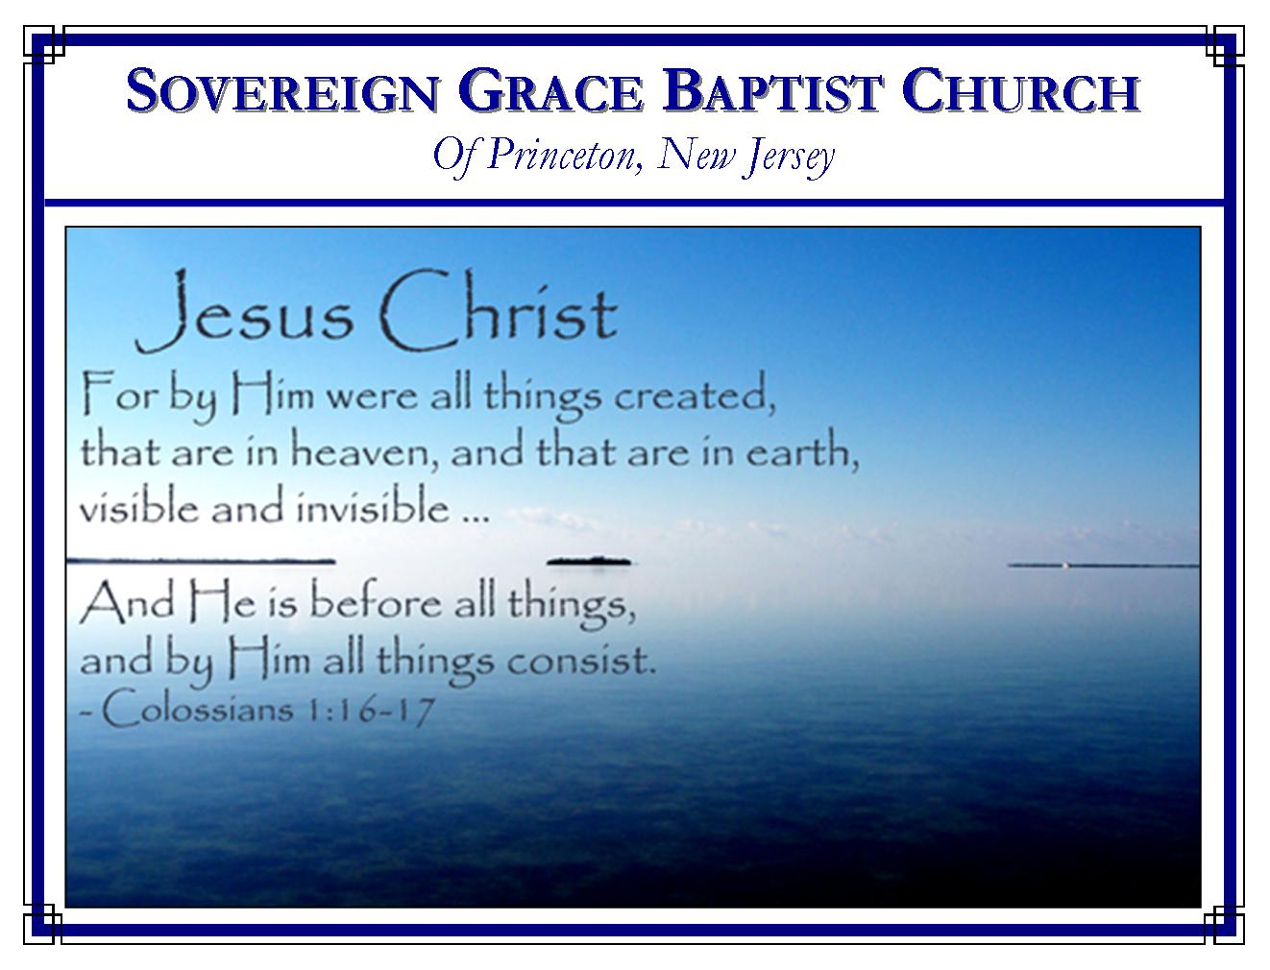
Weekly Schedule of Services
Sunday: | 10:15 AM | Bible Class
 | 11:00 AM | Morning Service
Thursday: | 7:30 PM | Mid-week Service
Skype Services @ sgbcpnj

Web Address
Be sure to bookmark our website for daily articles and audio messages:
www.FreeGraceMedia.com
Weekly Meeting Location  Rocky Hill Firehouse, 2nd floor  150 Washington Street  Rocky Hill, NJ 08553 | Mailing Address  7 Birch Street  Pennington, NJ 08534  Clay Curtis, pastor
Phone: 615-513-4464 | Email: clay@freegracemedia.com
If you would like to receive this bulletin sent weekly to your email then send a note to the email address above. Articles in this bulletin are by the pastor unless otherwise noted.
SCHEDULE OF SERVICES
10:15 a.m. Bible Class followed by short break
11:00 a.m. Service
Opening Hymns
Scripture Reading
Message
Closing Hymn
B’Days: Ariel I.—5th; Ravi D.—25th Nursery Today: Kris D. Nursery Thursday: Melinda C.

To say that a man or a woman’s election is based upon whether they believe or not is just another way of saying that salvation is by man’s free will decision. The elect of God will believe because they were chosen in Christ before the foundation of the world. And those that believe not, never were one of His sheep. David Eddmenson, pastor, Sovereign Grace Church, New Caney, TX
*******
THEY THAT BE WITH US ARE MORE
2 Kings 6: 13-17
The king of Syria sent his troops with orders to bring Elisha back dead or alive despite the fact Elisha was used of God to heal Benhadad’s general, Naaman, of leprosy. (v13) The Syrian king wanted Elisha dead because Elisha was confederate with the King of Israel. So the Syrian king sent a great host by night which surrounded the city where Elisha was. (v14)
See in this great host all our enemies camped around us continually. When through God’s preacher, God heals one of his elect, though believers thank God, those under the power of the prince of the air are enraged because believers are confederate with Christ. Like the king of Syria vented his anger toward Elisha, their enmity toward Christ is vented toward Christ’s ministers and the flock of
God. (Ecc 8:11) Whether intentional or not, the unregenerate camp attempts to do the same thing as the Pharisee’s toward Christ. They seek to find something with which to accuse us so as to justify themselves before men for their rejection of us and our gospel. (Jn 3: 19-20; 1 Jn 1: 6) But notice, the place where this occurred is “Dothan.” (v13) It means "two wells" or “double feast.” Everything the enemy intends toward us, God turns into a double feast for his child, a double blessing from the wells of salvation (1 Chr 16: 21-22)

The Dangers of Natural Sight
“And when the servant of the man of God was risen early, and gone forth, behold, an host compassed the city both with horses and chariots. And his servant said unto him, Alas, my master! how shall we do?” (v15) Believers are like this young man. He was a true servant of God who arose early, cheerfully ready to do whatever needed to be done in the service of God. But believers have two kinds of sight. We have the natural eye which sees only natural things. This eye feeds the old man of our flesh. Then we have spiritual sight whereby we see Christ by faith. This sight feeds our new man.
Brethren, we behold in this young man the danger of calculating with the natural eye. It made him became fearful and he failed to see the plenteous provision God had made. When we set our sights on the difficulties in the way, on those who oppose us, then we see the danger but not the deliverance in Christ. Remember, the difficulties are just opportunities for God to show us his greatness. The true enemy is not those we see with the natural eye; the true enemy is our own unbelief.

The Value of Spiritual Sight
Elisha “answered, Fear not: for they that be with us are more than they that be with them.” (v16) True God-sustained faith enables the believer to comfort our fearful brethren with the gospel. Elisha saw the same thing the young man saw. But Elisha also saw what the young man did not see, “the evidence of things not seen.” (Heb 11: 1) So he was able to comfort his brother with the reality of things: “they that be with us are more than they that be with them.” (v16) How desperately brethren need brethren! For every brother taken with “fear” God has provided us a brother whom God has just strengthened to remind us “Fear not.” (Ps 46: 1-3)
Brethren, the realization God gives through faith to conquer our fears is, “Ye are of God, little children, and have overcome them: because greater is he that is in you, than he that is in the world.” (1 Jn 4: 4) Our enemies are God’s enemies. God knows they are there. But they are there to teach us to look beyond the enemies and obstacles to Christ our Sovereign Savior. This is his church. He assembled it to bring glory to his holy name. (Eph 1: 23; 2: 19-22; 4: 10; 5: 23) As God has provided us all righteousness in the finished work of Christ Jesus, as God has fitted us together from the four corners of this globe, so shall Christ our Head make every provision for our security right here in this little corner of the world.
Lift up the eyes above all events below and look around, believer. “Ye are come unto mount Sion, and unto the city of the living God, the heavenly Jerusalem, and to an innumerable company of angels, To the general assembly and church of the firstborn, which are written in heaven, and to God the Judge of all, and to the spirits of just men made perfect, And to Jesus the mediator of the new covenant, and to the blood of sprinkling, that speaketh better things than that of Abel.” (Heb 12: 22-24)

Spiritual Sight is the Gift of God
“And Elisha prayed, and said, LORD, I pray thee, open his eyes, that he may see.” (v17) Elisha prayed thus because he knew he had no power to give the young man sight and he knew the young man could not do it for himself. So Elisha asked God to open his eyes because he knew only God can do so.
Sinner, you are not aware of your own blindness. It is not merely that man cannot come to Christ, but he will not come to Christ that he may have life; it is not merely that he cannot see the truth, but that he loves darkness rather than light, and does not want to see. Your blindness is blindness of heart, of will, of conscience, of understanding and of all things spiritual. It takes the divine will of God to overcome the wicked will of man. “Except a man be born again, he cannot see the kingdom of God.” (Jn 3: 3)

God Opens the Eyes
“And the LORD opened the eyes of the young man; and he saw: and, behold, the mountain was full of horses and chariots of fire round about Elisha.” (v17) God shall open the eyes of every one of his blood-bought children to behold Christ our Savior because God is greater than every enemy and obstacle in our way He put the enemies there that he might remove them so that we see that God can do all things that we might believe.
Everything we see with the natural eye shall be like a paper sack in a raging fire, all shall melt away. But Christ says, “Because I live, ye shall live also.” Believer, commit yourself to the keeping hand which was pierced with nails for you. Poverty! What poverty! Enemies! What enemies! Obstacles! What obstacles! (Php 4: 13; Isa 55:12)

