May 26, 2013
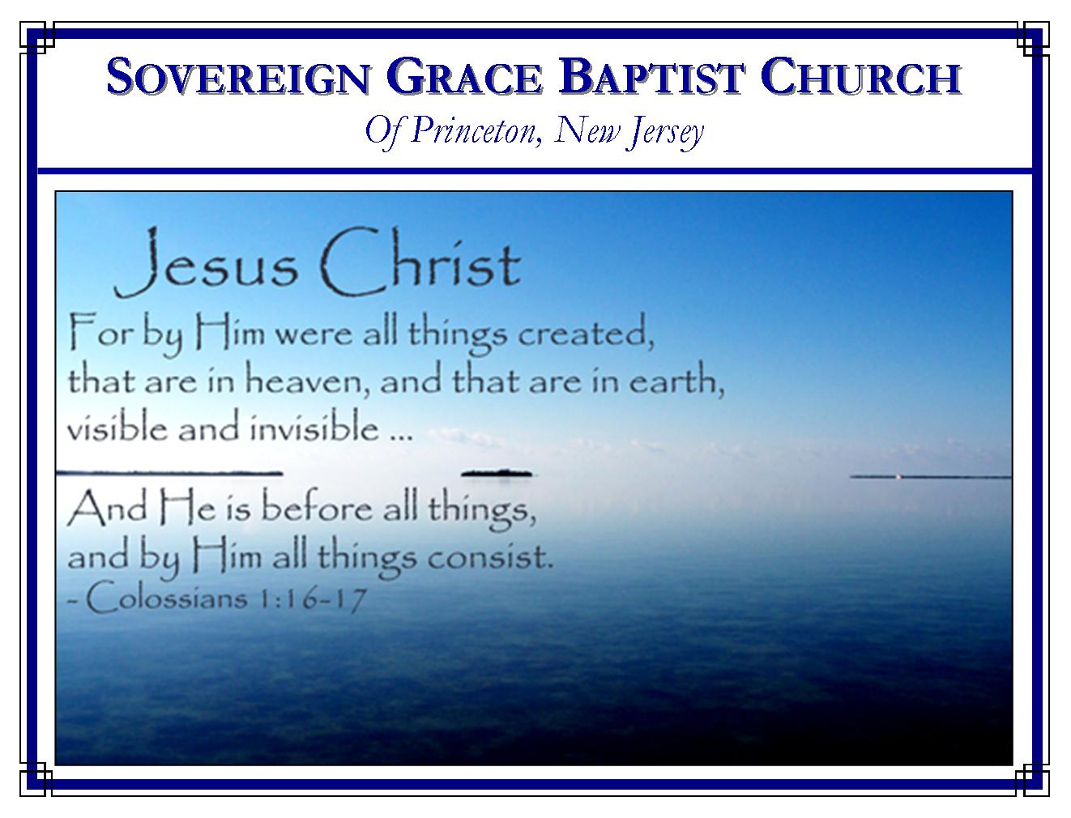
Weekly Schedule of Services
Sunday: | 10:15 AM | Bible Class
 | 11:00 AM | Morning Service
Thursday: | 7:30 PM | Mid-week Service
Skype Services @ sgbcpnj

Web Address
Be sure to bookmark our website for daily articles and audio messages:
www.FreeGraceMedia.com
Weekly Meeting Location  Rocky Hill Firehouse, 2nd floor  150 Washington Street  Rocky Hill, NJ 08553 | Mailing Address  7 Birch Street  Pennington, NJ 08534  Clay Curtis, pastor
Phone: 615-513-4464 | Email: clay@freegracemedia.com
If you would like to receive this bulletin sent weekly to your email then send a note to the email address above. Articles in this bulletin are by the pastor unless otherwise noted.
SCHEDULE OF SERVICES
10:15 a.m. Bible Class followed by short break
11:00 a.m. Service
Opening Hymns
Scripture Reading
Message
Closing Hymn
B’Days: Chloe Doodnath–26th; Anniversaries: Eric & Michelle L–21st, Mike & Jamie Lutz–23rd; Nursery Today: Carol D. Nursery Thursday: Christine K.
THE WAY OF ESCAPE
1 Corinthians 10: 1-14
The children of Israel travelling from Egypt through the wilderness pictures a church of professing believers where all partake of the same gospel privileges. All of us here have come out of bondage, all have been baptized, all partake of the same spiritual meat and drink which is Christ. “But with many of them God was not well-pleased: for they were overthrown in the wilderness. “Now these things were our examples” to teach us what we should avoid.

Lust
“We should not lust after evil things, as they also lusted.” (v6) The Israelites were where they were because God led them there. They were without the things they did not have because God withheld them. The problem was they did not like where God led them and wanted what God withheld. Brethren, God leads us. He gives and takes away for our good to teach us contentment is not in stuff. Contentment is found only in Christ. (Heb 13: 5-6)

Idolatry
“Neither be ye idolaters, as were some of them; as it is written, The people sat down to eat and drink, and rose up to play.” (v7) Israel turned to idolatry because God did not operate on their time table. “When the people saw that Moses delayed to come down out of the mount, the people gathered themselves together unto Aaron, and said unto him, Up, make us gods, which shall go before us; for as for this Moses, the man that brought us up out of the land of Egypt, we wot not what is become of him.” (Ex 32: 1) The Apostle Peter said “there shall come in the last days scoffers, walking after their own lusts, And saying, Where is the promise of his coming? for since the fathers fell asleep, all things continue as they were from the beginning of the creation.” (2 Pet 3: 3-4) Since Christ has not returned out of the holy hill of Zion many have said, “Up, make us gods, which shall go before us; for as for this Jesus, we wot not what is become of him.” Most have replaced the God-ordained means of gospel preaching with various forms of entertainment. Men are lovers of pleasures more than lovers of God, not only in the world, but in all these various forms of worship. (2 Ti 3: 4) Brethren, in this place, we will wait on God to do his will in his time rather than turning to the man-made means men love. “Wait on the LORD: be of good courage, and he shall strengthen thine heart: wait, I say, on the LORD.” (Ps 27: 14)

Fornication
“Neither let us commit fornication, as some of them committed, and fell in one day three and twenty thousand.” (v8) In Israel’s day, Balaam spoke truth but denied the Lord by his works. He joined will-worshippers, used the Moabite women to entice Israel to unite with the Moabites at Baalpeor, and called it the worship of Jehovah. (Nu 25: 1-9) Brethren, the Spirit of Christ dwells in the believer’s body so that the believer is one spirit with the Lord. Therefore, we are not to take the members of Christ and make them the members of a harlot. (1 Cor 6: 15-17) Likewise, we are one body, partaking of Christ our one Bread. Therefore, we are not to take the members of Christ and make them the members of the harlot of false religion. (1 Cor 10: 15-22)

Tempting Christ
“Neither let us tempt Christ, as some of them also tempted, and were destroyed of serpents.” (v9) Israel tempted Christ who led them when they spoke against God and Moses so that God sent serpents which destroyed them. Likewise, the Corinthians tempted Christ when they sat down at meat in the idol’s temple, testing whether Christ would preserve them or not. “Do we provoke the Lord to jealousy? are we stronger than he? All things are lawful for me, but all things are not expedient: all things are lawful for me, but all things edify not.” Let each of us seek not only our own welfare but the welfare of our brethren (vv22-24) “Whether therefore ye eat, or drink, or whatsoever ye do, do all to the glory of God. Give none offence, neither to the Jews, nor to the Gentiles, nor to the church of God.” (vv31-34)

Murmuring
“Neither murmur ye, as some of them also murmured, and were destroyed of the destroyer.” (v10) Israel complained in a rebellious spirit against the Lord’s providence, commandments, ordinances, and servants. They were destroyed for doing so. “Now all these things happened unto them for ensamples: and they are written for our admonition, upon whom the ends of the world are come. Wherefore let him that thinketh he standeth take heed lest he fall. There hath no temptation taken you but such as is common to man: Wherefore, my dearly beloved, flee from idolatry.” (vv11-14; Jam 1:2-4; 12-14; 1 Pet 1:6)

God is Faithful
Brethren, our faithful God is able to keep us from falling (Ju 24; 2Th 3:3; 2Ti 2:13) He honors his Son and all those who put their trust in him. (Gen 28: 15; Is 41:10; Ps 37: 28; Is 26: 3) In all our various trials, God is teaching us that though everything in this world changes, God is faithful. He “will not suffer you to be tempted above that you are able; but will with the temptation also make a way to escape, that ye may be able to bear it.” (v13) Christ Jesus is that Way. Throughout Israel’s journey, the Way of escape typified the Lord Jesus Christ: he is the tree that made the bitter waters of Marah sweet; the manna in the wilderness; the smitten rock; the serpent lifted up to whom they looked and were healed.
In our journey, the way of escape is not found in this world. We are kept from the evil by Christ the Way. His grace is sufficient to endure the trial, for with the Power of Christ resting upon us when we are weak then are we strong. (2 Cor 12: 9) Flee from idolatry to the Lord Jesus Christ. “We have an advocate with the Father, Jesus Christ the righteous. And he is the propitiation for our sins.” (1 Jn 2: 1-2) He who put away our sin by the sacrifice of himself is also touched with the feelings of our infirmities. (Heb 9: 26; 4: 15) Christ is able to comfort and strengthen us in every time of need. (Heb 12: 12-13; 18-25; 2:3; Is 43: 2; 46: 4) In all these things we see examples of what we should avoid. “In all these things we are more than conquerors through him that loved us.” (Ro 8: 37)

