January 20, 2013
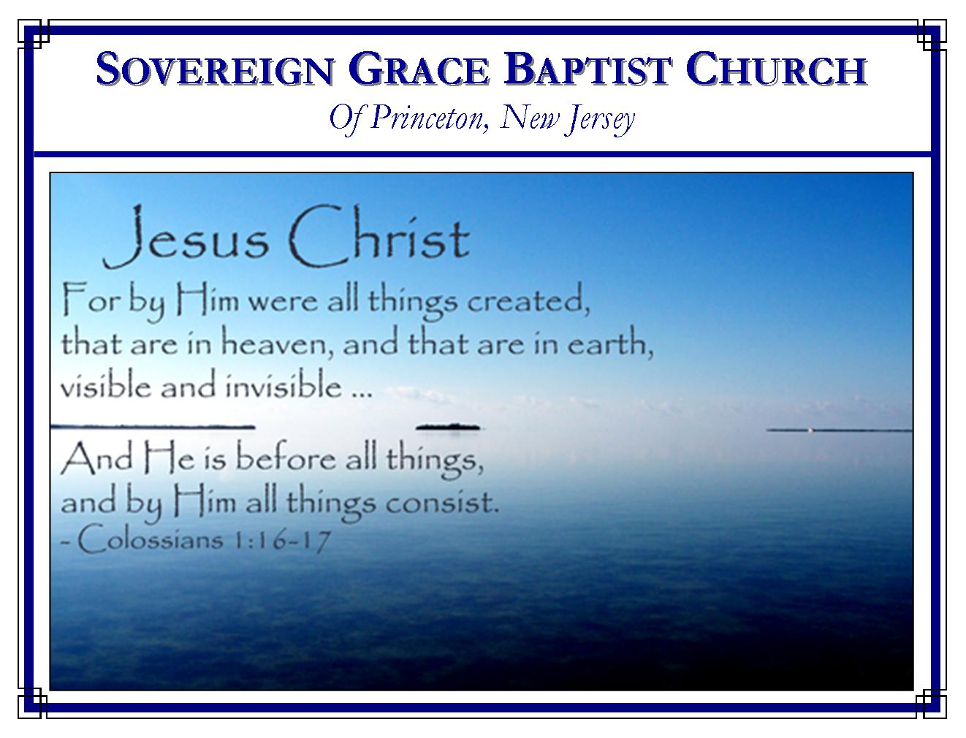
Weekly Schedule of Services
Sunday: | 10:15 AM | Bible Class
 | 11:00 AM | Morning Service
Thursday: | 7:30 PM | Mid-week Service

Web Address
Be sure to bookmark our website for daily articles and audio messages:
www.FreeGraceMedia.com
Weekly Meeting Location  Rocky Hill Firehouse, 2nd floor  150 Washington Street  Rocky Hill, NJ 08553 | Mailing Address  7 Birch Street  Pennington, NJ 08534  Clay Curtis, pastor
Phone: 615-513-4464 | Email: clay@freegracemedia.com
If you would like to receive this bulletin sent weekly to your email then send a note to the email address above. Articles in this bulletin are by the pastor unless otherwise noted.
SCHEDULE OF SERVICES
10: 15 a.m. Bible Class followed by short break
11:00 a.m. Service
Opening Hymns
Scripture Reading
Message
Closing Hymn
Nursery Today: Kris D.; Nursery Thursday: Christine K. January Bdays: Mary Ann L--17th; Vincent D-18th; John K-27th; Anniversary: Scott and Christine K—2nd
HEALING OF SPIRITUAL DROPSY
Luke 14: 1-14
The Lord went to eat on the Sabbath in the house of men swollen with pride of self. When a sinner is bloated with pride, there is no room for faith, love or mercy only strife, wrath, and division. Such is the old man of flesh that remains in every believer. So how are we healed of this disease? Christ our Savior overruled this occasion so that there was a man in the house with dropsy. Dropsy was an incurable blood disorder which caused extreme swelling of the body, exemplifying the spiritual condition of each member of this house bloated with pride. As Christ deals with the various persons in the house in this text see him dealing with one child of mercy. Here are five things Christ alone is able to do for his child to heal us of this disease.

Christ Shuts our Mouth
In verses 3 and 4 we see an example of how Christ is able to use the law to shut our mouth, in order to teach us that we do not understand the law and/or that we are misusing the word of God. The Sabbath day showed the mercy and rest God gives his people in Christ. God completely provided all on the 6th day so that on the 7th the ruler of the house and his servants could rest from all their works and worship God. It pictured the day of grace when God gives his servants rest in Christ our Sabbath, seated at the right hand of the Father because he has finished the work of redeeming his people from the law. But the Pharisee’s used the word of God unlawfully, binding instead of declaring Christ our Rest, exalting self instead of humbly worshipping the Redeemer. (Lk 13:14) Because we are Pharisees by nature, believers can yet fall into this error of using the word for vain reasons. The word of God is not to be used to exalt self and gender bondage but to exalt Christ before sin-sick sinners as we wait on the Spirit to give rest in Christ. Believers should never compromise the truth of God but if we get caught up in vain strivings we end up making ourselves the focus rather than Christ. Such strivings eat like a canker and overthrow the faith of some. A father and mother may desire to teach their children but if they argue they only teach the children how to fight and both end up swollen with pride. Thankfully, Christ faithfully applies his word, shutting our mouths, pricking and deflating us of our vain pride—“And they held their peace.”

Christ Heals Us and Sets Us Free
“And he took him, and healed him and let him go.” How gracious Christ is to yet take us even when we become swollen with spiritual dropsy. He took us to be our Surety in the everlasting covenant of grace. Christ took the sin of God’s elect, suffered and died in our place on Calvary’s cross. He took us when he called us to himself through the gospel. After he takes us he heals us. It is the blood of Christ with which the Spirit of God heals us, purging our conscious from dead works to serve the true and living God and his blood continually “cleanseth us” of our sin (1 Jn 1: 6-7; Is 53: 5) Then Christ frees us. As Christ freed us from the bondage of the curse of the law by being made a curse for us only Christ can free us from the bondage of our sin-nature and continually deliver us from the bondage of that pit of pride and legalism. (Jn 8: 36)

Christ Silences the Accusing Pharisee Within
In verses 5 and 6, Christ used something personal to these men. If even their own beast needed mercy they would not object. The man that had the dropsy had no objections to this miracle of mercy because he was shut up to mercy. We may be ready to cry down fire on another but when the Lord brings us to see we are the one personally in need of mercy that is when the proud accuser within us is silenced—“and they could not answer him again to these things.” When we stumble as brute beasts fallen into that pit, by God’s unchanging grace we are yet Christ’s beast. So in mercy, he comes to us and straightway pulls us out of the pit.

Christ Teaches Us Humility
In verses 7-11 it is us, brethren, bidden by God to this wedding feast of the gospel in his house. But Christ is the Guest of honor! Christ must and shall have all preeminence. So Christ teaches us to make ourselves the least. Christ made himself of no reputation. He became obedient even to the death of the cross, highly exalting God, wherefore God also hath hightly exalted him. If we try to exalt ourselves we shall be abased. But when, by his grace, Christ brings us down to cast all our care upon him then in due time, Christ shall “say unto thee, Friend, go up higher.” He does so in the day of conversion, in the present trial and shall do so in the day of glory—“then shalt thou have worship in the presence of them that sit at meat with thee.”

Christ Teaches Us to Love Mercy
In verses 12-14, we are reminded that Christ is not calling those with ability to recompense again. Spiritual dropsy causes us to have respect to the old man of flesh within us and in our brethren. That fleshly man will surely recompense: pride for pride. But Christ calls poor, maimed, lame, blind sinners. This is what we are and who we are sent to proclaim the gospel unto. We shall be blessed, for such sinners cannot recompense again to us. Think on that for a while! We shall be recompensed at the resurrection of the just when we see Christ in his glory, receiving all glory, for saving each one of his sheep. Spiritual dropsy rejoices in strife and judgment. The Spirit of Christ rejoices in truth, mercy and love (1 Corinthians 13: 1-13)

