December 16, 2012
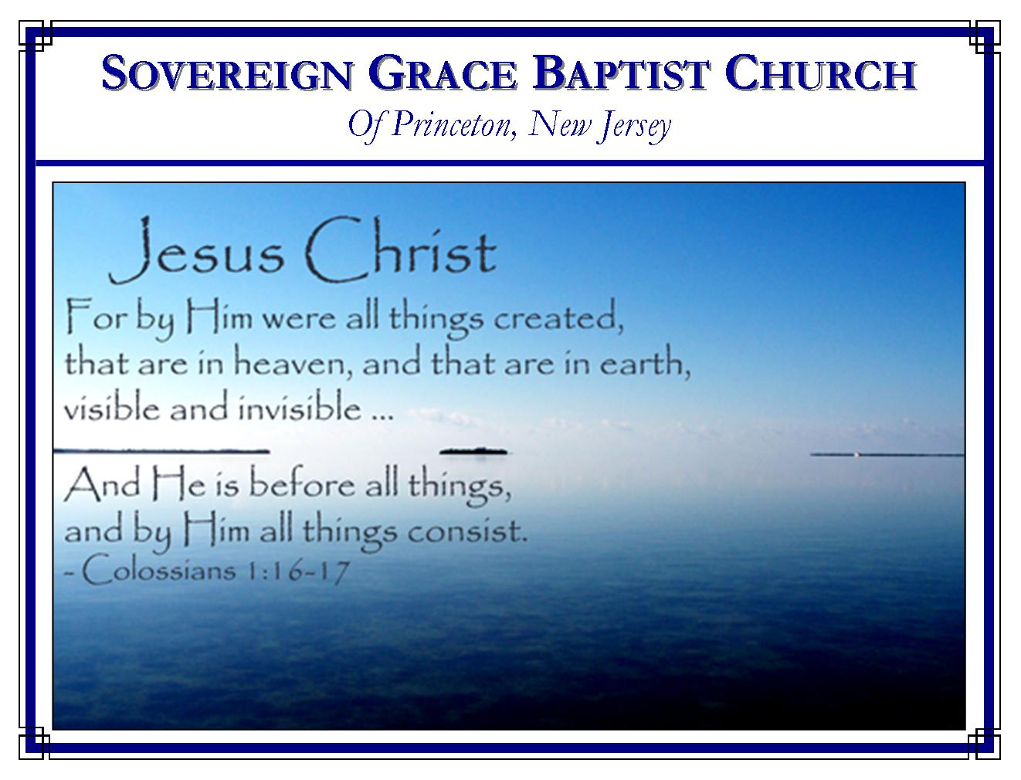
Weekly Schedule of Services
Sunday: | 10:15 AM | Bible Class
 | 11:00 AM | Morning Service
Thursday: | 7:30 PM | Mid-week Service

Web Address
Be sure to bookmark our website for daily articles and audio messages:
www.FreeGraceMedia.com
Weekly Meeting Location  Rocky Hill Firehouse, 2nd floor  150 Washington Street  Rocky Hill, NJ 08553 | Mailing Address  7 Birch Street  Pennington, NJ 08534  Clay Curtis, pastor
Phone: 615-513-4464 | Email: clay@freegracemedia.com
If you would like to receive this bulletin sent weekly to your email then send a note to the email address above. Articles in this bulletin are by the pastor unless otherwise noted.
What is Your Comfort?
SCHEDULE OF SERVICES
10:15 am Bible Class followed by short break
11:00 a.m. Service
Opening Hymns
Scripture Reading
Message
Closing Hymn
Nursery Today: Michelle Lutter; Nursery Thursday: Carol D’Armiento; December Bday: Cheryl D—3rd; Debbie D—17th; Anthony D—26th.

Henry T. Mahan
Are you happy? Yes! But I am not without times of sorrow. Like any human, I weep over loved ones, friends, sickness, death, and disappointment. But I sorrow not as those who have no hope. CHRIST IS MY HOPE! He loved me, gave Himself for me, and will make ALL THESE THINGS work together for my eternal good.
Are you at rest in your soul? Yes! But I am not free from concern and conviction over my sins and my infirmities. I love Christ but not as I should or as I desire. I am satisfied with Him, His mercy, His grace, and His love; but I will never be totally satisfied until I wake with His likeness.
Do you have peace? Yes! But that peace with God, peace of conscience, and peace in any situation or condition is not based on my merit, feelings, nor religious duties. CHRIST IS MY PEACE! He said, "In ME ye have peace. In the world ye shall have trouble."
Any man or woman who claims continual, uninterrupted joy, rest, and peace in this world is either not telling the truth or has no connection with reality! True joy, rest, and peace are things we enjoy in Christ IN THE MIDST of troubles, afflictions, and infirmities.
Paul's exhortation was "rejoice in the Lord." When I am conscious of my weakness, failures, and sins, I rejoice in Christ, my righteousness. When I am concerned about food, clothing, and shelter, I rejoice in Christ, my provider. When I am sick, Christ is my healer. When I am grieved, Christ is my comfort. When I am faced with death, Christ is my life! So it is not necessary to put on a false face and deceive others. We are still human; but our peace, rest, and joy is Christ."Thou wilt keep him in perfect peace, Whose mind is stayed on thee, because he trusteth in thee.”

FOUR GREAT PROMISES
Genesis 28: 15

Jacob was alone in the wilderness like all unregenerate sinners. (Gen 28: 10) His own sin had separated him from his father’s house just as sin separates the sinner from God. He lighted upon a certain place which was to him as good a place as the next, like many in religion, but he was in the dark. He took stones of that place for his pillow and lay down in that place to sleep. But God appeared to Jacob, revealing the great mercy of God in Christ toward him. (Rom 9: 11-13) If ever God comes to you dear sinner, this is where he will find you, asleep in your sin and rebellion in the dust of your own darkness.

The ladder Jacob was shown is a picture of Christ Jesus the Son of God. (Gen 28: 12) The Lord Jesus said of himself, “Verily, verily, I say unto you, Hereafter ye shall see heaven open, and the angels of God ascending and descending upon the Son of man.” (Jn 1: 51) The Lord stood above it as the ladder reached down to Jacob picturing Christ who is God and Man, who brings God and his children together in One. God’s elect have transgressed his law. Christ is the Way God can be just and the Justifier of all who believe in Jesus. (Rom 3: 24-26)

Christ is the Seed in whom God makes his everlasting covenant, ordered in all things and sure, in the newly created heart of each of his elect. (Gen 28: 13-14; 2 Cor 1: 18-20) Verse 15 gives us four promises full of comfort from God to the believer. These promises to you who believe are not yea and nay, they are yea and Amen in Christ Jesus.

I Am With Thee

The great I AM is with you, believer. Moses concern was, “If thy presence go not with us…” Here, God our Savior promises, “I Am with you.” Ask this question, “Who am I?” Have you ever asked this question of yourself, “Who am I?” When God the Holy Spirit makes us honest about who we are then we will rejoice that the great I AM promises, “I Am with thee.” We are dust and ashes. (Gen 18: 27) We are impotent earthen vessels. (Ex 3: 11) Everything we have comes from God’s hand. (1 Ch 29: 14) We are the least. (Eph 3: 8) But our Savior is God the great I AM! Because God is with us, God gives us favor with men. (Gen 39: 21) He is our strength for every battle. (Ju 6: 16) The counsel of our enemies shall come to nothing because God is with us. (Is 8: 10)

I Will Keep Thee

God our Savior keeps us by going before us, by going behind us, and by standing between us and our enemies. (Is 52: 12; 58: 8; Ex 14: 20) Most importantly Christ keeps us eternally. (Jn 6: 37-40) My brothers and sisters, do you become faint and weary in your mind at times? We do find ourselves troubled and perplexed. (2 Cor 4: 8) If God sees a need for it, we suffer heaviness through multiple trials. (1 Pet 1: 5-6) But let not your heart be troubled, Christ will keep us. (Jn 14: 1-3)

I Will Bring Thee

The land of Canaan pictures the great promised land in heaven’s glory with our great Shepherd. Jacob was in Canaan at this time but he had to leave and it would be many years before he would see it again. In the will and purpose of God, every elect child of God has been with God in the heavenly land of promise from eternity. (Eph 1: 3-4) But we have to wander in this land of exile for many years. Still, God promises, I will bring thee again into the land I promised you. He fulfilled his promise to Jacob. God exercised great patience toward Jacob who was slow of heart to believe. Through all Jacob’s ups and downs, God’s love for him changed not. God showed Jacob faithfulness which no unfaithfulness in Jacob could change. In the end, God brought him again to that land and the worm Jacob was turned into Israel, the prince of God. So too, one day, every regenerated child of God shall see Christ face-to-face and be like him because Christ shall bring us again to the land of promise. (Ps 17: 15)

I Will Not Leave Thee

The Lord God brought all this to pass for Jacob because God told Jacob he would. Salvation begins, continues and ends with the Word of God! You can read the rest of this passage later but I will give you a summary of what happened to Jacob when this revelation of Christ came into his heart. First, Jacob woke up. Wouldn’t it be amazing if that happened today for some unconverted sinner! Secondly, Jacob found himself in the house of God in the presence of God; he went from being in the land of separation to being separated from the world of unbelief into the house of God, Bethel. Thirdly, Jacob began really worshipping God at Christ our Altar. He was consecrated to God and willing to serve him with all God had given him the rest of his days. Brethren, simply believe the Word of God. He promises us, “Heaven and earth shall pass away, but my words shall not pass away.” (Mt 24: 35; He 13: 5) Rest in Christ, trust that his finished work is our finished work, consecrate to yourselves to his cause and remember these four great promises of our God. “Faithful is he that calleth you, who also will do it.” (1 Thess 5: 24)

