June 10, 2012
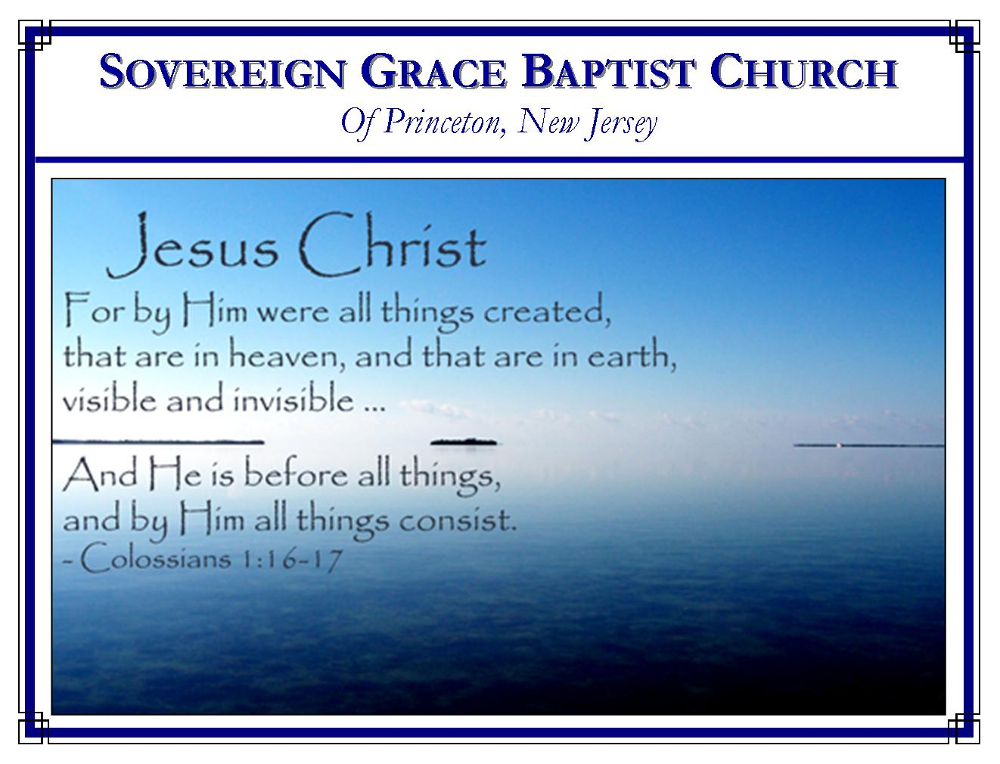
Weekly Schedule of Services
Sunday: | 10:15 AM | Bible Class
 | 11:00 AM | Morning Service
Thursday: | 7:00 PM | Mid-week Service

Web Address
Be sure to bookmark our website for daily articles and audio messages:
www.FreeGraceMedia.com
Weekly Meeting Location  Rocky Hill Firehouse, 2nd floor  150 Washington Street  Rocky Hill, NJ 08553 | Mailing Address  7 Birch Street  Pennington, NJ 08534
Phone: 615-513-4464 | Email: clay@freegracemedia.com
SCHEDULE OF SERVICES
10:15 a.m. Bible Study
Short Break 11:00 a.m. Service
Opening Hymns
Scripture Reading
Message
Closing Hymns
ANNOUNCEMENT: Don Fortner is scheduled to preach for us Thursday-Saturday, July 19-21, 7:30pm Th & Fri and 10:00am Sat.; Bro Scott Keller will bring the message this Thurs; Bro Eric Lutter will bring one message Sunday, June 17, at 11am.

When thou prayest rather let thy hearts be without words than thy words without heart. John Bunyan
The shooting stars of temporary prosperity may die out in everlasting night, but God is “the Father of lights, with whom is no variableness, neither shadow of turning.” Charles Spurgeon
HEALING FOR THE WITHERED
Mark 3: 1-8
While the Lord Jesus Christ walked this earth the enemies of our Lord never hindered Christ from doing the will of his Father for the glory of God and the welfare of the needy.
Christ Entered the Synagogue
The Lord has promised to meet with his people in the place where he has recorded his name. (Mk 3: 1; Ex 20: 24) As surely as God the Holy Spirit dwells in each particular believer, likewise, in whatever place the Lord has placed his name and assembled his saints for public worship, God promises to dwell in our midst: to bless his word for our growth, comfort, and establishment. (Php 2: 13) It is not the synagogue that is the house of the Lord it is his people. (1 Cor 3:16; Mt 18: 20) Having this assurance, let us never forsake assembling with the Lord’s people. (He 10: 23-25)
Two Kinds of People Present
There was a man with a need and those with no need. (Mk 3: 1-2) The man with the withered hand represents the truly needy sinner. Needy sinners are disabled from working for our salvation due to our total ruin in sin like as this man was disabled from working for his natural living by his withered hand (Is 1: 5-6) The Pharisees represent the hatred of the unregenerate heart toward God. They watched for something to use to accuse. The law was a letter to these men like as the Sabbath was only a day to them. They had no understanding that Christ is the end of the law for righteousness to the believer. He is Lord of the Sabbath and the Sabbath Rest of his people. (Mk 2: 27-28.) The Lord God rested after creating the heavens and the earth, because there remained nothing else to be done. That is what the believer finds in Christ. Believers keep the Sabbath, like we keep the rest of the law, by faith in Christ. (Mt 11:28; He 4: 9) Brethren, the enemies of our Lord did not hinder his work in the least nor shall they hinder ours. The Lord said the self-righteous will not be satisfied with the gospel (Mt 11: 17-19; Ps 69: 10-11.) Instead, continue trusting the Lord and let none turn you from Christ Jesus the Lord (Col 3: 1-25.)

An Example of the Power of the Gospel
First, all heard the word of the Lord as he taught but then the Lord singled out this man with the withered hand telling him to stand forth. (Mk 3:3) Rmember, the Pharisee’s had just openly asked the Lord the question whether or not it was lawful to heal on the Sabaath day. They watched that they might accuse. The man with the withered hand heard it all yet he came forth at the Master’s command. No matter who opposes, when the quickening grace of the Spirit comes into the heart, the sinner is given boldness to be identified with the Savior.

Secondly, through his gospel the Lord Jesus silences those who would prevent us from approaching the Lord just as he did the Pharisees. (Mk 3: 4-5) Remember that the Lord alone is able to silence our enemies and he does so by his word. (Is 44: 24-25)

Thirdly, Christ gives strength through the gospel to do what sinners cannot do of ourselves. He told the man to stretch forth his withered hand and the man did. (Mk 3: 5) By his power he gives the sinner life, ears to hear his word, faith to believe on him and strength to cast all into Christ’s hand to heal. “Of God Christ is made unto us Power and Wisdom” As long as something else is our strength such as we ourselves, our law-keeping, or things temporal then we will find it impossible to enter into the blessing our Lord has promised. As long as our power lies in what we perceive we have the ability to do then we cannot do anything for then all is reduced to complete inability. But when our Power and Wisdom is Christ, not us, then we have true strength and true wisdom. (Php 4: 13)

Fourthly, we see that Christ’s cures are not half cures. The man’s hand was restored whole. (Mk 3: 5) Christ fully “put away sin by the sacrifice of himself”. By Christ Jesus the believer is wholly "justified from all things." By his grace all who born of his Spirit are fully adopted, "Now are we the sons of God." Christ entirely, forever pardons, "having forgiven you all trespasses." When the Spirit of God enters in he makes a man altogether whole in the inward man. (1 Jn 3: 9; Jn 6: 63; Eph 4: 24; Col 3: 10)

Two Responses to Grace
The first response to grace we see in those whom the Lord left alone. They went forth right away and took counsel with men whom they had nothing in common with how they might destroy the Prince of Life. (Mk 3: 6) Before a self-righteous sinner will bow to the Lord and repent from a form of religion they will sooner lock arms with those whose doctrine they claim to oppose. Self-made men are merely looking for grounds on which they imagine they justify their rebellion against the Prince of Life! Another verse says they were “filled with madness”—that truly is madness. Note that Christ withdrew himself from those who hated him.

The second response to grace is exemplified in those who followed Christ (Mk 3: 7-8). When sinners are truly made to know our need and made to hear the great things Christ has done, they follow him. Peter said, “To whom shall we go!” These two things happen when sinners encounter the presence of the Lord Jesus Christ: the self-righteous are infuriated and depart while the needy follow Christ in hope. Contact with the Lord Jesus makes men either better or worse.

