April 22, 2012
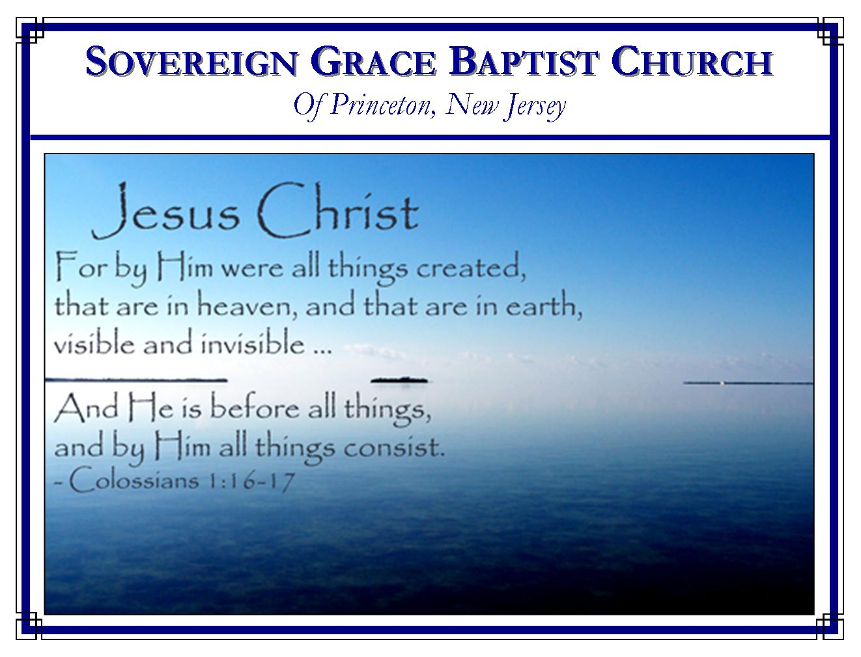
Weekly Schedule of Services
Sunday: | 10:15 AM | Bible Class
 | 11:00 AM | Morning Service
Thursday: | 7:30 PM | Mid-week Service

Web Addresses
Be sure to bookmark our website for daily articles and audio messages:
www.FreeGraceMedia.com | www.FreeGraceRadio.com
Weekly Meeting Location  Rocky Hill Firehouse, 2nd floor  150 Washington St., Rocky Hill, NJ 08553 | Mailing Address  7 Birch Street  Pennington, NJ 08534
Phone: 615-513-4464 | Email: clay@freegracemedia.com
If you would like to receive this bulletin sent weekly to your email then send a note to the email address above.
SCHEDULE OF SERVICES
10:15 a.m. Bible Study
Short Break
11:00 a.m. Service
Opening Hymns
Scripture Reading
Message
Closing Hymns

“He that trusteth in his own heart is a fool: but whoso walketh wisely, he shall be delivered.” (Proverbs 28: 26)

“Trust in the LORD with all thine heart; and lean not unto thine own understanding. In all thy ways acknowledge him, and he shall direct thy paths.” (Proverbs 3:5-6)

“I have not spoken in secret, in a dark place of the earth: I said not unto the seed of Jacob, Seek ye me in vain: I the LORD speak righteousness, I declare things that are right.” (Isa 45:19)

*******

ME AND MY WORDS
Mark 8: 38: Whosoever therefore shall be ashamed of me and of my words in this adulterous and sinful generation; of him also shall the Son of man be ashamed, when he cometh in the glory of his Father with the holy angels.
The reason a person will not submit to Christ and forsake all for him and his gospel, Christ says, is because he is, ASHAMED OF ME and OF MY WORDS. If we know the truth that Christ laid down his life for the sheep, justified them, and each shall be called by God for all flesh is grass, yet we are content to hear preaching which says Christ died for all and it is up to man’s will to make it effectual then we are ashamed of Christ and his gospel (Ps 101: 3.) The believer is not ashamed of Christ and must have the gospel. His words are eternal life. His gospel is “perfect, converting the soul: the testimony of the LORD is sure, making wise the simple.” (Ps 19:7.)

What is Grace and Peace?
2 Peter 1: 2

Grace and peace are of God. They are the sure work wrought by God for, and in, every child whom he saves through the righteousness and sacrifice of Christ Jesus the Lord.

What is Grace?
God is Grace. When we see Christ Jesus by faith we see Grace. Grace is sovereign, free, irresistible, unchanging, unchangeable, preserving, saving grace because the God of all grace is all of those things. Salvation is entirely by grace because salvation is entirely of the Lord and salvation is entirely of the Lord because salvation is entirely by grace (Ro 8: 29-30.) Grace and works exclude each other and cannot be mixed (Rom 11: 5-6.) By grace, God the Father chose and predestinated his children unto the adoption of children by Christ Jesus (Eph 1: 3-6.) By grace, Christ Jesus finished the work of redemption so that the believer is redeemed, forgiven, and justified (Eph 1: 7; Rom 3: 24.) By grace, every sinner for whom Christ died is quickened to life together with Christ Jesus (Eph 2: 5.) By grace, the Spirit of God gives faith and repentance, and all other graces that pertain to life and godliness, sanctifying us in Christ Jesus (Eph 2: 8-10.) By grace every believer shall be kept until the day Christ Jesus returns (Phil 1: 6-7.) By grace, every child of God shall be resurrected into glory to sing of God’s grace in Christ for all eternity (Ro 6: 23; Zec 4: 7.) We truly sing from the heart, “Oh to grace how great a debtor, daily I'm constrained to be!”
What is Peace?
When God crosses a sinner’s path with the gospel of grace, God reveals his righteousness in the face of Christ Jesus. At first we have no peace. God destroys every false refuge. A man will blame the preacher, the brethren, his dog and his cat. But when the Spirit of God takes the things of Christ, and shows them to him, the “Sun of righteousness” arises with “healing in his wings” saying, “Son, be of good cheer, thy sins are forgiven thee!” (Mt 9:2.) Peace flows into his heart. Peace of free justification by Christ’s righteousness, of full pardon and atonement by his blood and sacrifice, of being reconciled to God. Peace that we are complete in Christ Jesus. No more warring against God, no more guilt, no more working for acceptance, no more condemnation, the peace of assurance by faith in Christ Jesus (Ro 5: 1-2.) The peace Christ gives and the peace Christ is, is not the peace the world gives, nor is it given to his redeemed in the way the world tries to give peace (Jn 14: 27.) True peace that comes through the Holy Spirit is peace in believing (Ro 15: 13.)

When peace, like a river, attendeth my way,
When sorrows like sea billows roll;
Whatever my lot, Thou has taught me to say,
It is well, it is well, with my soul.

How so?

My sin, oh, the bliss of this glorious thought!
My sin, not in part but the whole,
Is nailed to the cross, and I bear it no more,
Praise the Lord, praise the Lord, O my soul!

How Are Grace and Peace Multiplied?
Grace and peace are multiplied through the gospel of our God and Savior (2 Pet 1: 5-8.) If we are too busy to hear the gospel and study the scriptures then we are too busy. The word continues to be made effectual by his Divine Power and Wisdom (2 Pet 1: 3-4.) His Divine Power and Wisdom brought the gospel to us, made us partakers of the divine nature in regeneration, and fulfills his exceeding great and precious promises to us. God and our Savior Christ Jesus multiplies his child in grace and peace and none shall be lost. In that great day we shall fall at his feet and praise him alone for the amazing grace and peace Christ wrought for us by his precious blood (Eph 1: 6; 1 Cor 15: 10.)

