October 30, 2011
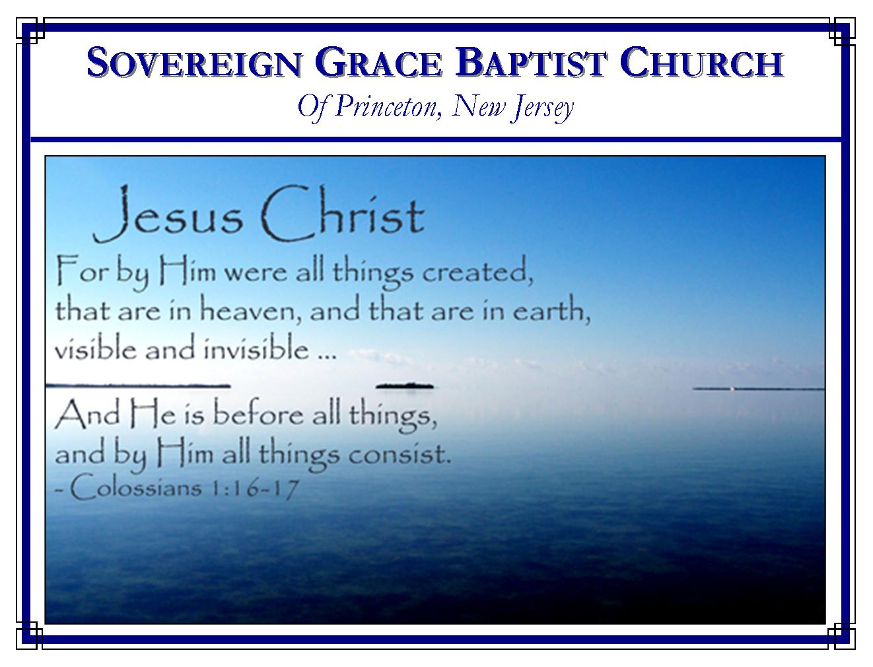
Weekly Schedule of Services
Sunday: | 10:00 AM | Bible Class
 | 11:00 AM | Morning Service
Thursday: | 7:00 PM | Mid-week Service

Web Addresses
Be sure to bookmark our website for daily articles and audio messages:
www.FreeGraceMedia.com | www.FreeGraceRadio.com
Weekly Meeting Location  Rocky Hill Firehouse, 2nd floor  150 Washington St., Rocky Hill, NJ 08553 | Mailing Address  7 Birch Street  Pennington, NJ 08534
Phone: 615-513-4464 | Email: clay@freegracemedia.com
If you would like to receive this bulletin sent weekly to your email then send a note to the email address above.

REMEMBER
- Next Sunday, November 6, if it is the will of the Lord we will have no 10 am service. Brother Scott Keller will bring the message at 11am. I will be preaching in San Diego.

- Sunday, November 13, we will observe the Lord’s Table and have lunch together after the service.

- The next few weeks the firefighters will be replacing the floor in the closet. It will be a bit cluttered around us as it was a few months ago. They plan to have the project finished within a few weeks.

- Brethren remember to ask the Lord’s direction and single-mindedness among the brethren as we look for a new meeting location. If anyone notices a potential building on your drive in please let me know. We will try to stay in the general central location that we are in now.

OUR SHIELD, GLORY, LIFTER and VICTORY
Psalm 3: 1-8

Believer, do you find that those who trouble you increase? David says, “LORD, how are they increased that trouble me!” David’s own son, Absalom, deceived him (2 Sa 14: 33-15: 1-11.) David’s own counselor betrayed him (2 Sa 15: 12.) David thought Mephiboseth forsook him (2 Sa 16: 3.) Shimei, of the house of Saul, cursed David (2 Sa 16: 5-12.) Often, we find that our God purposely works all things in our lives to do two things: to make us not trust in the flesh and to keep us trusting the LORD alone. In like manner as David’s enemies increased and his troops decreased, the Spirit of God makes the believer’s sins ever increase before us so that our own strength ever decreases so that Christ remains Preeminent in our hearts.

Sufferings of Christ
In David’s sufferings we see a shadow of the sufferings Christ bore as he saved us from our sins (Lam 1: 12.) First, we behold Christ in the betrayal of David’s closest companions. As one of his sons betrayed David so Judas betrayed Christ Jesus (Ps 41: 9.) David thought Mephibosheth had forsook him, so we behold Christ treading the winepress of God’s fury when all his closest companions had fled (Mat 26: 31.) Secondly, behold in David the mocking which Jesus our suffering Savior endured (Ps 3: 2; Mt 27:43.) Thirdly, behold Christ in the path which David took over the brook Kedron (2 Samuel 15: 23, 30; Mt 26: 30; Jn 18:1.) It was as the despised and rejected king that David now went forth, and so it was with the Redeemer. In the garden of Gethsamene we behold Christ Jesus crying out to the Father in perfect faithfulness as we do David. Christ Jesus drank of the sewer ditch Kedron being made sin for his people on the cross that we might be made the righteousness of God in him.

Christ our Shield
David says, “But thou, O LORD, art a shield for me.” (Ps 3: 3.) Christ Jesus is Jehovah, the LORD God, in human flesh, God our Savior. As a shield for his people, Christ Jesus bore the wrath of justice as our Substitute (Is 53.)

Christ our Glory
David says, “Thou, O LORD, art…my glory.” (Ps 3: 3.) God has provided himself a sacrifice so that none but God receives the glory in satisfying his own justice (Ro 3: 25-26.) We are decked in the finest garment in the glory of his righteousness! (2 Cor 5: 21; Jer 23: 6; 33: 16; Is 4: 5; Jn 17: 22.)

Christ our Lifter
David says, “But thou, O LORD,…the lifter up of mine head.” The glory to lift up our feeble heads is given to Christ Jesus. He is our Consolation (Ps 110: 7.) Because Christ cried and was heard so our High Priest hears when we cry (Ps 3: 4; Heb 5: 7.) Christ lay down is life but he awaked because the Father kept him (Ps 3: 5; Lu 23: 46.) So it is David was heard. So it is God hears his children through Christ when we cry. We are sure God hears us because he heard his Son. This was David’s hope, this is our hope, brethren (Ps 110.)

Christ our Victory
O believer, there is nothing we suffer in this life, but what our Redeemer has already suffered, infinitely more than we. Because he has perfect us forever—broken the jaw and the teeth of all our enemies—so Christ continues to do in us what he has done for us (Ps 3: 6-7.) “Salvation belongeth unto the LORD: thy blessing is upon thy people. Selah.” (Ps 3: 8.)

Deuteronomy 32: 31: For their rock is not as our Rock, even our enemies themselves being judges.

