October 23, 2011
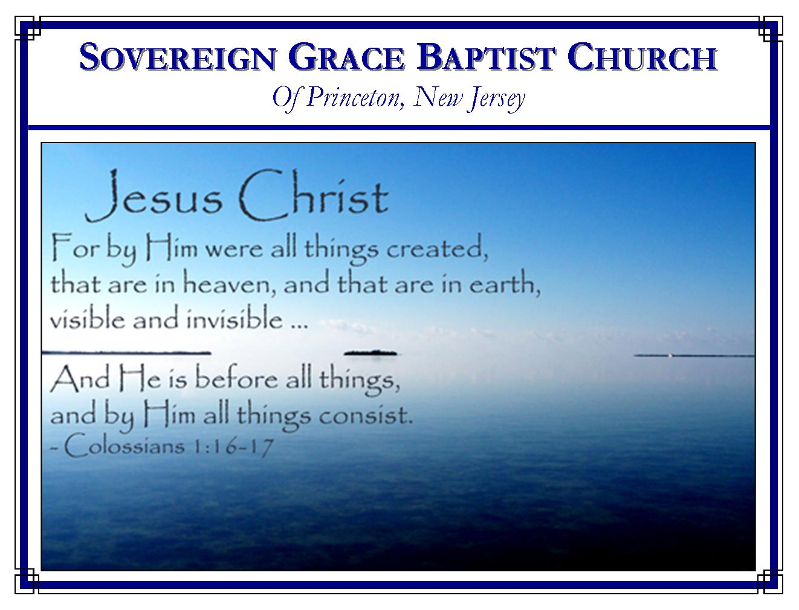
Weekly Schedule of Services
Sunday: | 10:00 AM | Bible Class
 | 11:00 AM | Morning Service
Thursday: | 7:00 PM | Mid-week Service

Web Addresses
Be sure to bookmark our website for daily articles and audio messages:
www.FreeGraceMedia.com | www.FreeGraceRadio.com
Weekly Meeting Location  Rocky Hill Firehouse, 2nd floor  150 Washington St., Rocky Hill, NJ 08553 | Mailing Address  7 Birch Street  Pennington, NJ 08534
Phone: 615-513-4464 | Email: clay@freegracemedia.com
If you would like to receive this bulletin sent weekly to your email then send a note to the email address above.
The Purpose of These Bulletins

These bulletins usually include a brief article from a sermon already preached and/or articles that blessed your pastors heart which I hope the Lord will use to bless yours. How may these bulletins be useful? First, as we gather to meet each Sunday morning these bulletins may be read to clear our minds and prepare our hearts to hear the word of the Lord prior to the beginning of the service. Secondly, the bulletin may be of use during the week as we read in our Bibles the passages of scripture expounded upon and look up the scripture references provided. Thirdly, the bulletin may be of use to give to a friend who has shown an interest in the gospel of our Redeemer. Every word your pastor preaches, writes or provides for you is for one purpose—the exaltation of the triune God in Christ Jesus that your souls be edified. May the Lord be pleased to do just that.

ENCOURAGMENT IN JUDGMENT
1 Peter 4: 17-19
Judgment strikes fear into the hearts of the unbeliever as well it should. For those who depart this world never believing on God our Savior, the Lord Jesus Christ, to save by his blood and righteousness apart from any works of righteousness we have done, judgment means everlasting condemnation. But the Spirit of God uses the judgment of God—the fiery trials in this earth—not to terrify, but to encourage and console the house of God in all our sufferings. Judgment must begin at the house of God because everything God does in this earth is for his house that we be kept from the condemnation of this world (1 Cor 11: 32; Heb 12: 5-6, 10; Jn 9: 39.) What consolation! What a cause to be encouraged in judgment.

Encouraged Because Christ has Brought Forth Judgment for His People.
Notice in the text that the righteous are scarcely saved. This is not to create fear or doubt concerning our salvation, brethren—the glory of the everlasting covenant is that our salvation is everlasting—ordered in all things and sure (Isaiah 45:17.) But this word “scarcely” shows the “preciousness” of our salvation. The salvation only Christ can accomplish. The righteous are scarcely saved, that is, “with the precious blood of Christ, as of a lamb without blemish and without spot: (1 Pe 1: 19.) By Christ coming forth when the time had come God has put away the judgment of condemnation for his people (Ro 8: 1-4; Je 50: 20; Is 43: 25; Ps 103: 12.) Therefore, when the time is come for the fiery judgment of God’s providential hand in this earth to purge his children from the dross that would turn us from Christ, his children shall be turned and found resting in Christ.

Encouraged because our Reproach from Wicked Judges is Due to his Grace
Reproach comes because we are born of the Spirit through this very gospel. Men reproach us because they do not understand us (1 Co 2: 15; 1 Pe 4: 4; 2 Pe 2: 12; Ju 1: 10.) Our manner of rejoicing in mercy rather than laying the blame on others in judgment is strange to the world (1 Pe 4: 7-10.) Our method of simply preaching the gospel of Christ and him crucified is strange to the world (1 Pe 4: 11.) Our motive of desiring for God in all things to be glorified through Christ Jesus is strange to the world (1 Pe 4: 11.) They think it strange that you run not with them in the same excess of sin and godless religion anymore. But it is for this cause that the gospel was preached unto us, even as it was to the saints of old (1 Pe 4: 6.) They were men in the flesh, but chastened of God so that they lived then for the glory of God and now live in glory with God—that is God’s purpose in the judgment of the fiery trials of weak economies, storms, sicknesses, even heresies in the church. Believer, if you be counted strange by men who do not understand us, rejoice, we have the mind of Christ and the Spirit of God rests on you—God will not let you go even if it means giving men and nations for you (1 Pe 4: 1, 14.) If undiscerning men rejected Christ for a form of religion what should we expect in our day? (Lu 23:31.)

Encouraged Because Christ Stands Ready to Avenge his Anointed
Peter encourages the believer by declaring that Christ is risen and stands ready to judge [avenge] all who would condemn us and reproach us for Christ’s name (1 Pe 4: 4-5.) Christ is risen. All judgment has been given unto him of the Father. Let us never seek vengeance. Christ is ready to avenge all his own, that is, the quickened who now live by his quickening Spirit; as well as those saints who have died for his name (He 10: 30; Re 6: 9-11.)

Now here is a question for those who would touch God’s anointed: if the righteous be saved with such a precious salvation, where shall the ungodly and the sinner appear? (1 Pe 4: 17.) Indeed, God will use ungodly and sinful men to bring about the judgment needed upon his house, to correct his children, to bring us through the fire strengthened in faith by his grace. God used the wicked Assyrian during Hezekiah’s day for this same purpose. But shall the wicked men God uses go unpunished? No! (Is 10:12; Je 25: 29.) Saul of Tarsus learned this by the power of God and renounced all his former religion as dead works (that is what repentance is) and believed on Christ (Php 3: 7-10.) “Be wise now therefore, O ye kings: be instructed, ye judges of the earth. Serve the LORD with fear, and rejoice with trembling. Kiss the Son, lest he be angry, and ye perish from the way, when his wrath is kindled but a little. Blessed are all they that put their trust in him (Ps 2: 10-12.)

Encouraged to Commit the Keeping of our Souls to Christ
Believer let us not think that God deals more kindly with the wicked because he suspends his judgments. Instead seeing that Christ has come and put away the judgment of our condemnation, seeing our reproach is due to God’s grace, seeing Christ stands ready to avenge his own, here is the word of instruction to us: “Wherefore let them that suffer according to the will of God commit the keeping of their souls to him in well doing, as unto a faithful Creator” (1 Pe 4: 19.) Entrusting the keeping of our souls to our faithful Creator is all we can do and that is the lesson in each trial of judgment!

