October 2, 2011
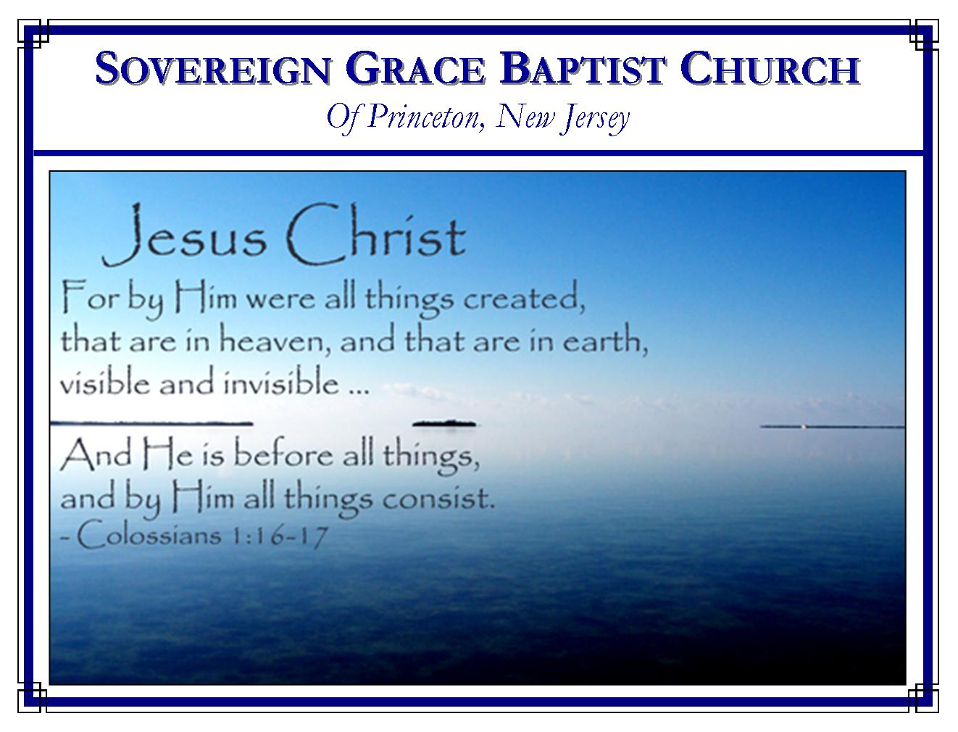
Weekly Schedule of Services
Sunday: | 10:00 AM | Bible Class
 | 11:00 AM | Morning Service
Thursday: | 7:00 PM | Mid-week Service

Web Addresses
Be sure to bookmark our website for daily articles and audio messages:
www.FreeGraceMedia.com | www.FreeGraceRadio.com
Weekly Meeting Location  Rocky Hill Firehouse, 2nd floor  150 Washington St., Rocky Hill, NJ 08553 | Mailing Address  7 Birch Street  Pennington, NJ 08534
Phone: 615-513-4464 | Email: clay@freegracemedia.com
If you would like to receive this bulletin sent weekly to your email then send a note to the email address above.
OCTOBER BIRTHDAYS
Alyssa L—8th; Joshua D—9th; Jonathan D—21st; David S—24th; Joe Z—27th; Jessie S—28th

SERVANTS OF THE LORD
Judges 6: 7-7: 1-22

Those God uses to spread his gospel are called through the gospel by which Christ is made the Power and Wisdom of God to us. We do not turn from that which pleases God to the strength of our flesh, of our wisdom, or our power lest we make the cross of Christ of none effect, making the faith of men to stand in the wisdom of men (1 Co 2: 1-5.) It is glorying in the Power and Wisdom of Jesus Christ our Lord when we are determined to preach Christ, not with excellency of speech, not using the natural wisdom that appeals to the flesh, but in the power of the Holy Spirit (1 Co 1: 18, 24-25.) Therefore, we use no other method but the preaching of the gospel comparing scripture to scripture, spiritual things with spiritual things. How will the Lord prepare us for this work?

God Chooses Weak Things (Judges 6: 12-16)

Each time the LORD delivered Israel from their captivity he did so through a prophet or judge (Judges 6: 7-8.) The Lord is calling Gideon. When Gideon was referred to as “a mighty man of valor,” Gideon did not answer “If the Lord be with ME” but with “us.” He counted himself a sinner (Judges 6: 13.) Gideon saw himself as poor, the least in his father’s house (Judges 6: 15.) That is the spirit God puts in the servant he uses. God does not use mighty “I’s” only powerless “us’s.” We are strong and wise in spirit when God has made us weak and ignorant in the flesh so that the Lord is our only Power and Wisdom (1 Co 1: 25.) The wisdom and strength of the servant of God is the Lord who calls him. The LORD told Gideon “go in this thy might…have not I sent thee.” (Judges 6: 14-16; See other examples: Ex 4: 10-12; Jeremiah 1: 6-10.)

That No Flesh Should Glory in his Presence (Judges 7: 1-8)

Those who served with Gideon in his army are a type of believers united together to publish the gospel under the immediate direction of Christ Jesus the Captain of our warfare. God will see to it that no flesh shall glory in his presence. All the servants of God shall know that it is by Christ alone that God conquers and saves his own (Judges 7: 2; Isaiah 45: 25; Jeremiah 4: 2.) Therefore, the LORD whittled the army down. Notice the three kinds of trial the Lord used to do so.

First, the greater part went away at the trial of the word (Judges 7: 3.) They had the very word the others had yet they departed because of the word of the Lord. A great part went away from the Lord because of the word Christ preached (John 6: 66-69.) The gospel of Christ and him crucified is foolishness to the intellectual and a stumbling block to those looking for life by their own works (1 Co 1: 22-23.) Many will go back because of this one message of salvation accomplished by Christ alone, delivered through this one method of preaching. But unto us who are saved this is the power of God (1 Co 1: 18.)

Secondly, the Lord said, “I will” try them. (Judges 7: 4-5.) We cannot discern what is good or bad in these men by the way they drank. That seems to be the point. The LORD did not tell Gideon which of these two styles of drinkers he was choosing; he just told Gideon that the Lord would do the choosing. It is the Lord who puts a difference between his people. You and I cannot tell who the Lord has chosen by looking at him. God chooses whom he will and passes by whom he will and God alone makes it known (Ex 11:7; 1 Co 4: 7.)

Thirdly, we see a trial of faith. Though facing a host of enemies that far outnumbered them, when the Lord told Gideon to send home the greater part of his men, believing on the Lord, Gideon did so. Likewise, believing God, that small remnant who remained went into battle looking to Gideon. So it is that God chooses and strengthens his saints by his word so that we believe God is able to perform that which God promises. Therefore we go forth with God’s remnant against a host of enemies looking to Christ alone (Judges 7: 6—8.)

Victory by the Gospel of Christ (Judges 7: 16-22)
Gideon and his small remnant of soldiers won the victory against a mighty enemy through a light (Christ), a trumpet and a shout (the gospel preached), and broken vessels (the sinner God uses). Those God uses are vessels with Christ the Light in our hearts (2 Co 4: 7.) But before the light shines forth, the vessel in which the light is has to be broken. God’s servants shall each be broken in the flesh so that we see that we have absolutely no strength, no sufficiency of ourselves for the work to which God has called us—that the excellency of the power may be of God and not of us. When Christ is made the Power and Wisdom of God unto us then shall we be made willing to go forth as the Lord has commanded, using the means God has ordained (1 Corinthians 2:5; 1 Corinthians 1: 18, 24-25, 29.) So is it that God allows no flesh to glory in his presence and brings his children to glory in the Lord (1 Cor 1: 27-31.)

***************

Proverbs 26: 17: He that passeth by, and meddleth with strife belonging not to him, is like one that taketh a dog by the ears.

**************

Abigail’s description of David’s salvation, “…the soul of my lord shall be bound in the bundle of life with the LORD thy God; and the souls of thine enemies, them shall he sling out, as out of the middle of a sling” (1 Samuel 25: 29.)

