September 4, 2011
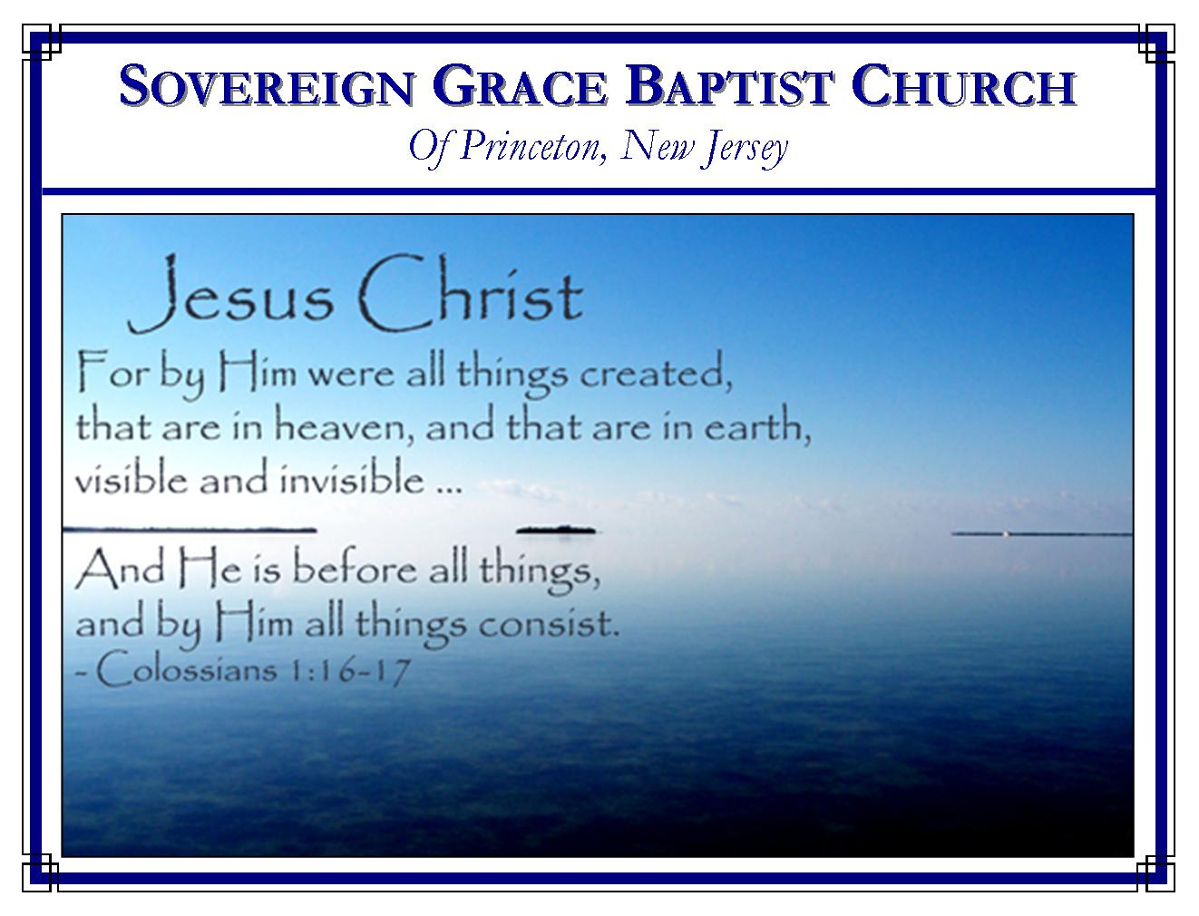
Weekly Schedule of Services
Sunday: | 10:00 AM | Bible Class
 | 11:00 AM | Morning Service
Thursday: | 7:00 PM | Mid-week Service

Web Addresses
Be sure to bookmark our website for daily articles and audio messages:
www.FreeGraceMedia.com | www.FreeGraceRadio.com
Weekly Meeting Location  Rocky Hill Firehouse, 2nd floor  150 Washington St., Rocky Hill, NJ 08553 | Mailing Address  7 Birch Street  Pennington, NJ 08534
Phone: 615-513-4464 | Email: clay@freegracemedia.com
If you would like to receive this bulletin sent weekly to your email then send a note to the email address above.
Christ the Covenant
Isaiah 42: 5-12

A covenant is a mutual agreement between two parties. Certain conditions must be met with the promise of certain rewards given. Each party is bound to fulfill his own conditions in order for the promise to be received. If either party fails then the covenant becomes null and void. God made a covenant with man in Adam but in Adam we broke covenant. But before God made a covenant with Adam, God made a covenant with Christ.

Thus Saith God the LORD (Isaiah 42: 5-6)
This is God who can swear by no greater, making his oath by himself to himself in his Son Christ Jesus the Lord. The LORD God gave Christ his Son the sole privilege to establish and mediate the new covenant-I the LORD have called thee. In declaring to Christ his faithfulness to accomplish judgment in the earth—the LORD God swears by his own name who created and sustains life. We see that the laws God created which hold the earth in place and sustain life do not do so partially, partly so, partly not. Gravity works in judgment, in truth, because it is God’s law. Concerning the human body, it either has breath and lives or the breath is gone and we die. God does not work in ambiguity in the realm of his laws of nature and life—neither in the salvation of God’s elect. God does all in righteousness, in truth, in judgment and brings all to pass effectually—not in ambiguity—not in yes and no—but yes and amen—because God is righteous and all-powerful to do so. His law is honored and magnified in truth even by the life and death of his own Son. He sends forth his gospel in truth (pastors according to mine heart which shall feed you with knowledge and understanding, for how can you call on him in truth, of whom you have not heard in truth). God regenerates to life his elect because he is righteous to do so. Justice demands it. God gives unction to the believer so that we know Christ is all our salvation, , apart from any works or will or additions of man’s flesh. Every believer worships God in spirit and in truth because it is God who creates spiritual life and teaches his children himself. The same God who is omnipotent to create heaven and earth and life is the omnipotent God who creates the new heaven and new earth by the righteousness of his Son, who set judgment in the earth by his life and death, who sets judgment in the heart of his people in truth. We would do well to listen to this omnipotent God tell us how he saves and believe on his Son.

Christ is the Covenant Given (Isaiah 42: 6)
There are many names to convey to the believer who Christ is to us: Jesus-Savior (Matthew 1: 21), the Lamb of God (John 1: 29), the Bread of life (John 6: 35), the Way, the Truth, the Life (John 14: 6), the Door of the sheep (John 10: 7, 9), the Good Shepherd who gives his life for the sheep (John 10: 11, 14), the Resurrection and the Life (John 11: 25), the Elect Servant of God in whom God delights (Isaiah 42: 1), but we find here another name full of comfort for our hearts, Christ is “a Covenant of the people.” God was in Christ fulfilling the conditions required of God’s holy character, magnifying the law and making it honorable that God might be both just and the justifier of all who believe on Christ. God is just to show mercy to his people for his righteousness is upheld by Christ. Christ as Man fulfilled the conditions required by all the elect given to him of God. He obeyed the precepts of the law in perfection as our representative Man. And he satisfied the debt of justice we owed as our Substitute dying in our place. In Christ, every believer has fulfilled the covenant of God as if he did it himself through Christ who did it for us. Brethren, we have a Daysman, Christ our Mediator, who laid his hand upon God fulfilling all the conditions God requires and lays his hand upon his elect fulfilling all the conditions required of them. In the day of his power, he makes each one willing to trust Christ alone to bring them to God. In this, Christ manages and dispatches all the business of the covenant, from the first to the last (1 Timothy 2:5; Hebrews 9:15.)

The Effectual Accomplishment of Christ (Isaiah 42: 7)
This is what all God’s elect are by nature: blind, in prison, sitting in darkness in the prison house of our own sin-dead hearts. But when the Spirit of God calls us to life, when Christ is formed in us—truly the everlasting covenant is made with us by God. Christ is that Light, that Covenant, wherein our blind eyes are opened, the prison door is opened and Christ says to us through the Spirit, “show yourselves” (Isaiah 49:9.) That is when we come to the Light. (John 3: 21.) All the everlasting promises of complete salvation are given in Christ who is the substance of the everlasting covenant of grace. We are given the earnest of the Spirit so that we are assured that all the promises of God are yea and amen in Christ Jesus (Ephesians 1: 13-14.)

That No Flesh Should Glory In his Presence (Isaiah 42: 8)
God saves sinner this way so that “no flesh should glory in his presence.” God will not share the glory due to his name with any. God will not give the praise due to him to some idol of man’s imagination. “He that glorieth, let him glory in the Lord.” (Ps. 115:1).

Our Assurance (Isaiah 42: 9-12)
What assurance does the believer have that the Lord God has and will perform everything promised in the covenant? First, the believer has the assurance of God’s past performance—Behold, the former things are come to pass. Has he not brought to pass exactly what he said he would? He is faithful and immutable. Secondly, the believer has the assurance of divine revelation--and new things do I declare: before they spring forth I tell you of them. Christ is the new and living way revealed in our hearts. The believer has been made a new creation in Christ. A new relationship has been revealed to us by God—God is our Father and we his sons (1 John 3: 1.) In a short time, God will reveal a new heavens and new earth and we will sing a new song to our God who makes all things new (Isaiah 42: 10-12.) May God put this new song in our hearts and on our lips.

