August 21, 2011
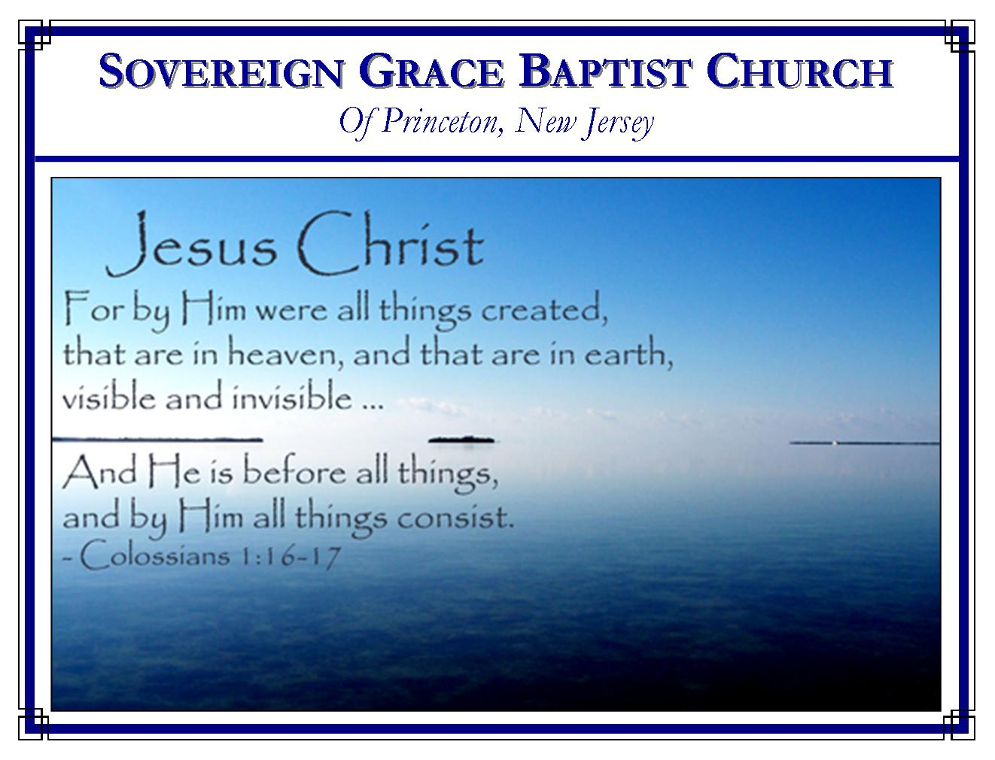
Weekly Schedule of Services
Sunday: | 10:00 AM | Bible Class
 | 11:00 AM | Morning Service
Thursday: | 7:00 PM | Mid-week Service

Web Addresses
Be sure to bookmark our website for daily articles and audio messages:
www.FreeGraceMedia.com | www.FreeGraceRadio.com
Weekly Meeting Location  Rocky Hill Firehouse, 2nd floor  150 Washington St., Rocky Hill, NJ 08553 | Mailing Address  7 Birch Street  Pennington, NJ 08534
Phone: 615-513-4464 | Email: clay@freegracemedia.com
If you would like to receive this bulletin sent weekly to your email then send a note to the email address above.

BEHOLD CHRIST!
Isaiah 42: 1-4
Matthew 12: 14-21
Is there anyone who has questions about who God is or how God saves sinners? Do you struggle in sin, in self-righteousness, in trials? Are you cast down and discouraged? Here is the command of God, “Behold my servant.” This chosen servant of God, is the GodMan Mediator, the Lord Jesus Christ. This is he who is the Righteousness of God in whom all God’s children are complete.

Behold the Servant of God (Isaiah 42: 1)
God requires perfect obedience from his servant (Deuteronomy 10: 12-13.) But concerning the service of all who are saved by grace, the Spirit of God says, ye were the servants of sin (Romans 6: 17.) God was not able to hold us up, to entrust into our hands the work of glorifying his name, to exalt any of us before the world, saying “here is my servant” (Isaiah 41: 28-29.) But concerning Christ’s service, God was able to entrust all to his Son. Christ came down from heavens glory. He took the form of a servant and served God in perfection for his people (Isaiah 59: 16; Romans 3: 25-26; Philippians 2: 5-11.) God holds up Christ for all to see giving him a name which above every name. By God-given faith in Christ, every believer has fulfilled the whole law of God. O, behold Christ the servant of God (Proverbs 16: 3.)

Behold Christ, the Elect of God (Isaiah 41: 1)
If left in our sin none of God’s elect would choose God’s choice (Romans 3: 11; 1 John 4: 10; John 15: 16.) Yet, God does not delight in any but his Elect and those he put in him (Isaiah 1: 14; Leviticus 26: 30.) But God the Father chose Christ and chose us unto salvation in his Elect (Psalms 89:19; 1 Peter 2:4. He blessed us with all spiritual blessing in Christ, making us holy and without blame before him in love. O what grace! (Ephesians 1:4, 6.) Behold, Christ, God’s elect and find delight for your souls in God’s electing grace.
Behold Christ, God’s Anointed (Isaiah 42: 1-3.)
The spirit that is in us by nature produces only sin and sorrow (Isaiah 50: 11.) Our discernment and dealing with men is carnal but for the grace of God (John 8: 15.) We see what we are in the Pharisee: we cry out—accusing; we lift up—justifying ourselves; we cause our voice to be heard in the streets—boasting of our many wonderful works; by nature we would break the bruised and quench the smoking flax (Isaiah 59: 7; Proverbs 26: 12.) But God poured out the Holy Spirit upon Christ without measure. The spirit of the LORD made him of quick understanding in the fear of the LORD. Christ did not (and does not) judge after the sight of his eyes, neither reprove after the hearing of his ears: but with righteousness judges the poor, and reproves with equity the meek of the earth while his word slays the wicked. Christ was (and is) tender to the weak and bruised. Christ has brougth forth judgment unto victory: for his people (Isaiah 11: 1-4.)

When the Spirit of God comes into our hearts then we become the bruised reed and the smoking flax, needy and without strength. But Christ binds up the heart he has broken, pouring in the oil of his Spirit making our lamps to burn in his Light, upholding us with the right hand of his righteousness, so that we are no more reeds shaken by every wind of doctrine (Isaiah 61: 1-3.) Behold Christ, hear his voice, come to him and find rest for your weary souls for Christ is meek and lowly in heart (Isaiah 42: 6-7; Matthew 11: 29.)

Behold, Christ Shall Not Fail (Isaiah 42: 2.)
He did not fail nor was he discouraged in the midst of his enemies, under the divine wrath of God inflicted on him as the substitute of his people but endured all in perfect fidelity to God. He has fully satisfied the justice of God for the sins of his people. Christ has finished the work of redeeming his people in righteousness. He has set his Gospel throughout the world through the messengers which he receives the glory for sending. Our King is setting the gospel in the hearts of his people in judgment in true discernment. And he shall return again when the last is called to him and none shall be lost

Dear sinner, are you yet trying to please God by your service, by your choosing, by some goodness in you? Hear the LORD God—BEHOLD CHRIST IN WHOM GOD DELIGHTS! (Galatians 5:5; Psalms 27:14; 37:34.)

“My favorite verse of scripture was the same before the Lord called me as it is now. But before I put the emphasis on me, saying, ‘I can do all things through Christ which strengthen me.’ Now the emphasis is on another, ‘I can do all things through CHRIST which strengthen me.’”
Jack Shanks

