July 31, 2011
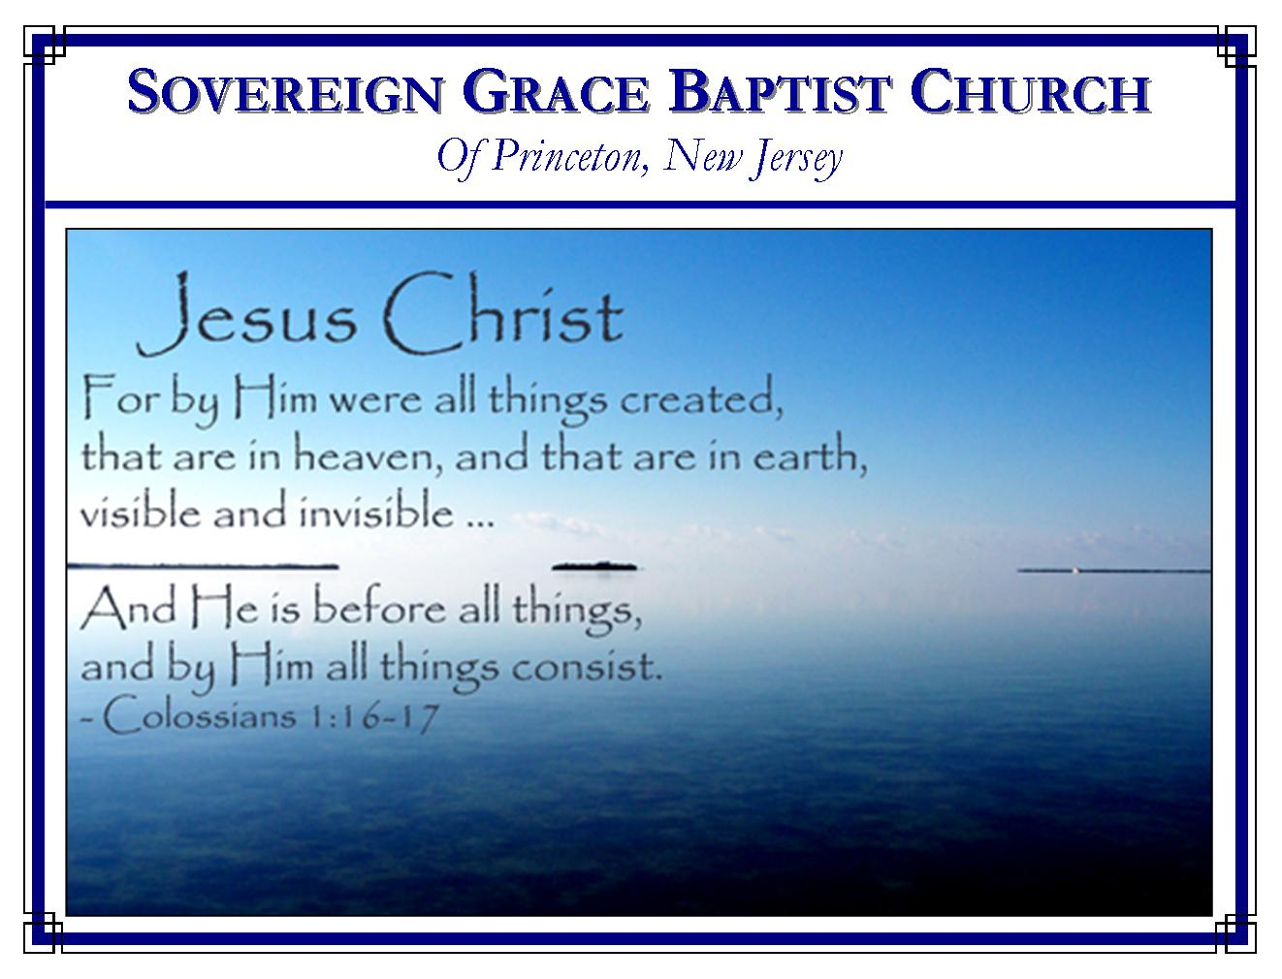
Weekly Schedule of Services
Sunday: | 10:00 AM | Bible Class
 | 11:00 AM | Morning Service
Thursday: | 7:00 PM | Mid-week Service

Web Addresses
Be sure to bookmark our website for daily articles and audio messages:
www.FreeGraceMedia.com | www.FreeGraceRadio.com
Weekly Meeting Location  Rocky Hill Firehouse, 2nd floor  150 Washington St., Rocky Hill, NJ 08553 | Mailing Address  7 Birch Street  Pennington, NJ 08534
Phone: 615-513-4464 | Email: clay@freegracemedia.com
If you would like to receive this bulletin sent weekly to your email then send a note to the email address above.
Remember
After the service today we welcome all to join us for a meal together. Next Sunday, we will meet at the regular time and place in the firehouse. We will not have our usual meal together. Again, we thank our brethren for opening their home to us this morning. We thank our gracious Lord for adding those who should be saved (Acts 2: 47.)

THE PASTOR WHO IS GOD
John 10: 14
God is the great I AM (Exodus 3:14.) There is none “good” but God (Mark 10:18.) Shepherd means pastor. Here, Christ Jesus says, “I am the good shepherd.” Christ is the Pastor who is both God and Man. His listeners heard him loud and clear (John 10: 33.)

Jesus Christ is the Good Shepherd (John 10: 1-2.)
Sheep were kept in a sheepfold for protection. A sheepfold had high walls with one door kept by a porter. The door was the lawful way of entry. The shepherd, to whom the sheep belonged, entered the sheepfold lawfully through the door. Christ is the Shepherd who entered lawfully to deliver his sheep out of the fold of fallen humanity into the one fold of his kingdom. His children were flesh and under the law. Therefore to lawfully redeem them from the curse of the law Christ was made of a woman, made under the law (Galatians 4: 4-5.) His children were made a curse by the disobedience of the first representative, Adam. In like manner, through the obedience of Christ those he represented are made the righteousness of God to lawfully enter God’s presence (Romans 5: 17, 19; Galatians 3: 13; 2 Corinthians 5: 21; John 10: 10-14). Like the porter (John 10: 3), God the Father opened to our risen Redeemer declaring God is satisfied with Christ (John 10: 17-18.) Christ is not only the Shepherd, he is the Door through whom his sheep leave the bondage of the curse and enter into the liberty of the sons of God (John 10: 7, 9.) The Way to God’s presence is through Christ the Door. All who enter by Christ through faith “shall be saved, and find pasture”. All who try to come some other way are thieves and robbers. Christ Jesus is the good Shepherd.
Christ Jesus Knows His Sheep
First, Christ knows his sheep by name—he calleth his own sheep by name, and leadeth them out (John 10: 3.) Secondly, Christ knows his sheep because by electing grace they are one with him, even as the Father and Son are one (John 10: 15.) Christ laid down his life for those given him of the Father (Ephesians 1: 3-6; 2 Thessalonnians 2: 13; Jeremiah 1: 5; 2 Timothy 2:19.)--“I lay down my life for the sheep.” Thirdly, Christ knows where his sheep are. The woman at the well lived in Samaria, therefore we read, “And he must needs go through Samaria” (John 4: 4). Lydia was in Macedonia therefore Paul was forbidden to go elsewhere. Christ had just called one of his sheep from among the Jews, but Christ said others I have which are not of this fold. He shall call each one and there shall be one fold and one shepherd (John 10: 16; Ezekiel 34: 22-24.) Fourthly, his knowing his sheep is how Christ imparts life so that his sheep follow him (John 10: 27; Psalm 110: 3.) As Adam intimately “knew” his wife, and she conceived and bare a son and they two became one flesh so the Spirit of God, like the porter, opens the door in the sinner’s heart. Christ Jesus “knows” his own; there is conception; a new child is born of the incorruptible Seed; and they follow Christ (Galatians 4:9; Ephesians 1: 5-6; Romans 8: 29-30; Galatians 4: 6; Ephesians 2: 5-9.) Christ “knowing” his sheep is the very foundation and certainty of our salvation.

Christ Jesus is known of all his Sheep
By his irresistible call, believers know Christ’s voice (John 10: 4.) His sheep are anointed and taught of God (1 John 2: 20-27.) The Shepherd and his sheep are in agreement (Isaiah 52: 6-8.) Not one sheep has ever or shall ever be deceived by the voice of strangers (John 10: 5.) None shall perish but have eternal life (John 10: 28-29.) This is the doctrine of Christ whereby he declares that he is the Son of God with power. Do you believe Christ?

True mourning for sin has a distinct and constant reference to the Lord Jesus. If I hate sin because I am exposed, I have not repented; I merely regret that I have been found out. If I hate sin because of judgment and hell, I have not repented; I merely regret that God is just. But if I see sin as a hateful offense against my Lord, and I see my sin as crucifying Him, then I mourn with a truly broken and repentant heart (Psalm 51:3-4). True mourning is a great bitterness, as one mourns the death of his firstborn (Zach 12: 10.) Someone said…‘Lord, let me weep for naught but sin; And after none but Thee; Then I would (Oh, that I might!); A constant weeper be!’ A broken heart over sin is a work of the Spirit of God and will be healed (Psalm 51:17; 34:18). Henry Mahan

“Or who hath first given to him, and it shall be recompensed unto him again?” (Rom 11:35)
God is the great Giver. Everything good comes down (James 1:17) from the Father of lights. His eternal decree of love and grace toward His people came down from His sovereign throne to be declared in this world and to govern the affairs of men. His only begotten, beloved Son came down into this world to save those sinners, of whom I am chief (1Tim 1:15). When Christ left this world He said He would send the Holy Spirit to show us the things of Himself, and He has (John 16:7-14). When the Lord Jesus ascended on high, He led captivity captive and gave gifts unto men (Eph 4:8); men who preach the gospel of Christ to sinners. He gives all good gifts, both temporal and eternal. Psalm 145:16: Thou openest thine hand, and satisfiest the desire of every living thing.

Who has ever first given anything to God? Honestly now, have you ever done anything for God? When you worship Him, you who know Him, is that you doing something for God, or Him doing something for you? When you support His Gospel, if you do, is that you giving Him something, or Him giving you something (1Chronicles 29:14)? When you pray, Who is the Benefactor and who the beneficiary? If you are enabled to render any service unto Him, of any kind, who has been blessed, and Who has done the blessing? We must all sing together, or be guilty of the grossest lie and ingratitude, “Praise God from Whom all blessings flow.”
Chris Cunningham

