July 24, 2011
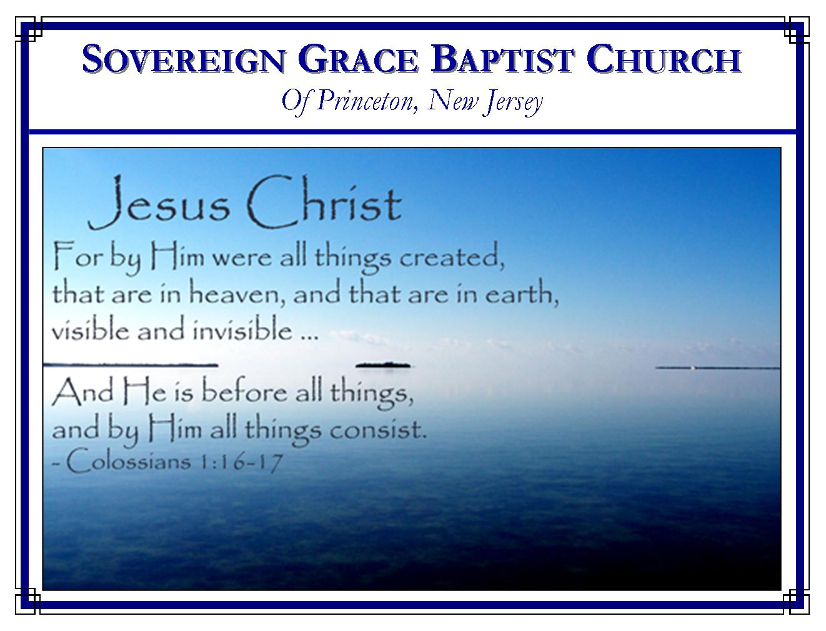
Weekly Schedule of Services
Sunday: | 10:00 AM | Bible Class
 | 11:00 AM | Morning Service
Thursday: | 7:00 PM | Mid-week Service

Web Addresses
Be sure to bookmark our website for daily articles and audio messages:
www.FreeGraceMedia.com | www.FreeGraceRadio.com
Weekly Meeting Location  Rocky Hill Firehouse, 2nd floor  150 Washington St., Rocky Hill, NJ 08553 | Mailing Address  7 Birch Street  Pennington, NJ 08534
Phone: 615-513-4464 | Email: clay@freegracemedia.com
If you would like to receive this bulletin sent weekly to your email then send a note to the email address above.
REMEMBER
Sunday, July 31, 10 AM, services will be held at the Santamaria’s home, 46 Cranbury Neck Road, Cranbury, NJ, 08512. I will bring one message followed by the baptism of several brethren. The alternate date in case of weather is August 7. Be sure to check the website for updates.

REST!
Exodus 34: 21

There were eight sabbaths in the law. Each were given to typify Christ, the believer’s rest (Colossians 2: 16-17; Romans 10: 4.)

Creation Work and Rest

The LORD points us back to creation when God rested the seventh day, blessing and hallowing that day (Exodus 20:11.) God did not rest for any other reason than this: there was nothing else to be done because the work was finished (Genesis 2: 1-2.) When you think of the word “Sabbath” remember THE WORK IS DONE! God gave the law to give the knowledge of sins until Christ should come to finish the work of making satisfaction for the sins of his people (Romans 3: 19-20; Galatians 3: 19.)

Salvation Work and Rest
God gave the work of putting away the sin of his people to Christ to finish, to make an end of sin, and to bring in everlasting righteousness (Daniel 9:24). Christ finished the work so that there remains no more work to be done (John 17: 4; 19: 30.) God the Father promised Christ that once there was nothing left to do Christ would enter into rest, just as God did when he finished the work of creation, so Christ sat down at rest (Hebrews 1: 3; 10: 11-14.)

The Believer’s Rest
When the Spirit of God writes his law on the heart of his child, he sanctifies his children so that we behold Christ in whom the work of making us accepted with God is finished. Our sins are gone. Through faith we enter into his sweet rest (Hebrews 4: 3, 9-10.) The believer has ceased from his own works, as God did from his because THERE IS NOTHING LEFT TO BE DONE!

The Sufficiency of Rest
The rest the believer has in Christ is the full sufficiency of Christ’s perfect righteousness. The law commanded rest in earing time and in harvest. Earing time marks the beginning. Harvest time marks the end. From beginning to end the believer has the full sufficiency of righteousness in Christ. Under the old covenant, the sabbath was always connected with six days of work because it was a conditional covenant. In the new testament the only time the sabbath is mentioned in connection with six days is when a few worms broke the whole law of God, the sabbath included, by rejecting Christ our Sabbath, in favor of their own work of observing a day (Luke 13:14.) The point is, the believers rest is not conditioned upon our works, nor is it a day following a week of work, but our Rest is Christ in whom we are in perpetual everlasting rest beginning to end because he finished every condition necessary for us in the everlasting covenant of grace.

Life in Rest
Earing and harvesting was in order to eat. Yet during the Sabbaths the people were to depend entirely upon God to feed them or they were dead (Exodus 35: 2-3; Exodus 16: 23-30.) Resting in Christ we find that Christ our Bread is full sufficiency of life. If we keep trying to go out and gather our own life when God has said stop working then we are saying that Christ is not sufficient Righteousness for us. Such a one will not stand in the strict judgment of God.

Stretch Out and Rest!

When you read the law commanding us to rest, do you think of doing? Amazing how sinners are able to make a work out of resting.

At the end of a hard weeks work it feels so good to stretch out in a big bed with plenty of covers and rest. So it is when the believer comes to the end of the law and stretches out in Christ, wrapped up in his righteousness. We rest! But there is no rest for the sinner who has not ceased from his own works—the bed is too short and the covering too narrow (Isaiah 28: 20.)

Are you tired of working for acceptance with God? Are you weary and heavy laden of the yoke of oppressive legal religion? Christ said, “Come unto ME, all ye that labor and are heavy laden, and I will give you rest. Take my yoke upon you, and learn of me; for I am meek and lowly in heart: and ye shall find rest unto your souls” (Matthew 11: 28-29.)

Use sin as Christ was used when He was made sin for us; lift it up, and make it naked by confession to God. And then pierce the hands of it, in respect of operation, that it may work no more; the feet of it, in respect of progression, that it go no further; and the heart, in respect of affection, that it may be loved no longer.
John Trapp

