June 19, 2011
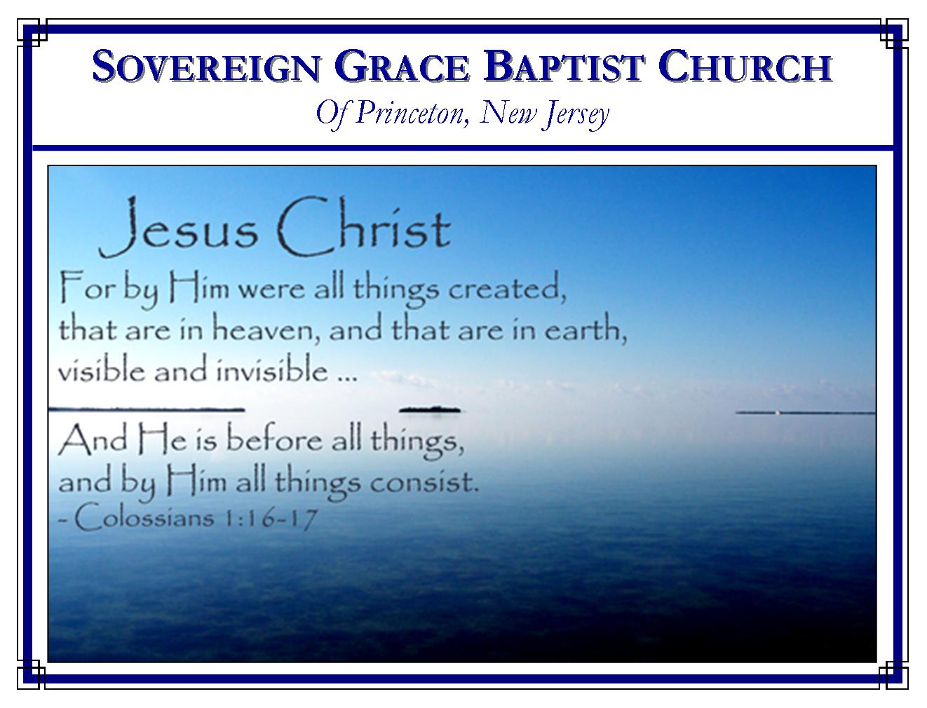
Weekly Schedule of Services
Sunday: | 10:00 AM | Bible Class
 | 11:00 AM | Morning Service
Thursday: | 7:00 PM | Mid-week Service

Web Addresses
Be sure to bookmark our website for daily articles and audio messages:
www.FreeGraceMedia.com | www.FreeGraceRadio.com
Weekly Meeting Location  Rocky Hill Firehouse, 2nd floor  150 Washington St., Rocky Hill, NJ 08553 | Mailing Address  7 Birch Street  Pennington, NJ 08534
Phone: 615-513-4464 | Email: clay@freegracemedia.com
If you would like to receive this bulletin sent weekly to your email then send a note to the email address above.
We welcome Brother Bob Coffey this morning. May the Lord be pleased to bless the hearts of his people.

When a sliver of light is visible in the moon it is because the world has come between it and the sun. There is a direct correlation to the believer’s rest of heart and our hearing the Light of the gospel preached--“faith cometh by hearing and hearing by the word of God.” There are hours of things we can omit in a week to rest the body, but omitting an hour from hearing the gospel brings unrest to the soul. “Come unto me…I will give you rest…ye shall find rest unto your souls.”

Feasting with a New Believer
Luke 5: 29-35
This is the account of Levi’s conversion by the grace of our Lord Jesus Christ. He was chosen of God in Christ his Surety therefore Levi was called in power and grace, as all the elect of God shall be. With one command the Lord Jesus Christ gave Levi spiritual life where there was no life, faith where there was no faith. Levi was turned by the Lord and therefore Levi turned from his former way and followed Christ with full forgiveness of sins: past, present and future. For the first time, some of you have experienced the power of the Lord’s call. You have confessed that all you are is sin and all your hope is the Lord Jesus Christ. When you are baptized you will be confessing publicly that you have: left all, risen with Christ, and are now following him. Here are four words to encourage you, to warn you and for you to follow.

Always Be Concerned for the Souls of Others (Luke 5: 29) We can relate to the joy that Levi had in his heart. He had met his Savior. This was a time of celebration for Levi. He wanted his friends to meet his Master. So Levi invited as many as he could to his house for dinner in the presence of the Lord. You know how Levi felt. You want the ones you love and care about most to know him. Always desire to want needy sinners to come to Christ. Levi spared no expense—you do the same; Levi invited all to come hear the gospel—you do the same. It is good witnessing to say with the Samaritan woman, “Come see a man who told me all things that ever I did. Is not this the Christ?”

Be Aware that Many Will Look Down Upon You (Luke 5: 30-32) Those who want nothing to do with religion will look down their nose at you, but do not be surprised when religious men criticize you as well. Sinners think they are whole therefore they will not come to Christ the Physician. Only the sin-sick flee to Christ. The reason I eat with sinners is because all I am is sin. But Christ calls sinners to his table. I eat at Christ’s table with sinners just like me because Christ came to call sinners just like me.

Be Aware that Many Will Attempt to Turn you From Christ (Luke 9: 33) The carnally minded man has his mind set on the flesh. He will try to set your mind on the flesh. The Pharisees tried to divide based on the preacher (1 Corinthians 1: 12-13; 3: 4). Whether called through John or by Christ, or by any true, God-sent messenger, those who are born of the Spirit of God are Christ’s disciples and one in Christ. Also, the Pharisees tried to divide based on outward observances. There is no doubt that John the Baptist taught his disciples the true, spiritual significance of the fast on the day of atonement which was the turning of the heart from earthly bread to Christ our Bread (Joel 2: 12-13). It is doubtful that John’s disciples did anything in the same manner or with the same spirit as the Pharisees. But the Pharisees’ caused some of John’s disciples to look to themselves and thus question the Lord (Matthew 9: 14). If you start to look at this world’s religion it will divide you from Christ and your brethren. Never make issues of things that do not matter such as “touch not, taste not, or handle not.” (Read Colossians 2: 8-23; 3: 1; Romans 14: 17).

Set Your Affection on Christ Only (Luke 5: 34-39) Here are four reasons believers do not join with natural religion: First, we have Christ. (Luke 5: 34). We rejoice at weddings. Christ is the Bridegroom. His church is his bride. Each individual elect child is a child of the bride chamber. When we are united with Christ, as Levi was, it is not a time of mourning but a time of rejoicing. When Christ went to the cross, his disciples indeed mourned (Luke 5: 35). Believer, there may be times when you do not feel the Lord’s presence and nothing will satisfy your appetite for Christ but Christ himself. But note, as soon as Christ rose from the dead, Christ came to his own, sat down and ate with them. Christ takes away our mourning (our fasting) by feeding us himself! It is a heart work, not an act of starving ourselves. He will never leave us nor forsake us.

Secondly, we do not join in with this world because we are robed in the Righteousness of Christ (Luke 5: 36). We are not attempting to piece Christ’s righteousness together with some righteousness in our selves. That kind of religion will not save and it makes the rent worse. By his grace, we have been stripped of our fig leaves and altogether clothed in Christ’s perfect righteousness. We are not trying to be righteous, we are righteous.

Thirdly, we are new creatures in whom the Spirit of God abides (Luke 5: 37-38). Just as new wine expands and makes the new wine skin expand, so every believer is one with Christ in us and preserved (Philippians 2:13; Colossians 1: 27).

Fourthly, we have been given a taste for that which is better—the gospel of God our Savior (Luke 5: 39). The good old wine of old eternity is the truth of God’s electing grace, Christ’s particular redemption of all God’s elect, the Holy Spirit’s invincible call, the preserving of God’s sheep by which we persevere in faith (Isaiah 25:6) Brethren, united with Christ Jesus, we have the Bridegroom, the wedding garment, and the wedding wine. Keep rejoicing in the marriage feast of Christ and all will be well.

NEXT WEEKEND: June 25, 26, Saturday/Sunday, 10 &11 AM both days, Todd Nibert will preach here at the firehouse.

