June 12, 2011
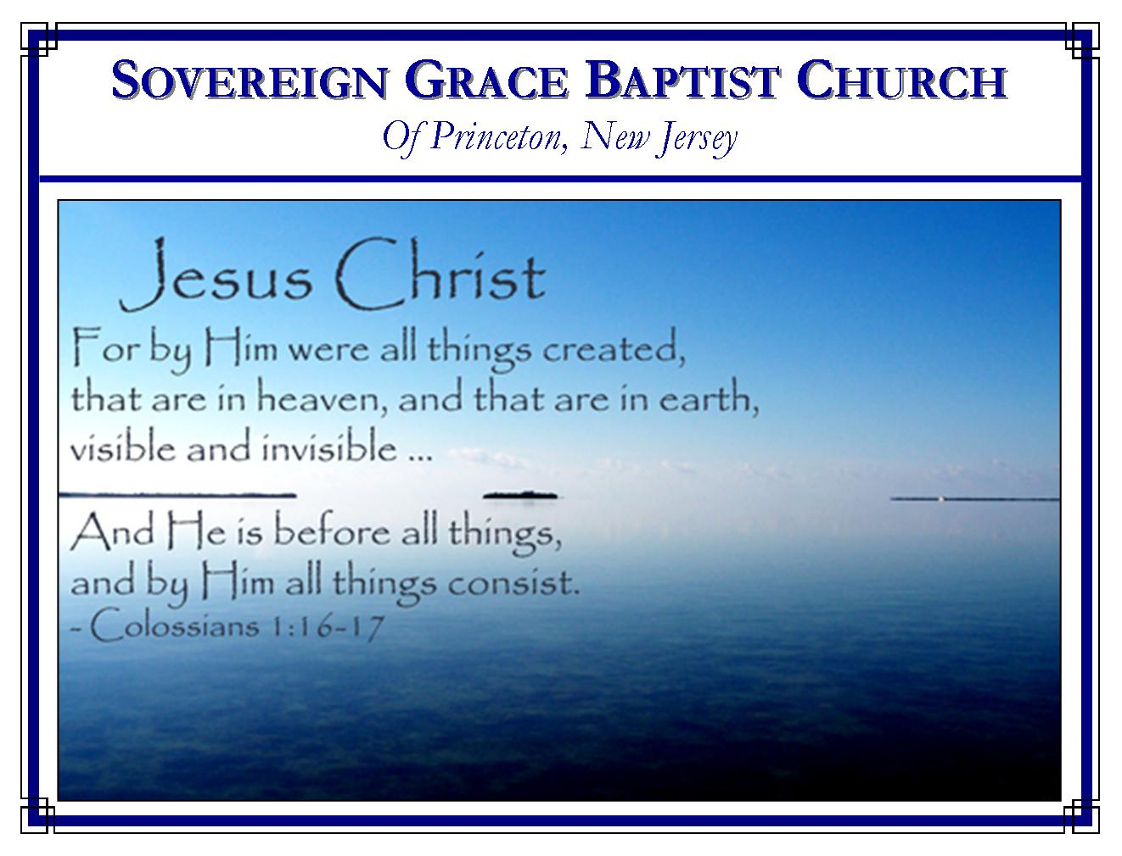
Weekly Schedule of Services
Sunday: | 10:00 AM | Bible Class
 | 11:00 AM | Morning Service
Thursday: | 7:00 PM | Mid-week Service

Web Addresses
Be sure to bookmark our website for daily articles and audio messages:
www.FreeGraceMedia.com | www.FreeGraceRadio.com
Weekly Meeting Location  Rocky Hill Firehouse, 2nd floor  150 Washington St., Rocky Hill, NJ 08553 | Mailing Address  7 Birch Street  Pennington, NJ 08534
Phone: 615-513-4464 | Email: clay@freegracemedia.com
If you would like to receive this bulletin sent weekly to your email then send a note to the email address above.

Disciples of Christ
Luke 14: 25-35
In our text, the Lord Jesus Christ declares plainly what true faith is and what it involves. The Lord is not discouraging men and women from coming to him. Christ is instructing us to make a deliberate, conscious evaluation of what faith is and of what it means to be his disciple.
Disciples of Christ Come to Christ (Luke 14: 26)
Believing on Christ is coming to Christ. It is altogether spiritual—the action of the heart (John 6: 35). Believing on Christ is altogether to the glory of God’s grace (John 6:44, 65; Ephesians 2:8-9). Coming to Christ is not done one-time but is continual all our days (1 Peter 2: 4; 2 Corinthians 1:10).
Disciples of Christ Worship Christ above All (Luke 14: 26)
The word “hate” does not mean we cease loving our families, or ourselves. It means we cannot be the disciple of the Lord Jesus Christ if we place anyone, even ourselves, above Christ (Matthew 10:37). Whatever our relationship—Christ must be first (Ephesians 5:22, 25; 6: 1, 4). When there is oneness in heart and affection between Jesus Christ and the soul: what he loves we love; what he hates we hate; his Father is our Father; his people our people. (Note what Ruth said to Naomi--Ruth 1: 16-17).

Disciples of Christ Lay Down our Lives (Luke 14: 27)
Bearing the cross means everything and everyone that will come between you and your Lord must be laid aside. When Christ went to the cross he willingly laid down his life. Christ preferred manifesting the righteousness of God, even when it meant being made a curse for his people. He preferred the salvation of God’s elect more than sparing himself the suffering of the cross. The will of God was more important to Christ than the personal suffering he had to bear. And because he bore his cross, he finished the work, that is, all those for whom he died, are made the righteousness of God in Christ. Bearing the cross may mean bearing the reproach of men, even from the dearest loved ones. But our constraint is the love of Christ for us for by his suffering we are complete (Mark 8:35).
Disciples of Christ Find Sufficiency in God (Luke 14: 28-33)
The Lord tells us to “count the cost.” Before building, we make sure we have full sufficiency. In the life of faith, if we count the cost to find we have sufficiency of ourselves, then we will not begin much less finish in faith. (2 Corinthians 2: 16; 3: 5). God our Savior must be all our sufficiency. Christ is the Foundation God laid by God himself; the believer’s Righteousness is Christ. The building is the Lord’s and the Lord does the building: by electing grace, by redeeming grace, by life-giving grace, by preserving grace, by resurrecting grace--“he shall bring forth the headstone thereof with shoutings, crying, Grace, grace unto it.” (Zechariah 4: 7; 1 Peter 2: 4-6).
Likewise, if we be found God’s army then Christ must be the Captain of our Salvation, the Author and Finisher of faith (Hebrews 2: 10; 12: 1-3). We must know from the beginning that the warfare is already won (Isaiah 40: 2). It must ever be our thankful understanding that God chose us to be his soldiers (2 Timothy 2: 3-4). We must consider and remember that we do not war after the flesh (2 Corinthians 10: 3-4). Our armor and weapons are all of God (Ephesians 6: 11-18). Oh, count the cost, then just as Abraham did, account that God is able (Hebrews 11:19). So forsake all for Christ (Luke 14: 33).
Disciples of Christ Walk in God’s Covenant (Luke 14: 34-35)
Salt represents the bond of God’s everlasting covenant of preserving grace. His covenant to the believer is ordered and sure by God in Christ (Leviticus 2:13; Psalm 89: 27-29; Hebrews 8: 10-12)—we add nothing to salvation because salvation is accomplished by Christ. This assurance of grace in our hearts is the wisdom of our walk, the seasoning of our speech, that which makes us to redeem the time (Colossians 4: 5-6).
If God has given you ears to hear then come to Christ, worship him above all, lay down your life, count God to be your full sufficiency, and walk in the assurance of his everlasting covenant mercies. So shall you be disciples of Christ, the salt of the earth (John 6: 37; Hebrews 10:23-31).
Dates to Remember at the Firehouse
Sunday, June 19, 10 & 11 AM, Bob Coffey
Saturday/Sunday, June 24-25, 10/11 AM each day, Todd Nibert
Sermons
The Builder and Keeper
Put to Death in the Flesh, Quickened by the Spirit
Covenant Broken, Covenant Fulfilled

