May 8, 2011
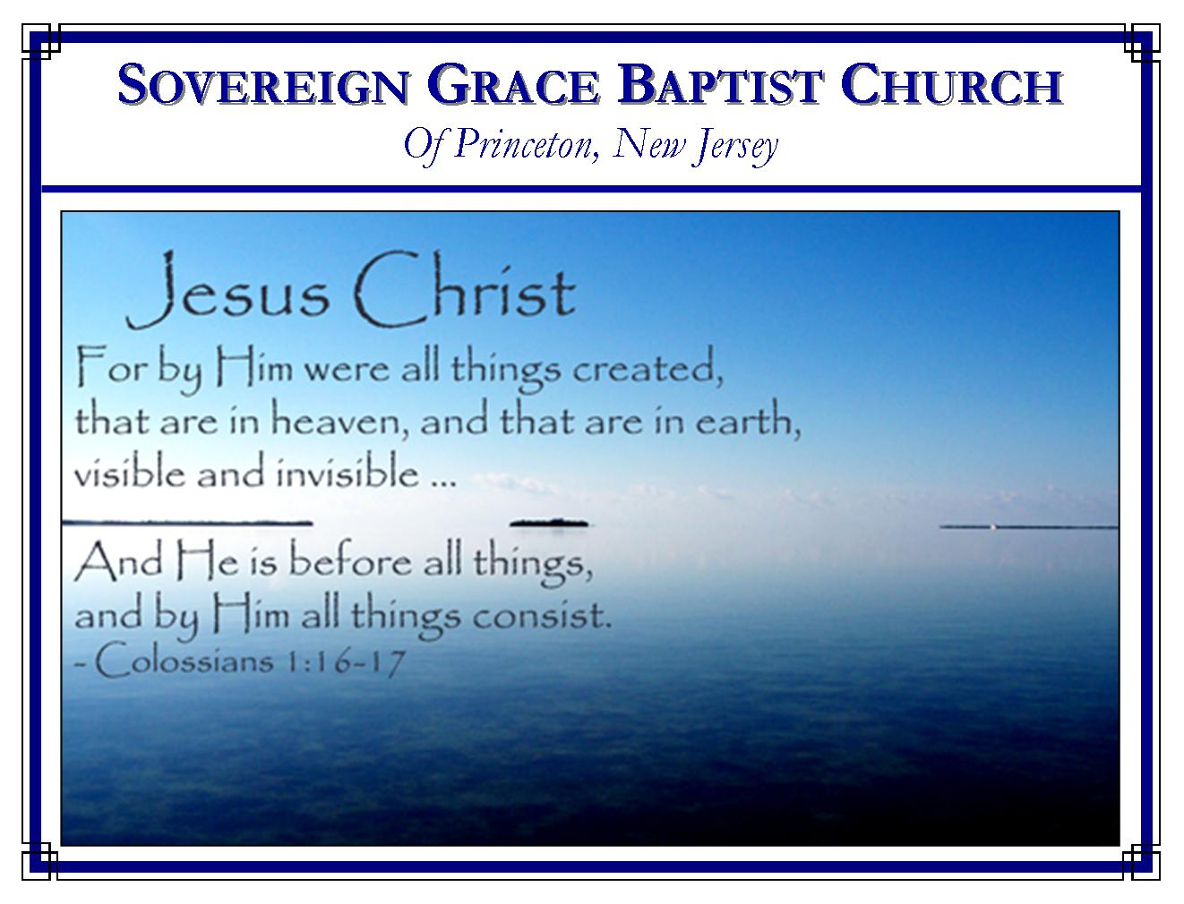
Weekly Schedule of Services
Sunday: | 10:00 AM | Bible Class
 | 11:00 AM | Morning Service
Thursday: | 7:00 PM | Mid-week Service

Web Addresses
Be sure to bookmark our website for daily articles and audio messages:
www.FreeGraceMedia.com | www.FreeGraceRadio.com
Weekly Meeting Location  Rocky Hill Firehouse, 2nd floor  150 Washington St., Rocky Hill, NJ 08553 | Mailing Address  7 Birch Street  Pennington, NJ 08534
Phone: 615-513-4464 | Email: clay@freegracemedia.com
If you would like to receive this bulletin sent weekly to your email then send a note to the email address above.

HAPPY MOTHER’S DAY
Psalm 113:9: He maketh the barren woman to keep house, and to be a joyful mother of children. Praise ye the LORD.

The Prophets Minds' Were Girded
1 Peter 1: 10-13
In the Orient they wore long flowing garments. These garments would interfere with walking when they were travelling. So when taking a journey they would gird up their garments around their loins where the life is. Brethren, you who are born of the Holy Spirit are sojourners in this life (v17). There are many thoughts, many fleshly pursuits which are like bulky garments. They only corrupt our minds, from the faith and hope we have in Christ (1 Peter 2: 11). The prophets were believers like us. They searched diligently and looked for the coming of Christ. They were not only used to give us the scriptures but the Spirit fed their faith in the midst of their own sufferings so that they themselves were assured that as the Savior would suffer and enter into his glory so would they after that they had suffered through this life awhile. So Peter encourages the saints then and us now. Rather than being depressed by afflictions, turned away from the hearing of the gospel, instead of being conformed to this world, who has better things to do than to the hear the gospel and search diligently the scriptures? As you journey, gird up the loins of your mind, feed the inner man, seek Christ in his word and in providence, be sober and hope to the end for the grace that is to be brought unto you at the revelation of Jesus Christ.
The Least and the Greatest
Matthew 11: 11: Verily I say unto you, Among them that are born of women there hath not risen a greater than John the Baptist: notwithstanding he that is least in the kingdom of heaven is greater than he.”
Those words are not to be understood as if there are great saints and lesser saints in God’s kingdom. There are not. He that is least in the kingdom is our Lord Jesus, who, because he made himself the least, is the greatest, the firstborn in the house of God.
Don Fortner

One Answer to Ten Thousand How’s
Faith brings God into the scene. Therefore, it knows absolutely nothing of difficulty; it laughs at impossibilities. In the judgment of faith, God is the answer to every question; He is the salvation to every difficulty…Unbelief says, how can such things be? Unbelief is full of flaws; but faith has one great answer to ten thousand how’s, and that answer is God Almighty. Scott Richardson

The Strength of God
Genesis 32: 25…he touched the hollow of his thigh
One of the principal designs of our gracious heavenly Father in the ordering of our path, in the appointing of our testings and trials, in the discipline of his love, is to bring us to the end of ourselves, to show us our own powerlessness, to teach us to have no confidence in the flesh, that his strength may be made perfect in our conscious and realized weakness. A. W. Pink
One Message throughout the Word

1 Peter 1: 11:…the sufferings of Christ, and the glory that should follow.

By Christ suffering unto death he has accomplished the complete redemption of every child given him before the world began (Hebrews 9: 12). He has entered into his glory at the right hand of the Father because God is well-pleased for his righteousness sake (Psalm 110: 1). He shall return, not one of his sheep shall perish, and great glory shall follow (John 6: 37-39; Matthew 25: 31-34). The prophets of the Old Testament scriptures were inspired by the Spirit to write about this one message (2 Peter 1: 21; Luke 24: 26-27). And here is Peter writing by the same Spirit about the same message in the New. There is one message throughout the word of God—the sufferings of Christ and the glory that should follow. Search all the scriptures looking for Christ. By the power of the Holy Spirit you might just come unto HIM! (John 5: 39).

BIRTHDAYS IN MAY
Eric Lutter--9th
Will Curtis--14th

ANNOUNCEMENT

Lord willing, we will have the youth Bible study, Friday, May 20, 7pm at our house.

