January 16, 2011
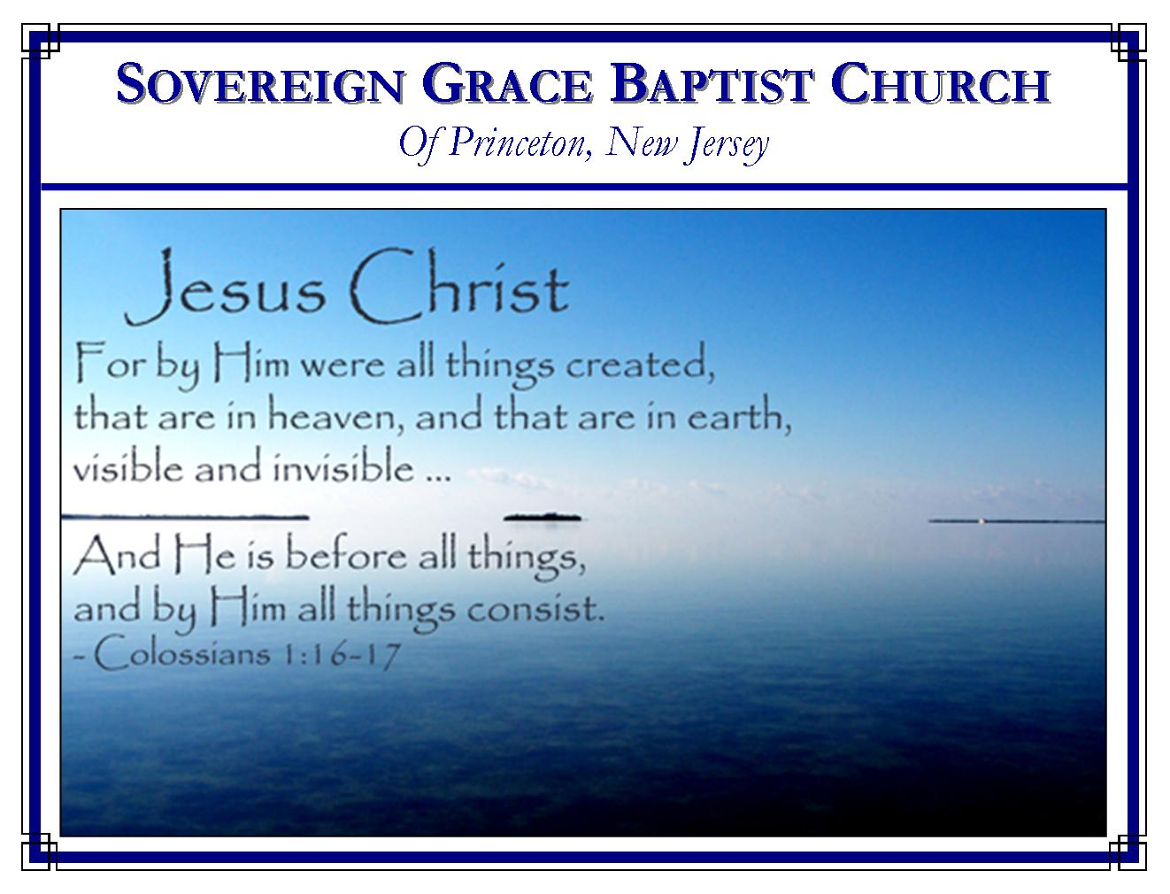
Weekly Schedule of Services
Sunday: | 10:00 AM | Bible Class
 | 11:00 AM | Morning Service
Thursday: | 7:00 PM | Mid-week Service

Web Addresses
Be sure to bookmark our website for daily articles and audio messages:
www.FreeGraceMedia.com | www.FreeGraceRadio.com
Weekly Meeting Location  Rocky Hill Firehouse, 2nd floor  150 Washington St., Rocky Hill, NJ 08553 | Mailing Address  7 Birch Street  Pennington, NJ 08534
Phone: 615-513-4464 | Email: clay@freegracemedia.com
If you would like to receive this bulletin sent weekly to your email then send a note to the email address above.

Wisdom is Justified of Her Children
Matthew 11: 16-19
The Lord Jesus described the rejection of John and himself as childish. The wise and prudent could not be taught anything because they knew everything. Many excuse themselves from bowing to the Truth by finding fault with the messengers (Matthew 11: 16-19). But wisdom is justified of her children. It is written of those babes in whom God revealed Christ through the preaching of John the Baptist, "And all the people that heard him, and the publicans, justified God, being baptized with the baptism of John. But the Pharisees and the lawyers rejected the counsel of God against themselves, being not baptized of him" (Luke 7: 28). At that time, the disciples came back justifying Wisdom, rejoicing in the power of Christ's name. At that time the Child, the Wisdom, justified Wisdom, "At that time Jesus answered and said, I thank thee, O Father, Lord of heaven and earth, because thou hast hid these things from the wise and prudent, and hast revealed them unto babes. Even so, Father: for so it seemed good in thy sight" (Matthew 11: 25-26) It pleased God to confound the wise and prudent by choosing base things and things despised, that no flesh should glory in his presence. But the babes in whom God reveals Christ justify God by glorying in the Lord only (1 Corinthians 1:21-31).

Full Revelation
Matthew 11: 25: At that time Jesus answered and said, I thank thee, O Father, Lord of heaven and earth, because thou hast hid these things from the wise and prudent, and hast revealed them unto babes. 26: Even so, Father: for so it seemed good in thy sight. 27: All things are delivered unto me of my Father: 27: and no man knoweth the Son, but the Father; neither knoweth any man the Father, save the Son, and [he] to whomsoever the Son will reveal [him].
In his deity, the Son of God had nothing delivered unto him, but as Christ the Mediator all things are delivered unto him of the Father. The Lord Jesus had just thanked the Father, for revealing "these things". Here he says "all things" are delivered unto me. The Lord Jesus had just thanked the Father for "revealing" then he says that it is the Son who "reveals the Father." What does this mean? When through the Holy Spirit the Father reveals the Son in the believer, seeing the Son we see the Father--the glory as of the only begotten of the Father (John 1: 14). And seeing the Son we behold all things that please the Father--For it pleased the Father that in his Son should all fullness dwell (John 14: 9; Colossians 1: 14-20). And of his fullness every believer receives, grace for grace. (John 1: 16).

My Yoke is Easy
Matthew 11: 28 Come unto me, all [ye] that labour and are heavy laden, and I will give you rest. 29 Take my yoke upon you, and learn of me; for I am meek and lowly in heart: and ye shall find rest unto your souls. 30 For my yoke [is] easy, and my burden is light.
The Lord had just been describing and condemning the Pharisee's. They put hard yokes and heavy burdens upon men, never restoring or refreshing the soul with rest, but they will not move them with one of their fingers (Mat 23: 4). Our Lord's yoke is the opposite. To come unto the Lord is to come to him by faith, to be taught of him, about him, to follow him and to find that he refreshes the soul with "grace for grace". He has moved every burden. "This is his commandment, That we should believe on the name of his Son Jesus Christ." By believing on his name, his establishing of the law is ours freely. He puts on us is to love one another.

He is meek and lowly in heart. When your soul is refreshed and full of joy whatever it is you are doing is easy and light--this is the rest he gives. "And love one another, as he gave us commandment." What an easy yoke faith and love make. He is meek and lowly of heart. Oh, we will not find this soul rest in the high places of the wise and prudent, but to those who come with a broken and contrite heart, he gives rest unto your souls.

Are you laboring to seek salvation by the righteousness of your works. That is a heavy load that will crush you forever.

Galatians 3: 10 For as many as are of the works of the law are under the curse: for it is written, Cursed [is] every one that continueth not in all things which are written in the book of the law to do them. 11 But that no man is justified by the law in the sight of God, [it is] evident: for, The just shall live by faith. 12 And the law is not of faith: but, The man that doeth them shall live in them. 13 Christ hath redeemed us from the curse of the law, being made a curse for us: for it is written, Cursed [is] every one that hangeth on a tree: 14: That the blessing of Abraham might come on the Gentiles through Jesus Christ; that we might receive the promise of the Spirit through faith.

Come to Christ--he promises, "I will give you rest".

Are you a believer, who is tempted of the devil, struggling against sin, or unbelief? Are the cares of this world weighing heavy on you? Come to Christ--he promises to give you "rest".

Hebrews 2: 18: For in that he himself hath suffered being tempted, he is able to succour them that are tempted

Application: The way this message came about: I found myself laboring with a very heavy load--seeking the message for you. This verse came to mind--I came to Christ--asked him to refresh my soul. I really felt the burden lifted from off me. My soul began to be revived--to find rest.
John 6: 37: All that the Father giveth me shall come to me; and him that cometh to me I will in no wise cast out.

1. For I am meek and lowly in heart--
1 Peter 2: 21: For even hereunto were ye called: because Christ also suffered for us, leaving us an example, that ye should follow his steps: 22: Who did no sin, neither was guile found in his mouth: 23: Who, when he was reviled, reviled not again; when he suffered, he threatened not; but committed himself to him that judgeth righteously: 24: Who his own self bare our sins in his own body on the tree, that we, being dead to sins, should live unto righteousness: by whose stripes ye were healed. 25: For ye were as sheep going astray; but are now returned unto the Shepherd and Bishop of your souls.

Commit all to him. Hebrews 4: 15: For we have not an high priest which cannot be touched with the feeling of our infirmities; but was in all points tempted like as we are, yet without sin. 16: Let us therefore come boldly unto the throne of grace, that we may obtain mercy, and find grace to help in time of need.

I John 3: 23: And this is his commandment, That we should believe on the name of his Son Jesus Christ, and love one another, as he gave us commandment.

John 15: 11: These things have I spoken unto you, that my joy might remain in you, and that your joy might be full.

- Trusting his obedience unto death as our only righteousness and redemption, we obtain the rest of a good conscience.
- Following his example and revealed will, we obtain the rest of a faithful servant.
- Trusting his providence, we obtain the rest of a believing heart.

Come to Christ now!
Ye shall find rest unto your souls!
Amen!

January Birthdays
Vincent D'Armiento--18th
John Keller--27th

Look Upon Zion
Isaiah 33: 20: Look upon Zion, the city of our solemnities:
We behold that we are compassed about with a great cloud of witnesses, the spirits of just men made perfect. Not one has ever been plucked out of his hand. We behold the King in his beauty--Jesus the Author and Finisher of faith who despised the shame and is set down on the right hand of the throne of God--the Mediator of the everlasting covenant--whose blood demands our eternal salvation. We behold "the LORD our judge, the LORD our lawgiver, the LORD our king; he will save us." Our Lord promises his lame children that we are more than conquerors through him that loved us. Though our iniquities are many, our gracious Lord says in Christ, thy sins are forgiven!

SERMONS
After clicking on the following sermon links you will go to sermon notes where you will find an option at the top of the page to access the audio.

Rest Unto Your Souls
Vengeance Belongs to God

ARTICLES
Rejoicing in Ourselves Alone

ARTICLES FROM OTHERS

