January 9, 2011
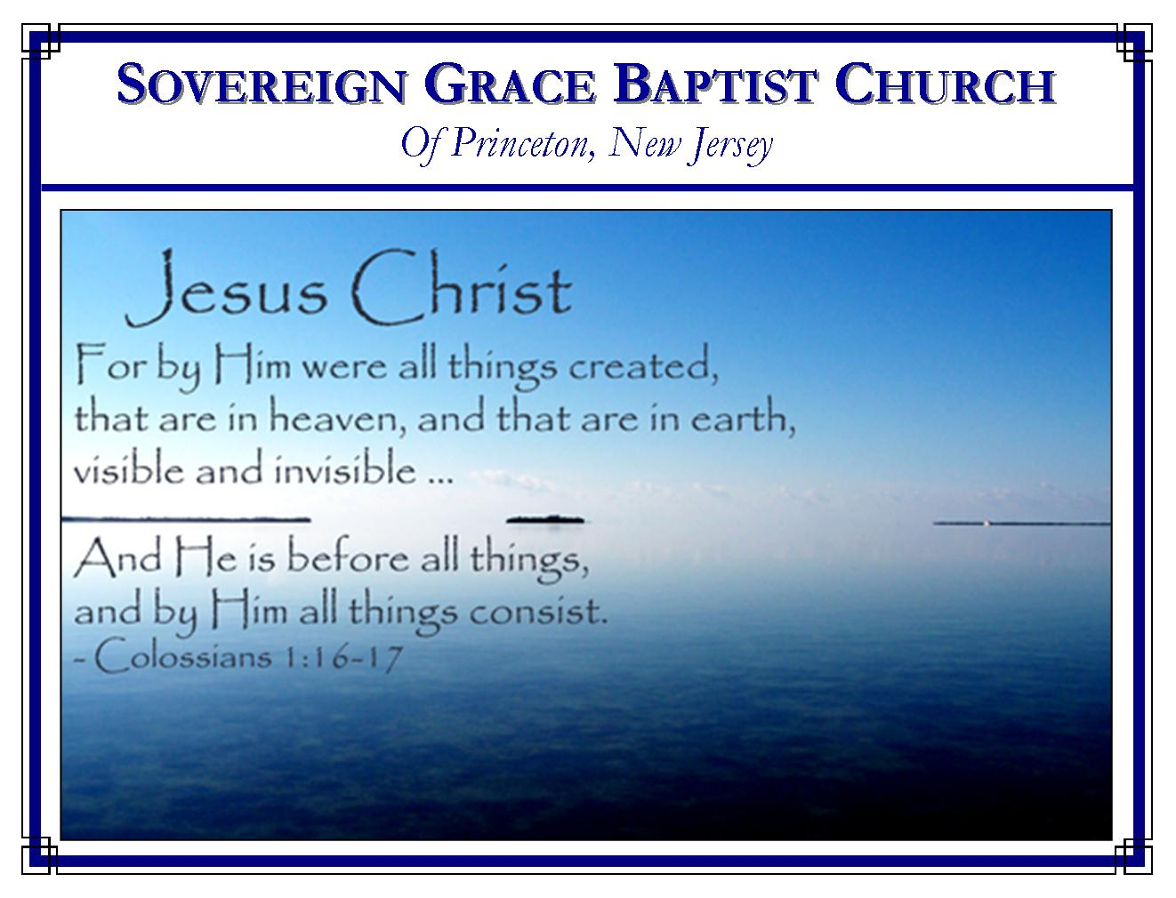
Weekly Schedule of Services
Sunday: | 10:00 AM | Bible Class
 | 11:00 AM | Morning Service
Thursday: | 7:00 PM | Mid-week Service

Web Addresses
Be sure to bookmark our website for daily articles and audio messages:
www.FreeGraceMedia.com | www.FreeGraceRadio.com
Weekly Meeting Location  Rocky Hill Firehouse, 2nd floor  150 Washington St., Rocky Hill, NJ 08553 | Mailing Address  7 Birch Street  Pennington, NJ 08534
Phone: 615-513-4464 | Email: clay@freegracemedia.com
If you would like to receive this bulletin sent weekly to your email then send a note to the email address above.

The Way Up with God is Down
II Kings 5: 1-14
Are you a sinner? Naaman had much honor given him by a man but it was the LORD who had used him to give deliverance to Syria. In himself, Naaman was nothing but a leper. You may have great honor from men, but can do nothing apart from the Lord. And apart from Christ you have the incurable disease of sin. (Isaiah 1: 5-6; Job 14: 4). Are you a sinner?

Has God sent you his word? God saves through the gospel (1 Cor 1: 21). The LORD used Naaman's army to bring an Israelite girl to Naaman's house to wait on his wife. This girl told of a prophet in Israel who could heal Naaman of his leprosy. This was by the sovereign hand of God who chooses whom he will and passes by whom he will (Luke 4:27). Has God sent you his word? You would be wise to give your undivided attention to what God says.

Are you trying to buy salvation? Naaman came with gifts to pay the prophet for his service. Even the king in Israel knew this was wrong. Naaman stood outside the door of Elisha's house full of pride with his horses and chariots and all his valuable gifts. Yet, Elisha did not go out to him but sent a messenger out with this message. First, you must lay aside all your gifts, all your fancy attire, all honor you think you have or deserve for you are a loathsome leper, defiled in your sin. Secondly, you must dip in Jordan 7 times, that is, you must wash in the sin-cleansing blood of Christ Jesus. Are you trying to buy salvation? What do you think of this message?

Naaman got angry, saying, "I thought…" If God told you there was some great thing for you to do then would you not do it? Why not repent and believe on his Son? Naaman eventually went down, washed and came away clean. Do you hear the Voice of Christ! Come down. Lay aside the rags you think will impress God. The sacrifice has been made by Christ. Seek mercy and it is yours (Matthew 9: 10-12). Believe on Christ Jesus. Thou shalt be clean!
GRACE AND PEACE
Every believer is chosen by grace, regenerated by grace, called by grace, redeemed by grace, kept by grace and shall be delivered by grace. It is by grace that we have peace between us and God. This is what gives us a peaceable spirit toward our brethren and, as much as possible, with all men. Only God gives it and only God is to be glorified for it.

ALL THINGS NEW
Revelation 21: 5: And he that sat upon the throne said, "Behold, I make all things new."

New Heaven and New Earth (Revelation 21:1)
The believer is looking for a new heaven and a new earth (2 Peter 3: 10-13.) In the end, the new creation will have none of the dividing effects of sin, as the sea represents. In Revelation 13: 1 the beast rose up out of the sea and on his heads the name "blasphemy". In Revelation 17: 15 the harlot of anti-christ religion sat upon the waters and "the waters…are peoples, and multitudes, and nations and tongues." But in the new creation there will only be the Lord's chosen generation, his royal priesthood, his holy nation, his purchased people and all shall speak but one language, " Blessing, and honour, and glory, and power, be unto him that sitteth upon the throne, and unto the Lamb for ever and ever." (Revelation 5: 9-10, 12-13). Try to think upon a heaven and earth without briars or sweat or division, only a perfect garden wherein dwells righteousness.

New Jerusalem (Revelation 21: 2)
This city is its citizens who were chosen in Christ by God the Father, sanctified by the Spirit of God in the new birth through the gospel, prepared by the Lamb who was slain in her room and stead. Christ is the husband who prepared this city as a bride by his finished work of righteousness--our glory and light is our God and our Lamb (Revelation 21: 9-11; Revelation 4: 2-3; Isaiah 54:5) And Christ not only made the preparations but Christ presents her to himself (Ephesians 5: 25-27, 30-32; Isaiah 61:10). Brethren, our citizenship is not in any earthly Jerusalem, but our conversation is in the heavens from whence we look for the Savior, the Lord Jesus Christ. Let this thought comfort you, very soon your vile body shall be fashioned like unto his glorious body. (Philippians 3: 20-21; Hebrews 12: 22-25; Galatians 4: 23-26).

New Communion (Revelation 21: 3-4)
In the midst of this world of tribulation, the Lord is with us in Spirit now. He dwells in each of his newly created children and his children dwell in him for he said, "I will never leave you, nor forsake you." As we are gathered to worship him, he declares, "There am I in the midst" (Hebrews 13: 5; Matthew 18: 20). But may this precious thought be our strength in this troubling hour, God himself shall be with us forever. Soon we shall have uninterrupted communion with our Savior forever! Perfect conformity and perfect commitment to our God forever! No more death, no sorrow, no crying, no pain for we will have no more sin. And think on this as personally and as intimately as you can: God himself shall wipe away all tears from your eyes.

Assurance (Revelation 21: 5-7)
As you think on the glorious day when our King shall make all things new is it more than you can take in? Does it sound too good to be true? Here is the most blessed assurance for you, believer, it is not of your doing, but of the almighty hand of God. God who cannot lie said, "Write, for these words are faithful and true…It is done. I am Alpha and Omega, the beginning and the end. I will give unto him that is athirst of the fountain of the water of life freely. He that overcometh shall inherit all things; and I will be his God, and he shall be my son." (Revelation 21: 5-6). O, happy day!

SERMONS
After clicking on the following sermon links you will go to sermon notes where you will find an option at the top of the page to access the audio.

Beginning to End
All Things New
He Went Down
Grace and Peace Multiplied

ARTICLES
Joshua is a Type of Christ Jesus
Jesus Christ Served Under the Law
The Law and Prophets Bear Witness of Christ
The Governing of Christ
Christ Has, Is and Shall Save All The Children of God

ARTICLES FROM OTHERS
The Slothful Man Does Not Roast What He Took in Hunting
Christ our Substitute
Is There Any Real Hope for Real Sinners?
Why Christ Came
True Humility

