October 3, 2010
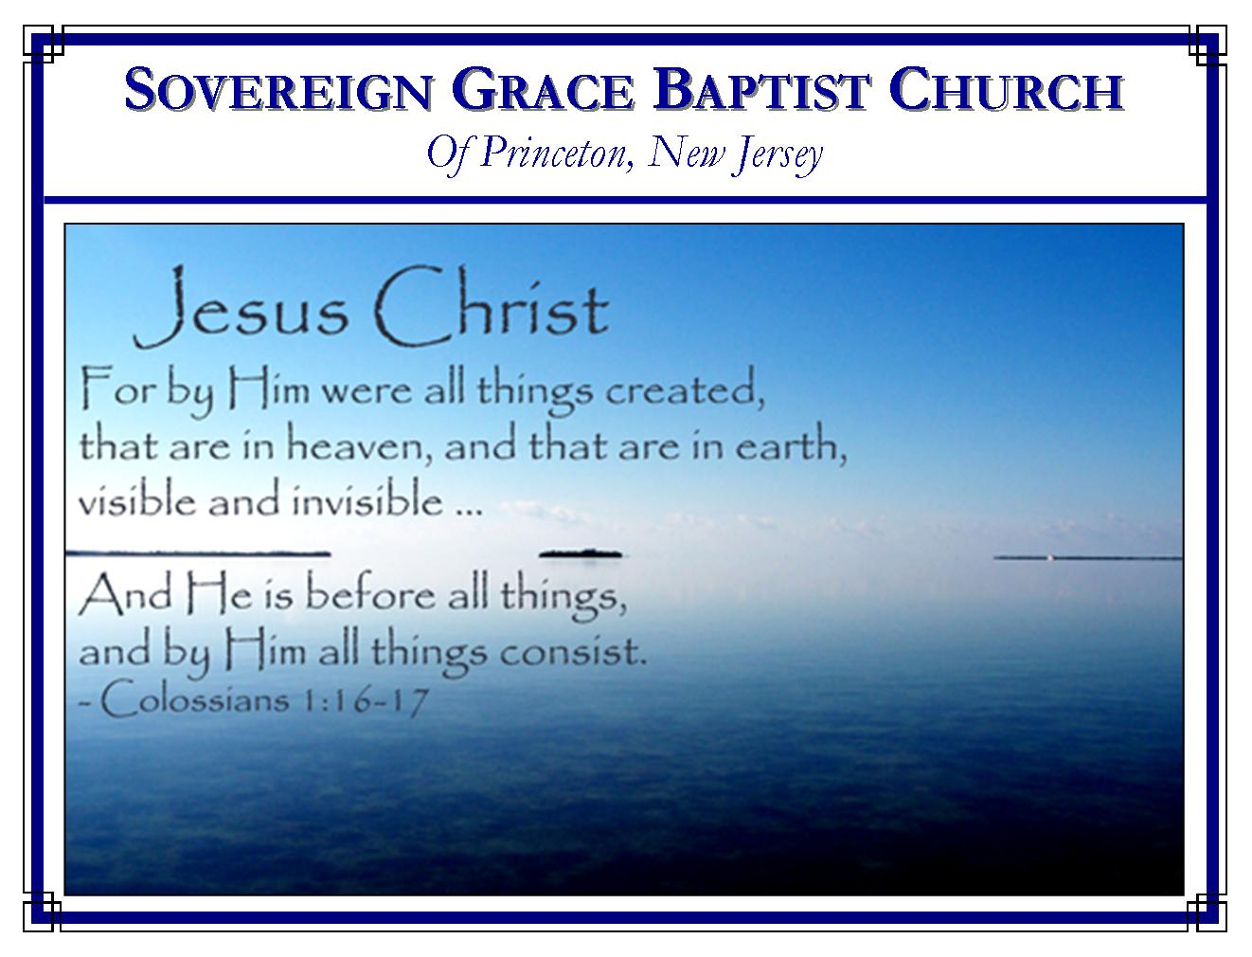

Weekly Schedule of Services
Sunday: | 10:00 AM | Bible Class
 | 11:00 AM | Morning Service
Thursday: | 7:00 PM | Mid-week Service

Web Addresses
Be sure to bookmark our website for daily articles and audio messages:
www.FreeGraceMedia.com | www.FreeGraceRadio.com
Weekly Meeting Location  Rocky Hill Firehouse, 2nd floor  150 Washington St., Rocky Hill, NJ 08553 | Mailing Address  7 Birch Street  Pennington, NJ 08534
Phone: 615-513-4464 | Email: clay@freegracemedia.com
If you would like to receive this bulletin sent weekly to your email then send a note to the email address above.

JOSHUA, THE END OF MOSES
Deuteronomy 34: 1-12; Joshua 1: 1-9; Romans 10: 4
Joshua is a type of Christ Jesus the Lord. In two places in the New Testament, instead of referring to him by the name "Joshua", he is called "Jesus" (Acts 7: 45; Hebrews 4: 8.) The name "Joshua" and the name "Jesus" mean "salvation" or "Jehovah Salvation" (Matthew 1:21; Acts 4:12; Romans 10: 13; Philippians 2: 9-11).

The Spiritual Lesson
In our text, the children of Israel have been brought to the edge of the promise land. But God would not allow Moses to lead the children of Israel into Canaan. Instead, Joshua is the one who did so. In our text we have the end of Moses' rule over the children of Israel and the beginning of Joshua's rule. What is the spiritual lesson in this? (John 1: 17) Moses is a type of the law. The law can not bring God's children into heaven. God's children shall be delivered into God's promised rest only by Jesus Christ our Savior. Christ is the end of the law for the believer just as real as Joshua is the end of Moses (Romans 10:4).

Jesus Christ Served Under the Law
As Joshua was servant under Moses, Christ Jesus served and fulfilled both the moral and ceremonial law of God (Galatians 4: 4-5). Christ Jesus became obedient throughout his life from his birth even unto his death fulfilling the law for his people and honoring God by fulfilling all that is written in the law and the prophets. But the children of God had also broken the law. The righteousness of God's justice had to be satisfied. So Jesus became obedient even unto the death of the cross. He who knew no sin, was willingly made sin by God and suffered under the wrath of God that his children might be made the righteousness of God in him (2 Cor 5: 21). So through life and death, even the death of the cross, Christ Jesus became obedient, and is the Righteousness of those born of grace (Philippians 2: 8; Ro 5:19).

The Law and the Prophets Bear Witness
The apostle Paul gave the illustration of the woman who is married to a man. As long as he lives she is bound to him by law. But if he dies then the law bears witness that she is free to be married to another. So it is that God's children died to the law when Christ died and are free to come under the rule of another, even Christ (Romans 7:4). The law and the prophets bear witness that the righteousness of the law, without man's doing, is fulfilled by the Faith and Fidelity of Christ Jesus (Romans 3: 21-22.) Verse nine says, "Joshua the son of Nun was full of the spirit of wisdom; for Moses had laid his hands upon him." Moses is a type of the law and Moses was also a prophet of God. By Moses laying his hands on Joshua we see a type of the law and the prophets (the whole word of God) bearing witness that the righteousness of God is Christ alone. Joshua was full of the spirit of wisdom because Moses had laid his hands on Joshua. Christ Jesus is the spirit and the wisdom of the law and the prophets, that is, both came by the Spirit of Christ and both are they which testify of Christ (1 Pet 1: 11). Christ Jesus is the Power and Wisdom, the Fulfillment of the law and the prophets, the one in whom God is just and the Justifier of his people, which God has declared in the law and the prophets from the beginning.

The Government Upon Christ's Shoulder
Verse nine says "and the children of Israel hearkened unto him, and did as the LORD commanded Moses." When the LORD revealed through Moses that Joshua was the only one who would deliver them into the land of promise then the children obeyed the LORD, obeyed the whole word of God, by looking only to Joshua to lead them. They were no longer under the rule of Moses, but under the rule of Joshua. They no longer looked to Moses but only to Joshua.

So it is when the LORD God through the preaching of the gospel contained in the written word reveals Christ in each of his children. Believers obey God and establish every word of the law and the prophets, through faith in Christ Jesus our King, our Life, our Righteousness (1 Cor 9:21.) (Gal 4: 6-7; Rom 3: 21). Those born of the Spirit of God pass from under the rule of the law to the direct leadership of Jesus Christ whose Spirit dwells in us (Gal 3: 23-25). If ye be led of the Spirit, ye are not under the law (Gal 5: 18; 4: 7-9).

Christ Has, Is, and Shall Save All the Children of God
Vested with complete power and authority from God, every promise God made to the children of Israel was fulfilled by Joshua. He led them to victory and possession of the land, conquering all their enemies.

Our Lord Jesus is King of kings and Lord of lords. He has all authority in heaven and earth, power over all flesh. Christ has conquered Satan, sin and death. He is able to subdue all things unto himself (Phi 3: 21). Believers are more than conquerors through him that loved us (Rom 8:37). He shall save his people from their sins (Mat 1: 21).

Beholding Christ, how every believer desires to grind to powder our awful taskmaster's whip! Still, how often we find ourselves playing the harlot by turning again to the weak and beggarly elements. Oh, but we have this great hope as we see our Lord and Savior typified in Joshua. When Joshua came to Rahab the harlot, seeing the scarlet thread in her window, he spared her house. So Christ is merciful and faithful to save all sinners who cast all their care upon him (Heb 7:25; Jude 24-25).

REMEMBER
We are thankful that we have various mediums in our day which make it easy for us to access the gospel like never before. But always remember that they are a supplement and not a substitute for hearing in person those whom God has sent to preach the gospel to us.

SERMONS
After clicking on the following sermon links you will go to sermon notes where you will find an option at the top of the page to access the audio.

The End of All Men
Joshua, The End of Moses
A Contrast in Hearts
Three Confirmations

ARTICLES
Elias the Example
Converting From Error
How Did Jacob Prevail?
The Firstborn is Coming!

PRINTABLE TRACTS
A Good Place to Rest and Raise our Young
Saved in Childbearing
A Letter to a Preacher
The Church Were Everybody is a Nobody
O Ye of Little Faith

ARTICLES FROM OTHERS
Let Us Not Sleep
The Doctrine of Grace
The Friend and Brother
Are You As Righteous As God?
Loving Obedience

