August 29, 2010

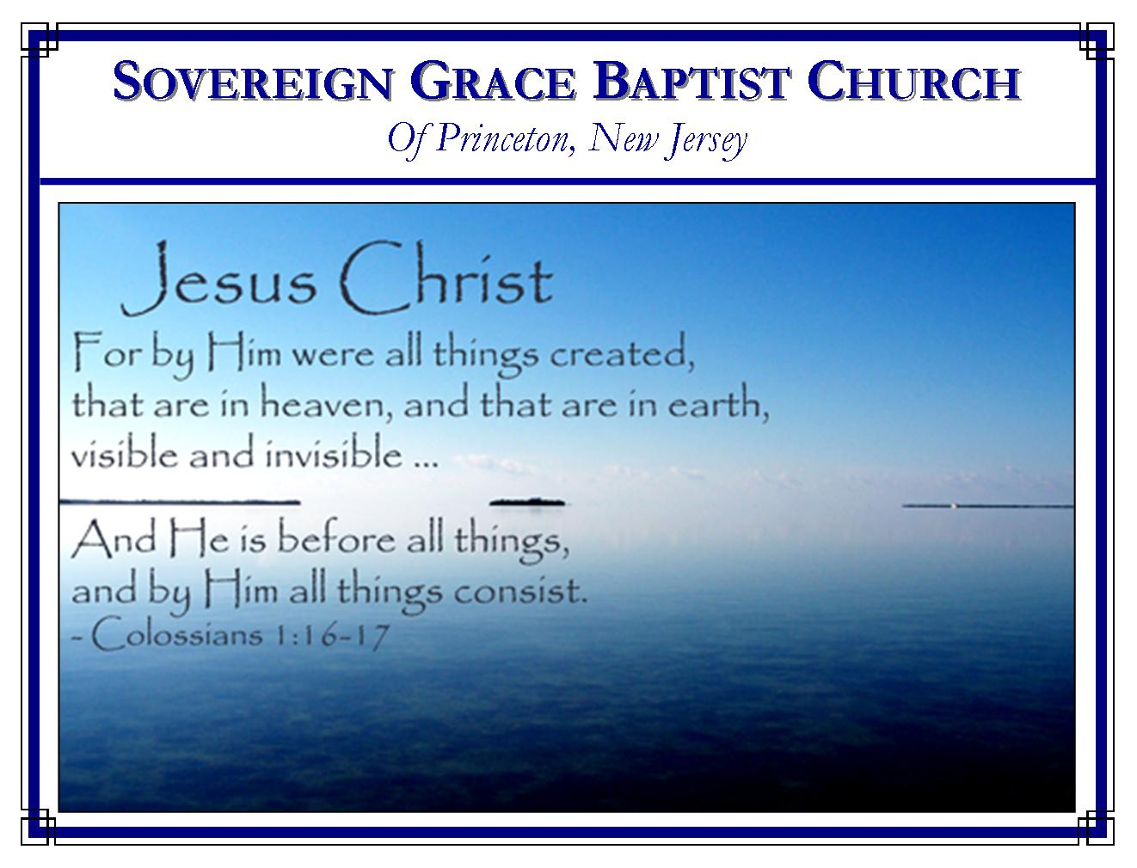

Weekly Schedule of Services
Sunday: | 10:00 AM | Bible Class
 | 11:00 AM | Morning Service
Thursday: | 7:00 PM | Mid-week Service

Web Addresses
Be sure to bookmark our website for daily articles and audio messages:
www.FreeGraceMedia.com | www.FreeGraceRadio.com
Weekly Meeting Location  Rocky Hill Firehouse, 2nd floor  150 Washington St., Rocky Hill, NJ 08553 | Mailing Address  7 Birch Street  Pennington, NJ 08534
Phone: 615-513-4464 | Email: clay@freegracemedia.com
If you would like to receive this bulletin sent weekly to your email then send a note to the email address above.

THE MORE EXCELLENT SACRIFICE
Genesis 4: 1-8

No Natural Difference (Genesis 4: 1, 2.)
Both Cain and Abel were sons of Adam. They were both born with the same corrupt nature which Adam passed on to them in natural generation. Both appear to have been taught by Adam the promise of Christ, which God taught Adam in the garden, because each came to the LORD to make an offering. But Hebrews 11: 4 tells us that there was a difference in these two, "By faith Abel offered unto God a more excellent sacrifice than Cain."

The Difference Grace Makes (Hebrews 11: 4.)
How did Abel have faith in God? The same way every sinner has faith (Ephesians 2: 1, 8-11.) Abel was born of the Spirit of God. He was given faith by the grace of God. Abel was the workmanship of God, created in Christ Jesus. When he offered unto God a more excellent sacrifice he performed a good work which God before ordained that Abel should walk in. By grace when God speaks: faith hears, faith believes, and faith obeys. Faith stands only on the rock, Christ Jesus. Faith trusts in what the finger of God writes and reasons, this way, "The mouth of the Lord has spoken it" (Isaiah 1: 20.)

Cain's Offering (Genesis 4: 3.)
The way in which Cain came to God manifests what was in his heart just as the way you come to God manifests what is in your heart. First, Cain offered unto the LORD his self-will. He placed his polluted reason above the word of Almighty Wisdom, turning from the revealed will of God and approached in the darkness of his own vain conceits (Romans 1: 22, 25.) Secondly, Cain offered unto the LORD his pride. Blood signifies the need of pardon for sin. Cain felt neither sin, nor need of pardon because he came without blood. He proudly trampled under foot the blood of Christ. Pride is the stuff of the deceitful heart. Thirdly, Cain offered unto the LORD unbelief. In unbelief he closed his eyes—he would not look to Christ; in unbelief he closed his hand—he would not lay hold on Christ; in unbelief his feet stumbled over that Sure Foundation; in unbelief he closed his ear—he would not hear of Christ; in unbelief he closed his mouth--—he would not cry unto Christ; in unbelief he closed his heart—he would not receive the free Gift. This is the worthless condition of all sinners born in Adam (Isaiah 1: 5, 6.)

Abel's Offering (Genesis 4: 4.)
Abel selects the firstborn of his flock. He offers the fat thereof, meaning his lamb was slain, and the blood, along with the fat offered unto God. First, Abel confessed that in himself he was lost, ruined and undone, apart from God's free, justifying grace in Christ. He confessed he had no power to save himself, but must be saved in the blood of Christ the Lamb of God. Secondly, Abel confessed that he believed God. By faith Abel believed Christ was the promised Messiah; by faith Abel laid hold of the promised Messiah; by faith Abel ran after Christ; by faith he heard the Word of his voice; by faith Abel cried out to Christ; by faith Abel's heart overflowed with gratitude. Abel is the new man within Abel who delighted in the law of God--Christ his High Priest, his Mediator, his Intercessor, his All (Galatians 2: 20.)

The LORD's Respect (Genesis 4: 4-8)
The LORD accepted Abel in the Beloved: fully pardoned, fully justified, fully righteous, fully holy and accepted of God. Abel's offering through faith in Christ came up to God, as every believer's work of faith does, with the fat thereof as a sweet smelling savor. Cain was rejected. His heart was enmity against God all along but now he could no longer hide it with a disguise of religion. There is no joy, no heart cheerfulness, anywhere but through faith in Christ. Abel had peace through faith--he obtained witness that he was righteous, God testifying of his gifts--that is, God purged his conscious, the Spirit bearing witness with his spirit that he was a child of God. Faith is the evidence of things not seen (Hebrews 11: 1, 4.)

Hardness of Heart (Genesis 4: 7, 8.)
In Cain we see the hardness of man's heart. When God declared the truth to Cain, instead of heeding God's word, repenting and casting himself upon the mercy of God, Cain still sought his own way. And just as it was when he made his offering, Cain's way was murder. Sinner, it is not that God is not willing to save you if come to him through faith in Christ. The problem is that you will not come to Christ, commit all to him and trust him alone save you (John 5: 40; 3: 19-21.)

Final Word
The only two beliefs in the whole world throughout all time are seen in Cain and Abel--works and grace. The way of Abel is the way of grace. The way of Cain is the way of works. (Romans 11: 6.) God accepted Abel and rejected Cain.

In the twilight of the world, Abel believed on the Sun of Righteousness by faith. He staggered not through unbelief. He embraced the truth wholly unto life eternal. Now what about you who here at the end of the world who have the full blaze of the Sun of Righteousness?

Satan threatens. The law condemns. Conscience accuses. If you look to self you will despair; if you look to the world it will mock your pain; if you look to reform you look to a broken cistern; if you to your outside performances of devotion they will prove to be reeds which break and pierce your hand. Abel is yet testifying. Hear him this day. Flee to Christ. The Lord Jesus is the More Excellent Sacrifice!

ANNOUNCEMENTS
- No midweek service, Thursday, September 2.
- One service Sunday morning, September 5, at 11am. Scott Keller preaching. No meal afterwards.
- We will have our regular meal together after services, Sunday, September 12.
SERMONS
After clicking on the following links you will go to sermon notes where you will find an option at the top of the page for the audio.

The More Excellent Sacrifice
First Things First
The Mighty Hand of God
Hear and Heed the Word

ARTICLES
He Giveth More Grace
Submission
Ye Speak Evil of Christ
Ye Speak Evil of the Law of Christ
There is One Lawgiver
Who Are You?

ARTICLES FROM OTHERS
Elder, Pastor, Bishop
The Son of the Bondwoman Shall Not Be Heir
Love Saves!
Alone
For Whom Did Christ Die?

